# 1. Información del dataset

El dataset contiene 5239 muestras y 11 columnas.

Las columnas o variables son:

SEX

RACE

ETHNICITY

AGE

CANCER_TYPE

ONCOTREE_CODE

CANCER_TYPE_DETAILED

SAMPLE_TYPE

AJCC_PATHOLOGIC_TUMOR_STAGE

HISTORY_NEOADJUVANT_TRTYN

AGE_GROUP

## 1. Descripción de variables categóricas

|  |  |  |  |  |
| --- | --- | --- | --- | --- |
| Variable | count | unique | top | freq |
| SEX | 5239 | 2 | Male | 2656 |
| RACE | 5239 | 5 | White | 4204 |
| ETHNICITY | 5239 | 2 | Not Hispanic Or Latino | 5031 |
| CANCER_TYPE | 5239 | 17 | Breast Cancer | 906 |
| ONCOTREE_CODE | 5239 | 42 | IDC | 628 |
| CANCER_TYPE_DETAILED | 5239 | 42 | Breast Invasive Ductal Carcinoma | 628 |
| SAMPLE_TYPE | 5239 | 2 | Primary | 4923 |
| AJCC_PATHOLOGIC_TUMOR_STAGE | 5239 | 19 | STAGE I | 947 |
| HISTORY_NEOADJUVANT_TRTYN | 5239 | 2 | No | 5177 |

## 2. Descripción de variables numéricas

|  |  |  |  |  |  |  |  |  |
| --- | --- | --- | --- | --- | --- | --- | --- | --- |
| Variable | count | mean | std | min | 25% | 50% | 75% | max |
| AGE | 5239.0 | 59.91200610803588 | 14.20705740503389 | 14.0 | 51.0 | 61.0 | 70.0 | 90.0 |

# 2. Tablas de Frecuencias y gráficos

## Variable SEX

|  |  |  |  |  |  |  |
| --- | --- | --- | --- | --- | --- | --- |
| SEX | F_ABS | F_ABS_AC | F_REL | F_REL_AC | % | %_AC |
| Female | 2583 | 2583 | 0.493 | 0.493 | 49.3 | 49.3 |
| Male | 2656 | 5239 | 0.507 | 1.0 | 50.7 | 100.0 |

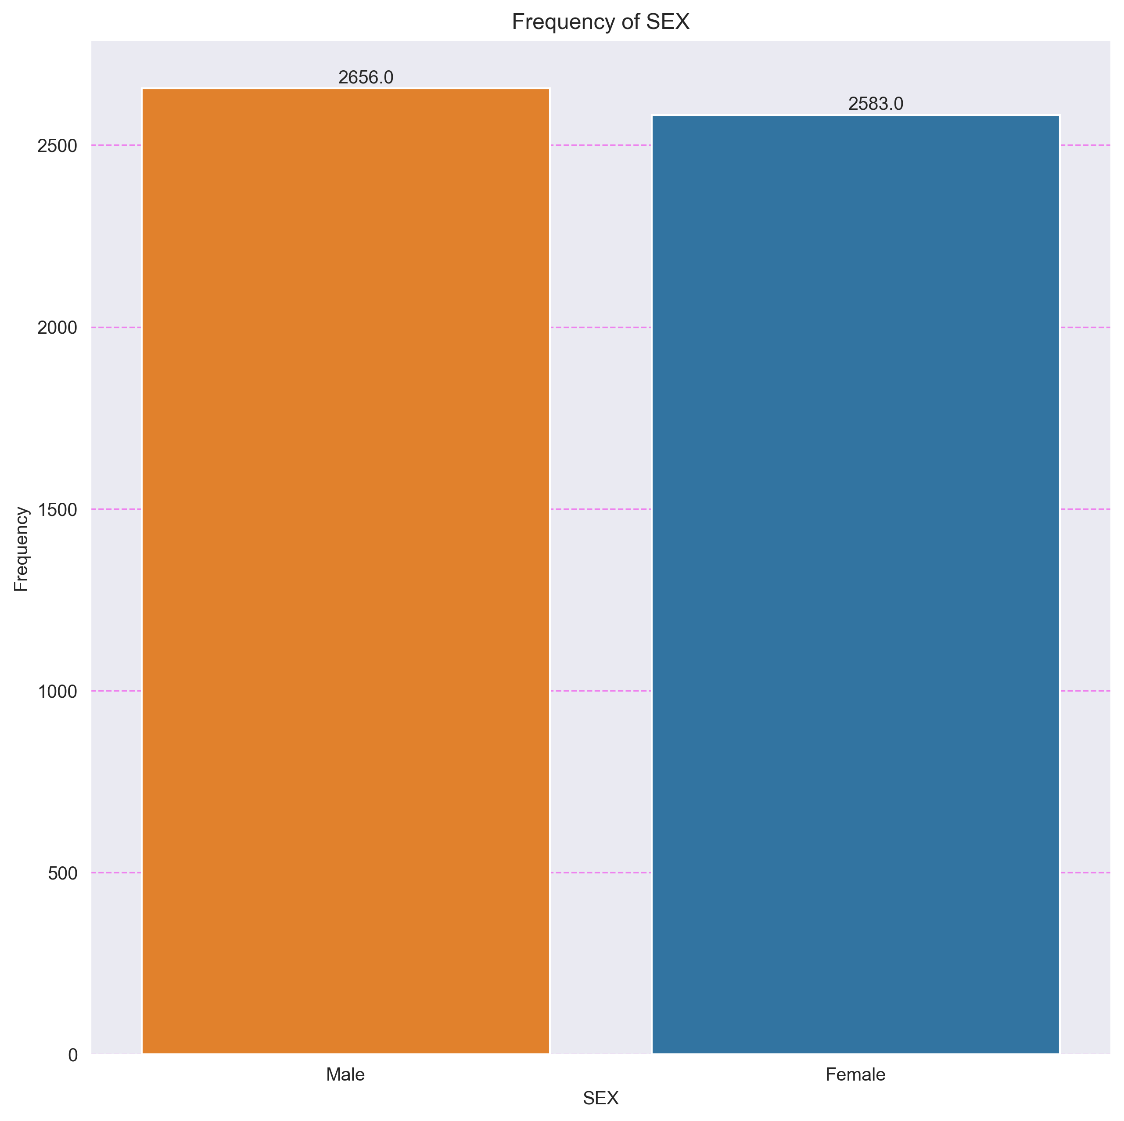

## Variable RACE

|  |  |  |  |  |  |  |
| --- | --- | --- | --- | --- | --- | --- |
| RACE | F_ABS | F_ABS_AC | F_REL | F_REL_AC | % | %_AC |
| American Indian or Alaska Native | 8 | 8 | 0.0015 | 0.0015 | 0.15 | 0.15 |
| Asian | 499 | 507 | 0.0952 | 0.0967 | 9.52 | 9.67 |
| Black or African American | 527 | 1034 | 0.1006 | 0.1973 | 10.06 | 19.73 |
| Native Hawaiian or Other Pacific Islander | 1 | 1035 | 0.0002 | 0.1975 | 0.02 | 19.75 |
| White | 4204 | 5239 | 0.8024 | 0.9999 | 80.24 | 99.99 |

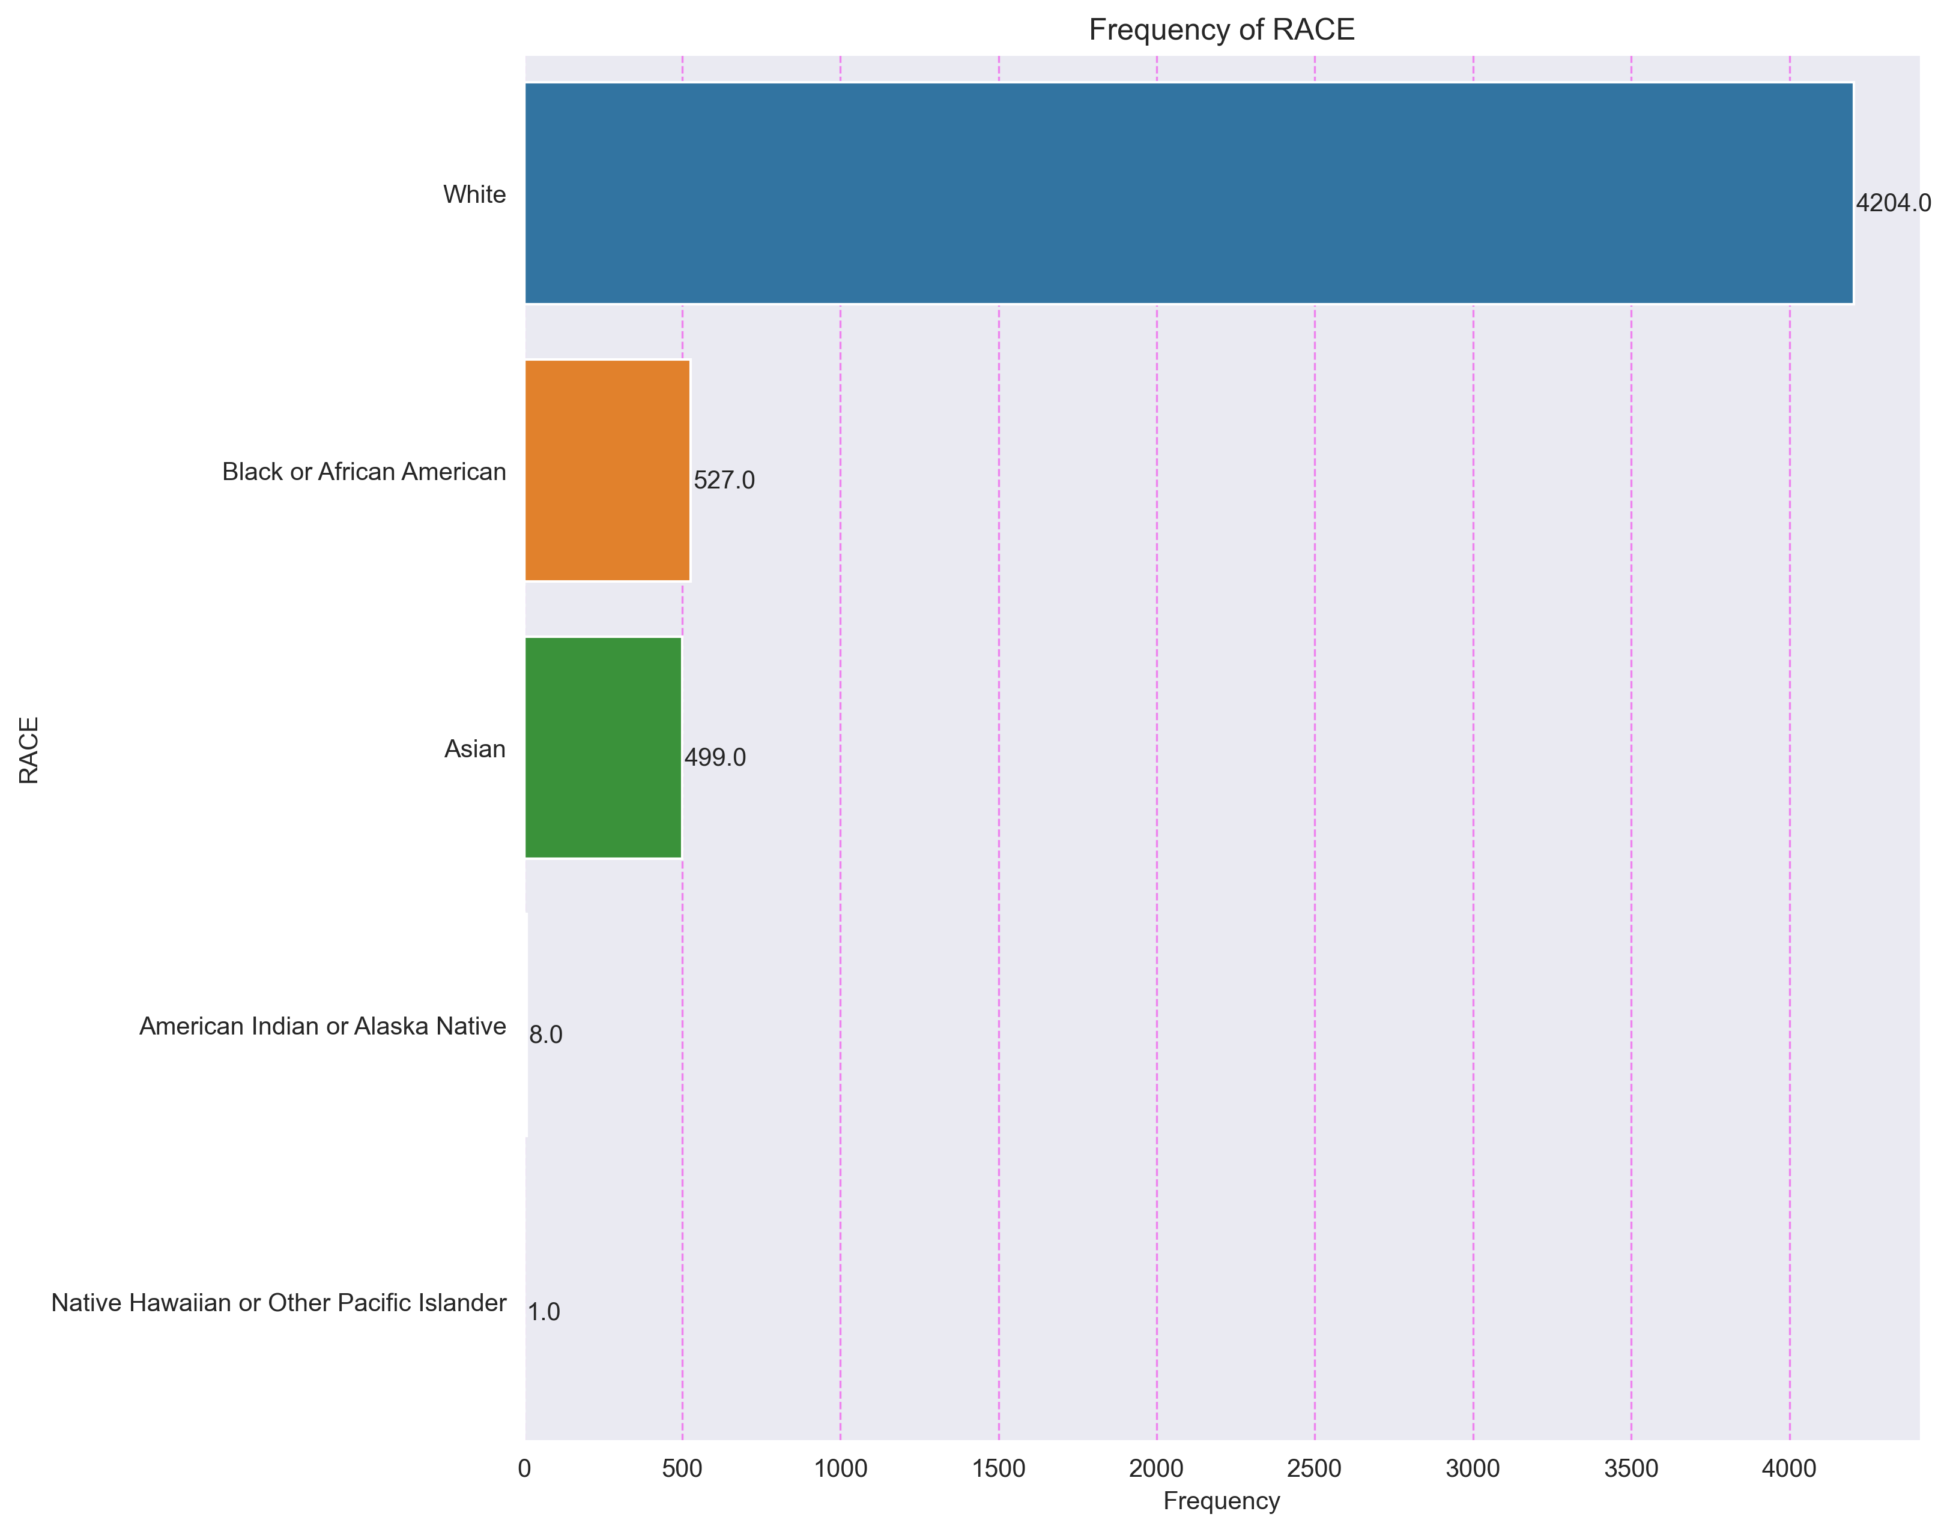

## Variable ETHNICITY

|  |  |  |  |  |  |  |
| --- | --- | --- | --- | --- | --- | --- |
| ETHNICITY | F_ABS | F_ABS_AC | F_REL | F_REL_AC | % | %_AC |
| Hispanic Or Latino | 208 | 208 | 0.0397 | 0.0397 | 3.97 | 3.97 |
| Not Hispanic Or Latino | 5031 | 5239 | 0.9603 | 1.0 | 96.03 | 100.0 |

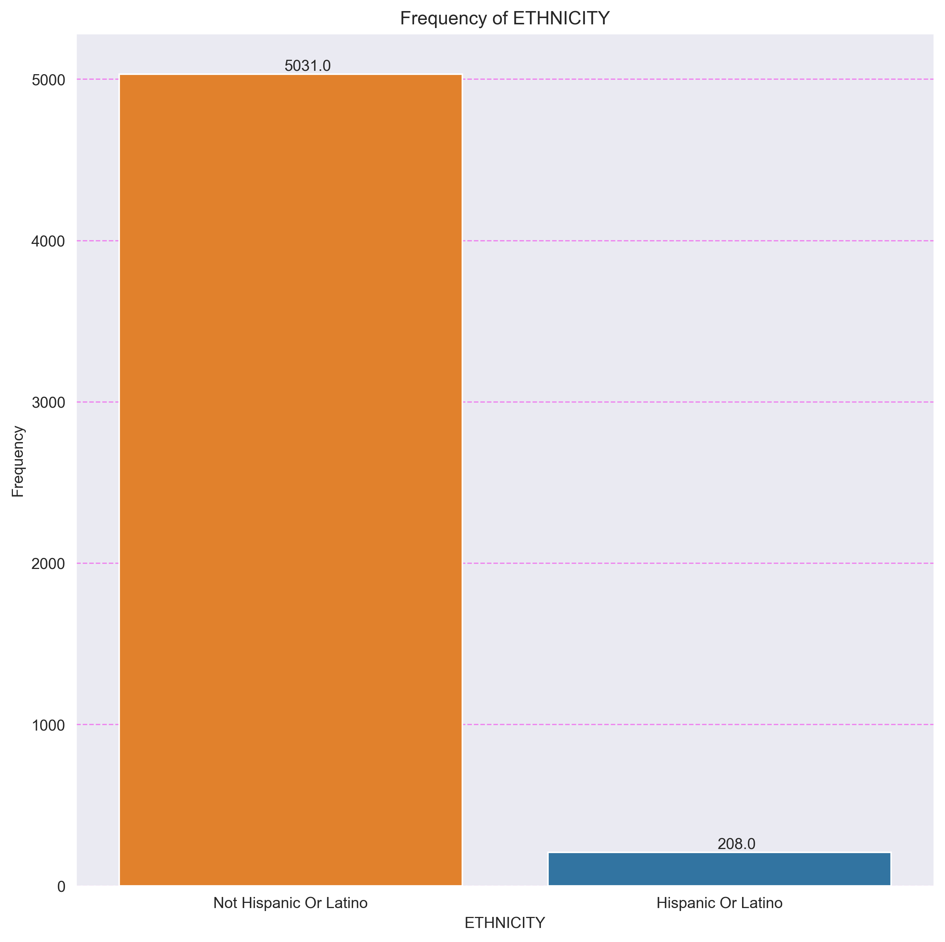

## Variable CANCER_TYPE

|  |  |  |  |  |  |  |
| --- | --- | --- | --- | --- | --- | --- |
| CANCER_TYPE | F_ABS | F_ABS_AC | F_REL | F_REL_AC | % | %_AC |
| Adrenocortical Carcinoma | 48 | 48 | 0.0092 | 0.0092 | 0.92 | 0.92 |
| Bladder Cancer | 372 | 420 | 0.071 | 0.0802 | 7.1 | 8.02 |
| Breast Cancer | 906 | 1326 | 0.1729 | 0.2531 | 17.29 | 25.31 |
| Cholangiocarcinoma | 35 | 1361 | 0.0067 | 0.2598 | 0.67 | 25.98 |
| Colorectal Cancer | 343 | 1704 | 0.0655 | 0.3253 | 6.55 | 32.53 |
| Esophagogastric Cancer | 379 | 2083 | 0.0723 | 0.3976 | 7.23 | 39.76 |
| Head and Neck Cancer | 413 | 2496 | 0.0788 | 0.4764 | 7.88 | 47.64 |
| Hepatobiliary Cancer | 330 | 2826 | 0.063 | 0.5394 | 6.3 | 53.94 |
| Melanoma | 387 | 3213 | 0.0739 | 0.6133 | 7.39 | 61.33 |
| Non-Seminomatous Germ Cell Tumor | 61 | 3274 | 0.0116 | 0.6249 | 1.16 | 62.49 |
| Non-Small Cell Lung Cancer | 696 | 3970 | 0.1328 | 0.7577 | 13.28 | 75.77 |
| Pancreatic Cancer | 139 | 4109 | 0.0265 | 0.7842 | 2.65 | 78.42 |
| Pleural Mesothelioma | 73 | 4182 | 0.0139 | 0.7981 | 1.39 | 79.81 |
| Renal Clear Cell Carcinoma | 366 | 4548 | 0.0699 | 0.868 | 6.99 | 86.8 |
| Renal Non-Clear Cell Carcinoma | 255 | 4803 | 0.0487 | 0.9167 | 4.87 | 91.67 |
| Seminoma | 55 | 4858 | 0.0105 | 0.9272 | 1.05 | 92.72 |
| Thyroid Cancer | 381 | 5239 | 0.0727 | 0.9999 | 7.27 | 99.99 |

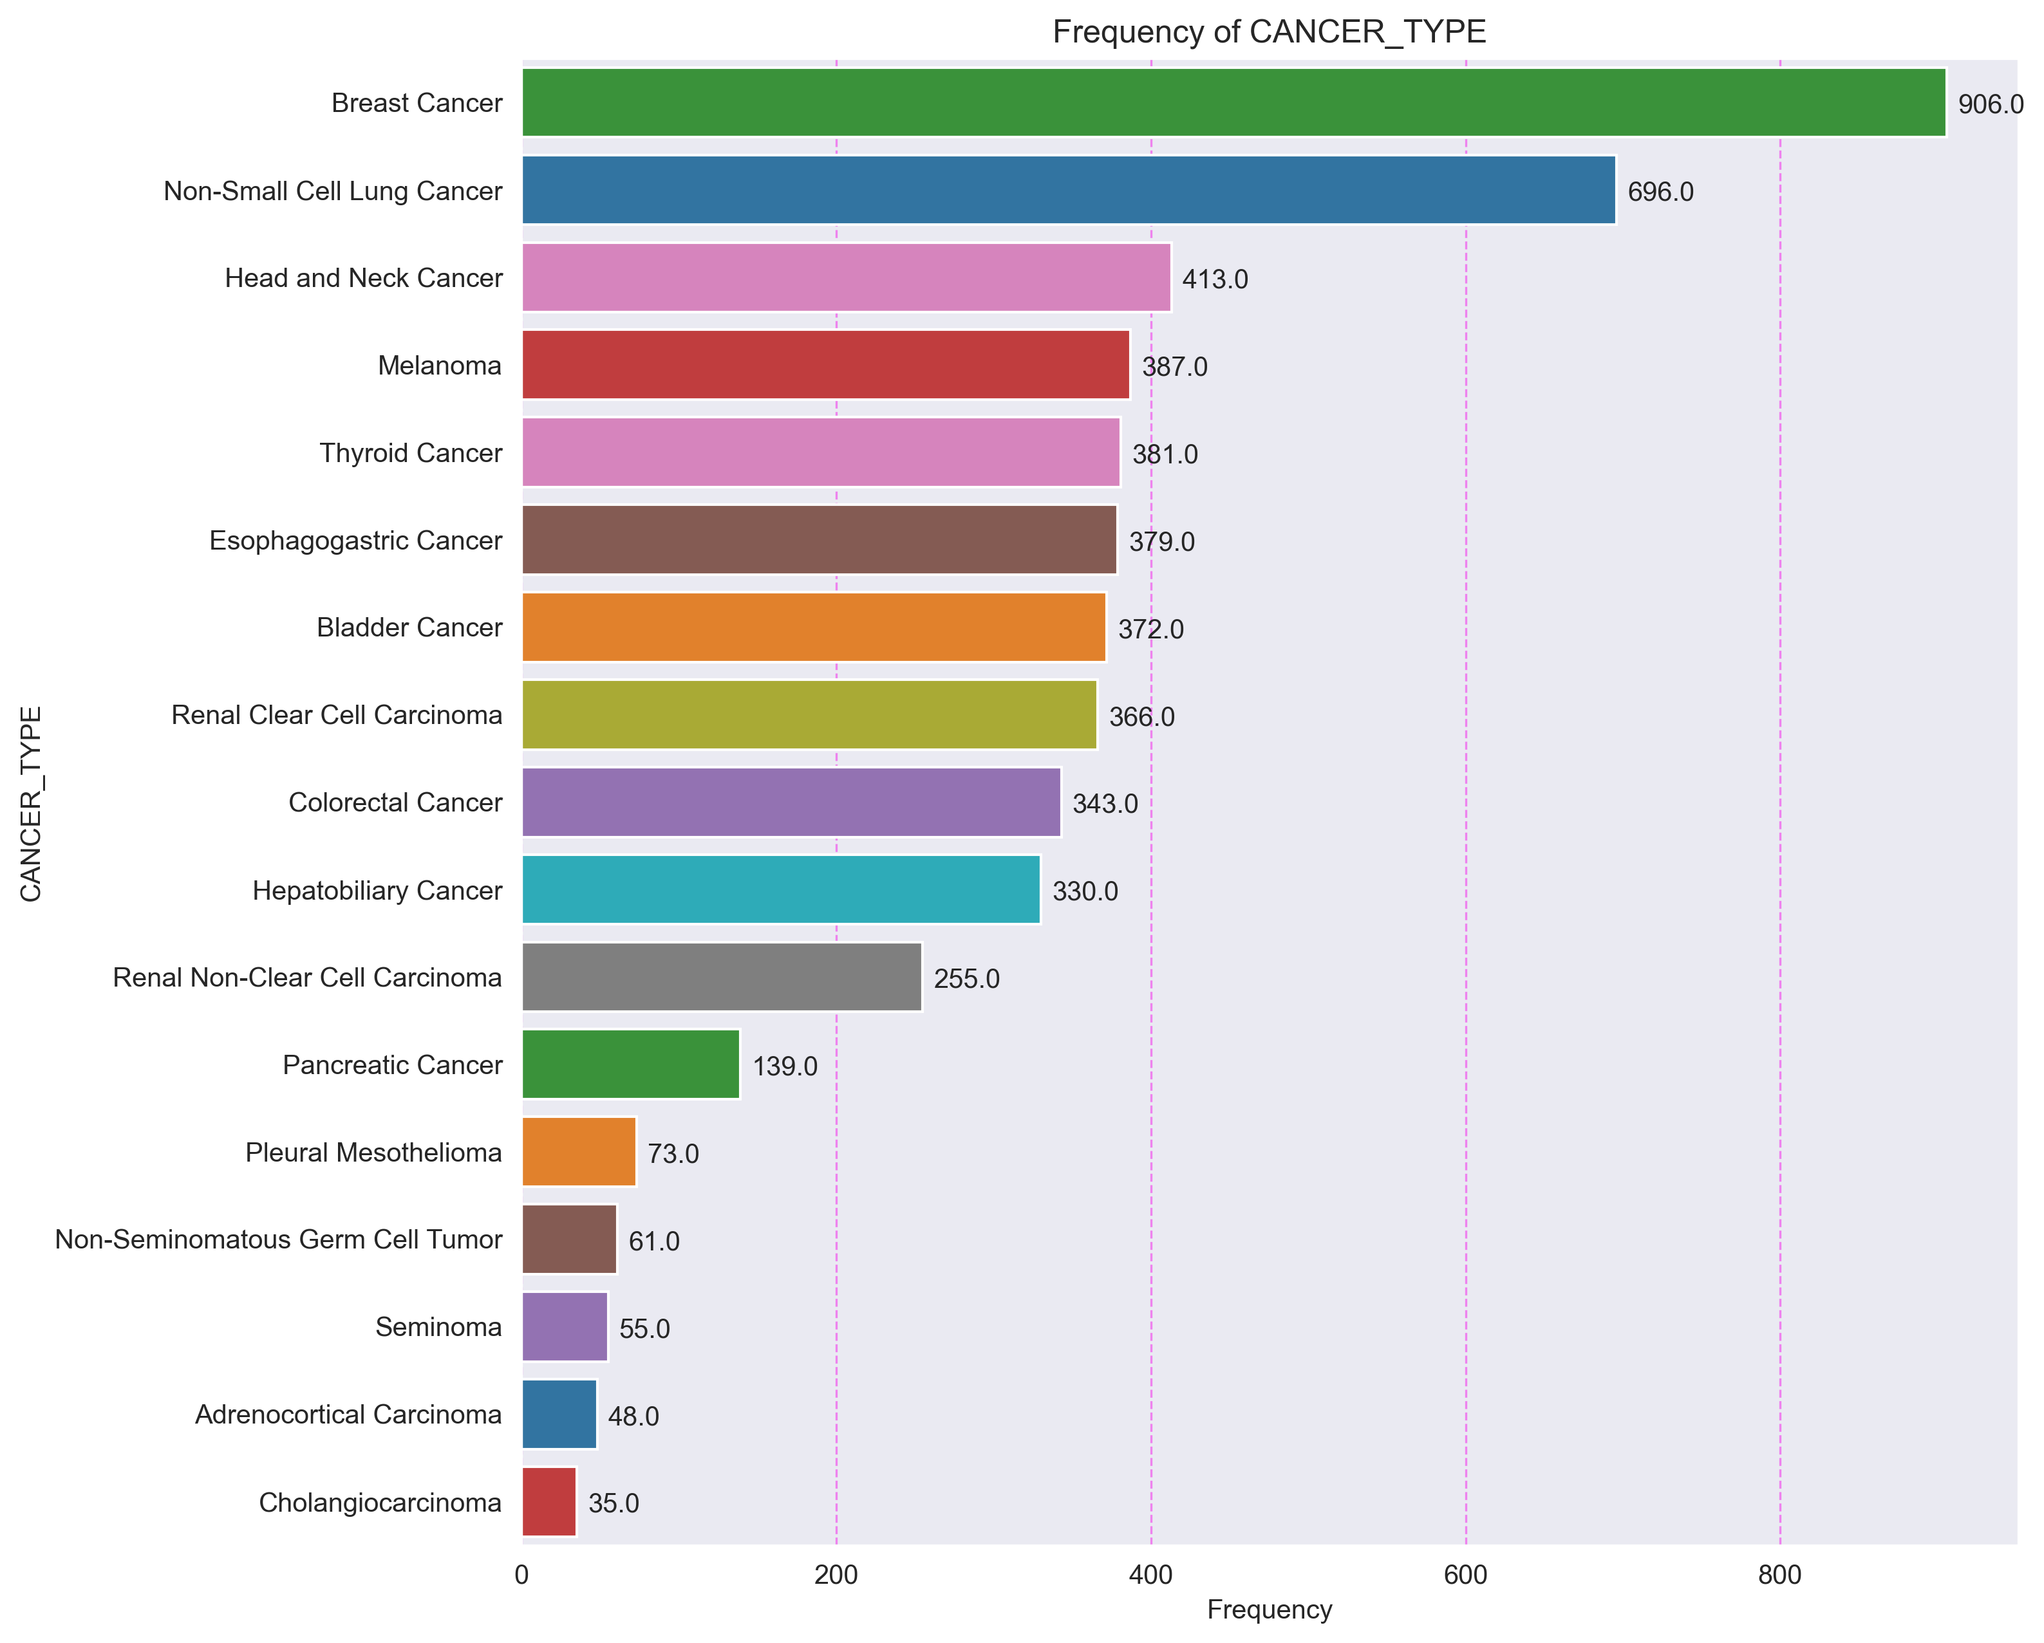

## Variable ONCOTREE_CODE

|  |  |  |  |  |  |  |
| --- | --- | --- | --- | --- | --- | --- |
| ONCOTREE_CODE | F_ABS | F_ABS_AC | F_REL | F_REL_AC | % | %_AC |
| ACC | 48 | 48 | 0.0092 | 0.0092 | 0.92 | 0.92 |
| BLCA | 372 | 420 | 0.071 | 0.0802 | 7.1 | 8.02 |
| BRCA | 1 | 421 | 0.0002 | 0.0804 | 0.02 | 8.04 |
| BRCNOS | 72 | 493 | 0.0137 | 0.0941 | 1.37 | 9.41 |
| CCRCC | 366 | 859 | 0.0699 | 0.164 | 6.99 | 16.4 |
| CHOL | 2 | 861 | 0.0004 | 0.1644 | 0.04 | 16.44 |
| CHRCC | 34 | 895 | 0.0065 | 0.1709 | 0.65 | 17.09 |
| COAD | 227 | 1122 | 0.0433 | 0.2142 | 4.33 | 21.42 |
| DSTAD | 62 | 1184 | 0.0118 | 0.226 | 1.18 | 22.6 |
| EMBCA | 14 | 1198 | 0.0027 | 0.2287 | 0.27 | 22.87 |
| ESCA | 10 | 1208 | 0.0019 | 0.2306 | 0.19 | 23.06 |
| ESCC | 65 | 1273 | 0.0124 | 0.243 | 1.24 | 24.3 |
| FLC | 1 | 1274 | 0.0002 | 0.2432 | 0.02 | 24.32 |
| HCC | 329 | 1603 | 0.0628 | 0.306 | 6.28 | 30.6 |
| HNSC | 413 | 2016 | 0.0788 | 0.3848 | 7.88 | 38.48 |
| IDC | 628 | 2644 | 0.1199 | 0.5047 | 11.99 | 50.47 |
| IHCH | 30 | 2674 | 0.0057 | 0.5104 | 0.57 | 51.04 |
| ILC | 180 | 2854 | 0.0344 | 0.5448 | 3.44 | 54.48 |
| IMMC | 17 | 2871 | 0.0032 | 0.548 | 0.32 | 54.8 |
| ISTAD | 32 | 2903 | 0.0061 | 0.5541 | 0.61 | 55.41 |
| LUAD | 388 | 3291 | 0.0741 | 0.6282 | 7.41 | 62.82 |
| LUSC | 308 | 3599 | 0.0588 | 0.687 | 5.88 | 68.7 |
| MACR | 38 | 3637 | 0.0073 | 0.6943 | 0.73 | 69.43 |
| MBC | 8 | 3645 | 0.0015 | 0.6958 | 0.15 | 69.58 |
| MGCT | 42 | 3687 | 0.008 | 0.7038 | 0.8 | 70.38 |
| MSTAD | 15 | 3702 | 0.0029 | 0.7067 | 0.29 | 70.67 |
| PAAD | 139 | 3841 | 0.0265 | 0.7332 | 2.65 | 73.32 |
| PHCH | 3 | 3844 | 0.0006 | 0.7338 | 0.06 | 73.38 |
| PLBMESO | 21 | 3865 | 0.004 | 0.7378 | 0.4 | 73.78 |
| PLEMESO | 51 | 3916 | 0.0097 | 0.7475 | 0.97 | 74.75 |
| PLSMESO | 1 | 3917 | 0.0002 | 0.7477 | 0.02 | 74.77 |
| PRCC | 221 | 4138 | 0.0422 | 0.7899 | 4.22 | 78.99 |
| PSTAD | 6 | 4144 | 0.0011 | 0.791 | 0.11 | 79.1 |
| READ | 78 | 4222 | 0.0149 | 0.8059 | 1.49 | 80.59 |
| SEM | 55 | 4277 | 0.0105 | 0.8164 | 1.05 | 81.64 |
| SKCM | 387 | 4664 | 0.0739 | 0.8903 | 7.39 | 89.03 |
| SSRCC | 4 | 4668 | 0.0008 | 0.8911 | 0.08 | 89.11 |
| STAD | 136 | 4804 | 0.026 | 0.9171 | 2.6 | 91.71 |
| THPA | 381 | 5185 | 0.0727 | 0.9898 | 7.27 | 98.98 |
| TSTAD | 49 | 5234 | 0.0094 | 0.9992 | 0.94 | 99.92 |
| TT | 2 | 5236 | 0.0004 | 0.9996 | 0.04 | 99.96 |
| TYST | 3 | 5239 | 0.0006 | 1.0002 | 0.06 | 100.02 |

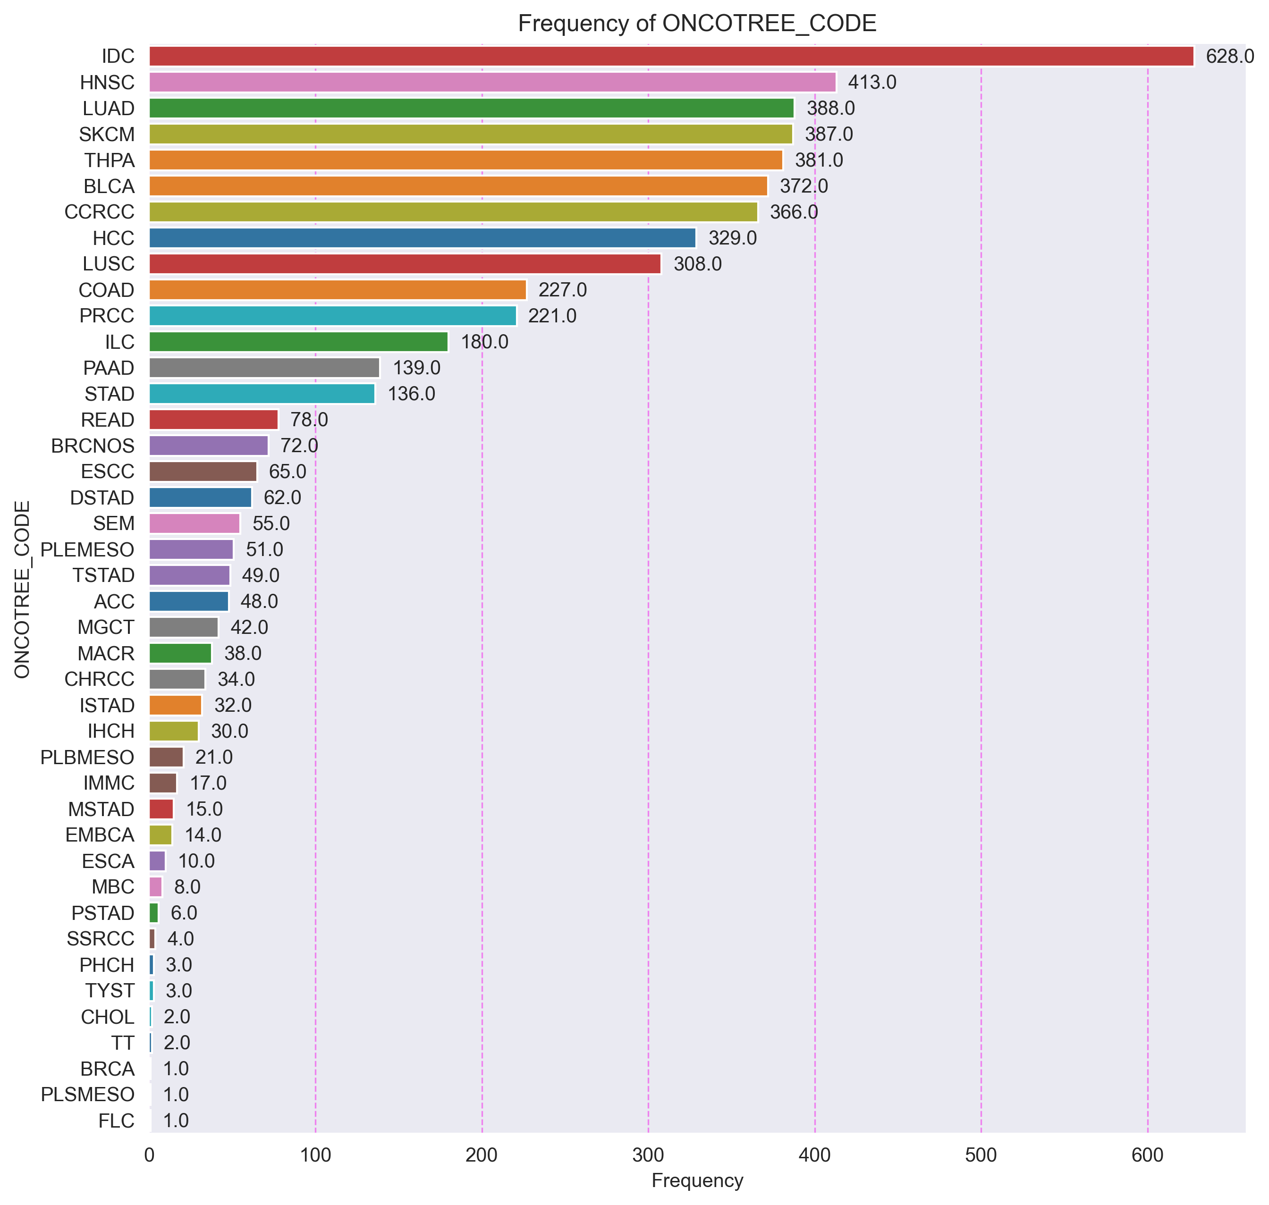

## Variable CANCER_TYPE_DETAILED

|  |  |  |  |  |  |  |
| --- | --- | --- | --- | --- | --- | --- |
| CANCER_TYPE_DETAILED | F_ABS | F_ABS_AC | F_REL | F_REL_AC | % | %_AC |
| Adrenocortical Carcinoma | 48 | 48 | 0.0092 | 0.0092 | 0.92 | 0.92 |
| Bladder Urothelial Carcinoma | 372 | 420 | 0.071 | 0.0802 | 7.1 | 8.02 |
| Breast Invasive Carcinoma (NOS) | 72 | 492 | 0.0137 | 0.0939 | 1.37 | 9.39 |
| Breast Invasive Ductal Carcinoma | 628 | 1120 | 0.1199 | 0.2138 | 11.99 | 21.38 |
| Breast Invasive Lobular Carcinoma | 180 | 1300 | 0.0344 | 0.2482 | 3.44 | 24.82 |
| Breast Invasive Mixed Mucinous Carcinoma | 17 | 1317 | 0.0032 | 0.2514 | 0.32 | 25.14 |
| Cholangiocarcinoma | 2 | 1319 | 0.0004 | 0.2518 | 0.04 | 25.18 |
| Chromophobe Renal Cell Carcinoma | 34 | 1353 | 0.0065 | 0.2583 | 0.65 | 25.83 |
| Colon Adenocarcinoma | 227 | 1580 | 0.0433 | 0.3016 | 4.33 | 30.16 |
| Cutaneous Melanoma | 387 | 1967 | 0.0739 | 0.3755 | 7.39 | 37.55 |
| Diffuse Type Stomach Adenocarcinoma | 62 | 2029 | 0.0118 | 0.3873 | 1.18 | 38.73 |
| Embryonal Carcinoma | 14 | 2043 | 0.0027 | 0.39 | 0.27 | 39.0 |
| Esophageal Adenocarcinoma | 10 | 2053 | 0.0019 | 0.3919 | 0.19 | 39.19 |
| Esophageal Squamous Cell Carcinoma | 65 | 2118 | 0.0124 | 0.4043 | 1.24 | 40.43 |
| Fibrolamellar Carcinoma | 1 | 2119 | 0.0002 | 0.4045 | 0.02 | 40.45 |
| Head and Neck Squamous Cell Carcinoma | 413 | 2532 | 0.0788 | 0.4833 | 7.88 | 48.33 |
| Hepatocellular Carcinoma | 329 | 2861 | 0.0628 | 0.5461 | 6.28 | 54.61 |
| Intestinal Type Stomach Adenocarcinoma | 32 | 2893 | 0.0061 | 0.5522 | 0.61 | 55.22 |
| Intrahepatic Cholangiocarcinoma | 30 | 2923 | 0.0057 | 0.5579 | 0.57 | 55.79 |
| Invasive Breast Carcinoma | 1 | 2924 | 0.0002 | 0.5581 | 0.02 | 55.81 |
| Lung Adenocarcinoma | 388 | 3312 | 0.0741 | 0.6322 | 7.41 | 63.22 |
| Lung Squamous Cell Carcinoma | 308 | 3620 | 0.0588 | 0.691 | 5.88 | 69.1 |
| Metaplastic Breast Cancer | 8 | 3628 | 0.0015 | 0.6925 | 0.15 | 69.25 |
| Mixed Germ Cell Tumor | 42 | 3670 | 0.008 | 0.7005 | 0.8 | 70.05 |
| Mucinous Adenocarcinoma of the Colon and Rectum | 38 | 3708 | 0.0073 | 0.7078 | 0.73 | 70.78 |
| Mucinous Stomach Adenocarcinoma | 15 | 3723 | 0.0029 | 0.7107 | 0.29 | 71.07 |
| Pancreatic Adenocarcinoma | 139 | 3862 | 0.0265 | 0.7372 | 2.65 | 73.72 |
| Papillary Renal Cell Carcinoma | 221 | 4083 | 0.0422 | 0.7794 | 4.22 | 77.94 |
| Papillary Stomach Adenocarcinoma | 6 | 4089 | 0.0011 | 0.7805 | 0.11 | 78.05 |
| Papillary Thyroid Cancer | 381 | 4470 | 0.0727 | 0.8532 | 7.27 | 85.32 |
| Perihilar Cholangiocarcinoma | 3 | 4473 | 0.0006 | 0.8538 | 0.06 | 85.38 |
| Pleural Mesothelioma, Biphasic Type | 21 | 4494 | 0.004 | 0.8578 | 0.4 | 85.78 |
| Pleural Mesothelioma, Epithelioid Type | 51 | 4545 | 0.0097 | 0.8675 | 0.97 | 86.75 |
| Pleural Mesothelioma, Sarcomatoid Type | 1 | 4546 | 0.0002 | 0.8677 | 0.02 | 86.77 |
| Rectal Adenocarcinoma | 78 | 4624 | 0.0149 | 0.8826 | 1.49 | 88.26 |
| Renal Clear Cell Carcinoma | 366 | 4990 | 0.0699 | 0.9525 | 6.99 | 95.25 |
| Seminoma | 55 | 5045 | 0.0105 | 0.963 | 1.05 | 96.3 |
| Signet Ring Cell Carcinoma of the Stomach | 4 | 5049 | 0.0008 | 0.9638 | 0.08 | 96.38 |
| Stomach Adenocarcinoma | 136 | 5185 | 0.026 | 0.9898 | 2.6 | 98.98 |
| Teratoma | 2 | 5187 | 0.0004 | 0.9902 | 0.04 | 99.02 |
| Tubular Stomach Adenocarcinoma | 49 | 5236 | 0.0094 | 0.9996 | 0.94 | 99.96 |
| Yolk Sac Tumor | 3 | 5239 | 0.0006 | 1.0002 | 0.06 | 100.02 |

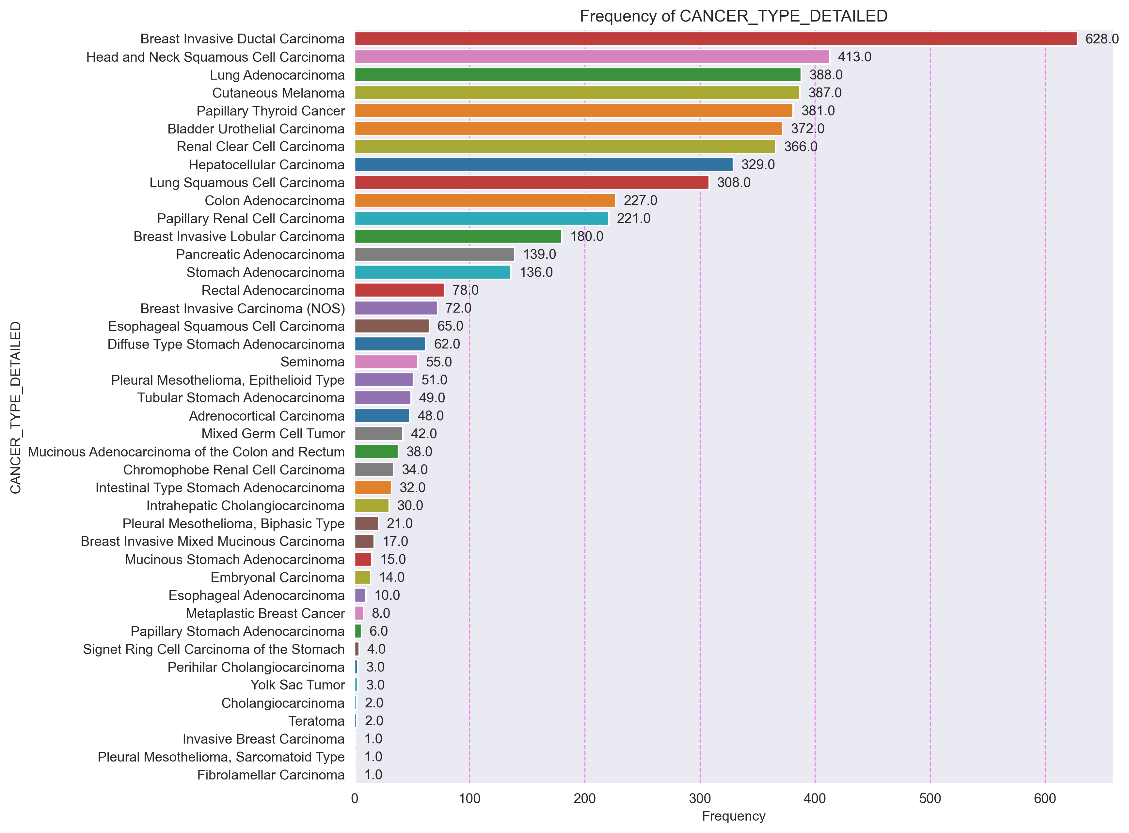

## Variable SAMPLE_TYPE

|  |  |  |  |  |  |  |
| --- | --- | --- | --- | --- | --- | --- |
| SAMPLE_TYPE | F_ABS | F_ABS_AC | F_REL | F_REL_AC | % | %_AC |
| Metastasis | 316 | 316 | 0.0603 | 0.0603 | 6.03 | 6.03 |
| Primary | 4923 | 5239 | 0.9397 | 1.0 | 93.97 | 100.0 |

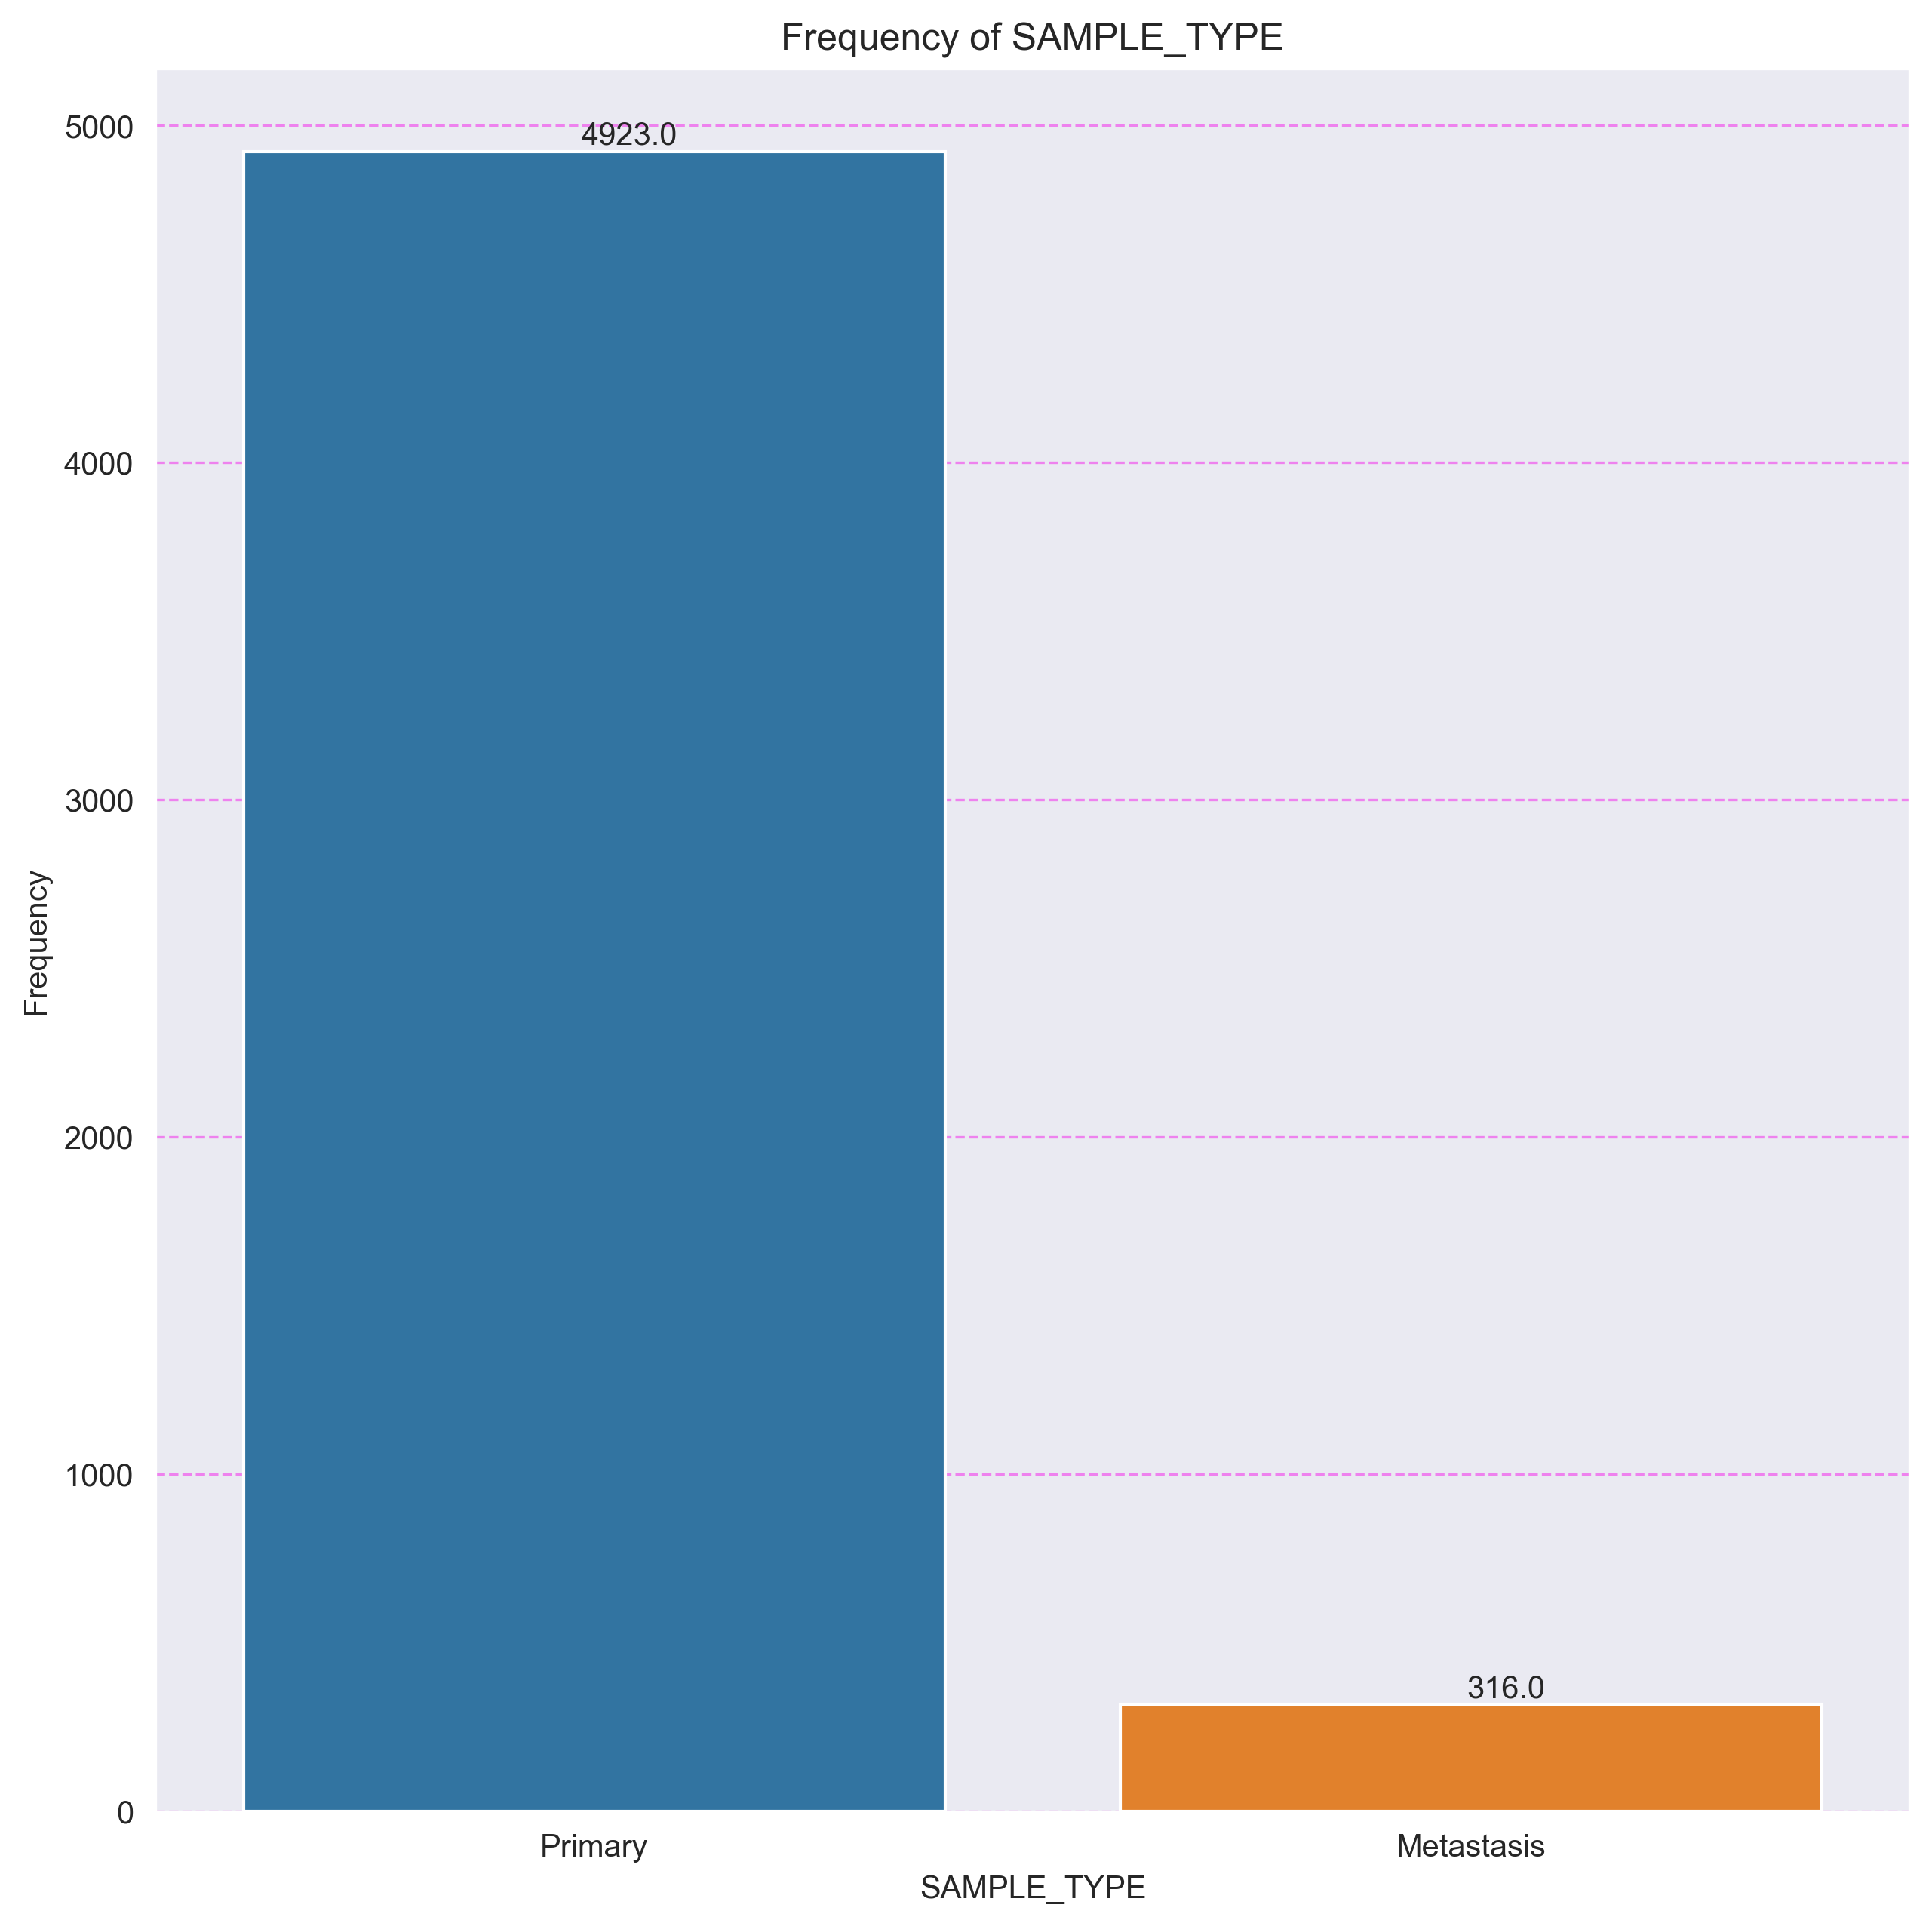

## Variable AJCC_PATHOLOGIC_TUMOR_STAGE

|  |  |  |  |  |  |  |
| --- | --- | --- | --- | --- | --- | --- |
| AJCC_PATHOLOGIC_TUMOR_STAGE | F_ABS | F_ABS_AC | F_REL | F_REL_AC | % | %_AC |
| STAGE 0 | 6 | 6 | 0.0011 | 0.0011 | 0.11 | 0.11 |
| STAGE I | 947 | 953 | 0.1808 | 0.1819 | 18.08 | 18.19 |
| STAGE I/II (NOS) | 9 | 962 | 0.0017 | 0.1836 | 0.17 | 18.36 |
| STAGE IA | 315 | 1277 | 0.0601 | 0.2437 | 6.01 | 24.37 |
| STAGE IB | 280 | 1557 | 0.0534 | 0.2971 | 5.34 | 29.71 |
| STAGE II | 484 | 2041 | 0.0924 | 0.3895 | 9.24 | 38.95 |
| STAGE IIA | 617 | 2658 | 0.1178 | 0.5073 | 11.78 | 50.73 |
| STAGE IIB | 495 | 3153 | 0.0945 | 0.6018 | 9.45 | 60.18 |
| STAGE IIC | 50 | 3203 | 0.0095 | 0.6113 | 0.95 | 61.13 |
| STAGE III | 543 | 3746 | 0.1036 | 0.7149 | 10.36 | 71.49 |
| STAGE IIIA | 383 | 4129 | 0.0731 | 0.788 | 7.31 | 78.8 |
| STAGE IIIB | 197 | 4326 | 0.0376 | 0.8256 | 3.76 | 82.56 |
| STAGE IIIC | 195 | 4521 | 0.0372 | 0.8628 | 3.72 | 86.28 |
| STAGE IS | 44 | 4565 | 0.0084 | 0.8712 | 0.84 | 87.12 |
| STAGE IV | 347 | 4912 | 0.0662 | 0.9374 | 6.62 | 93.74 |
| STAGE IVA | 293 | 5205 | 0.0559 | 0.9933 | 5.59 | 99.33 |
| STAGE IVB | 19 | 5224 | 0.0036 | 0.9969 | 0.36 | 99.69 |
| STAGE IVC | 6 | 5230 | 0.0011 | 0.998 | 0.11 | 99.8 |
| STAGE X | 9 | 5239 | 0.0017 | 0.9997 | 0.17 | 99.97 |

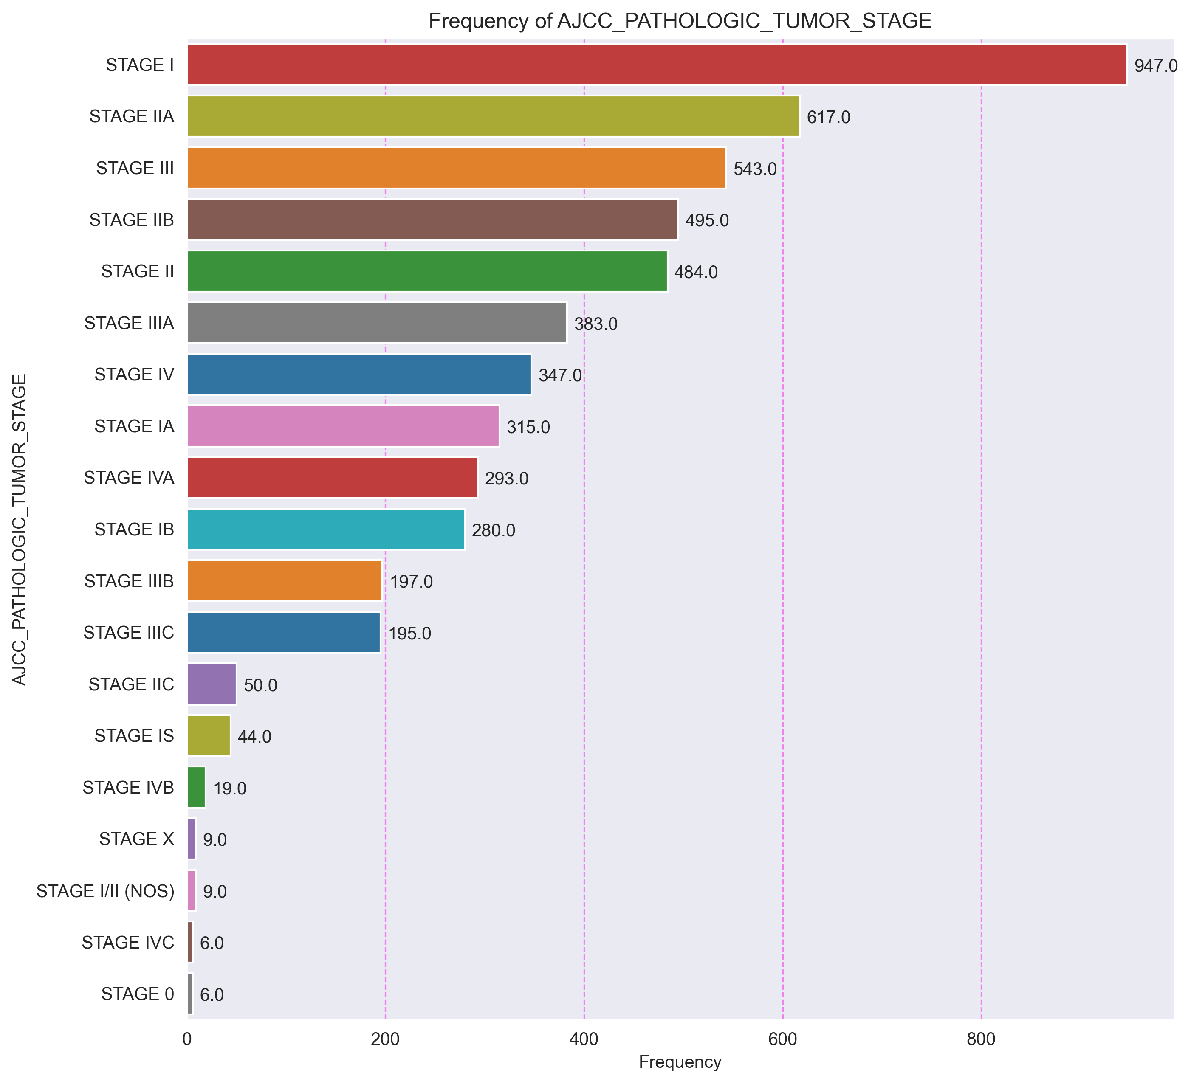

## Variable HISTORY_NEOADJUVANT_TRTYN

|  |  |  |  |  |  |  |
| --- | --- | --- | --- | --- | --- | --- |
| HISTORY_NEOADJUVANT_TRTYN | F_ABS | F_ABS_AC | F_REL | F_REL_AC | % | %_AC |
| No | 5177 | 5177 | 0.9882 | 0.9882 | 98.82 | 98.82 |
| Yes | 62 | 5239 | 0.0118 | 1.0 | 1.18 | 100.0 |

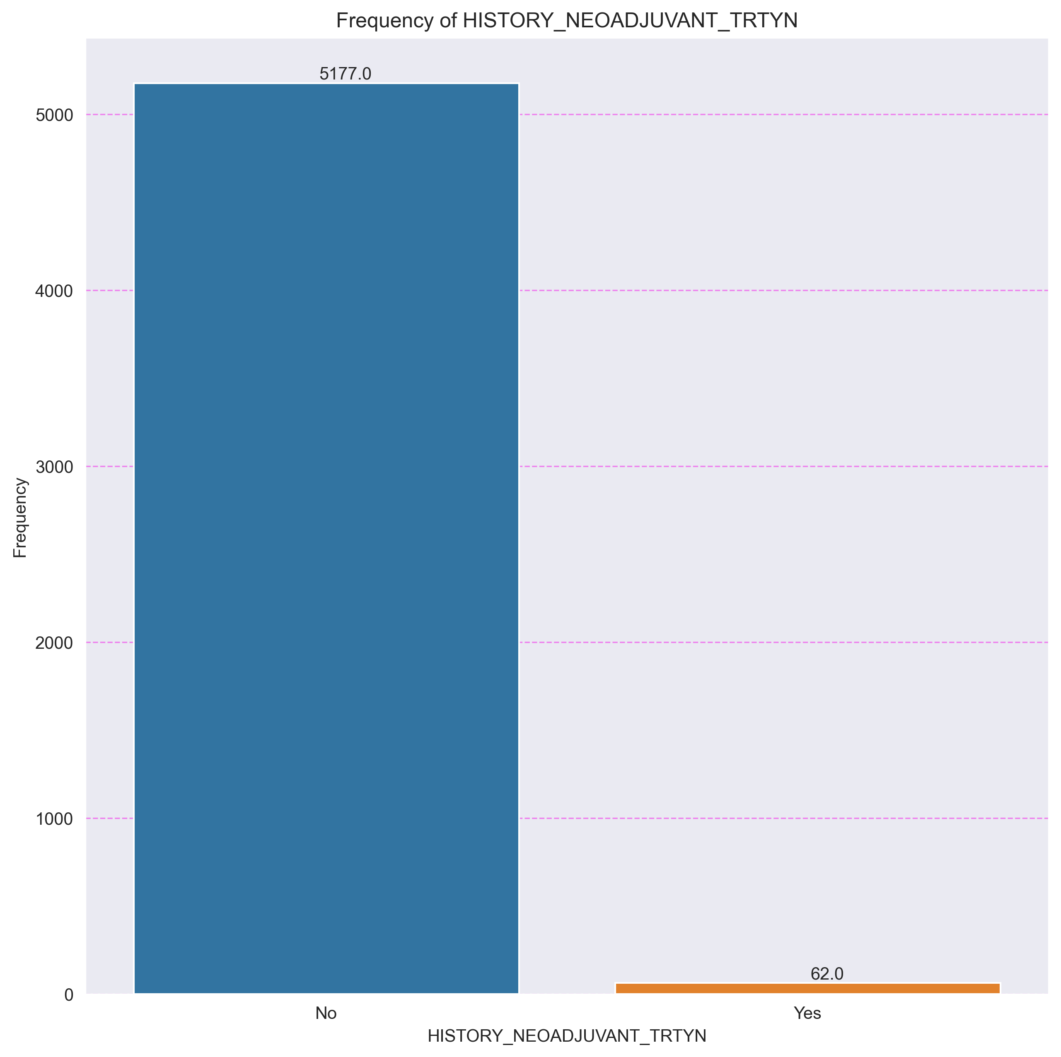

## Variable AGE_GROUP

|  |  |  |  |  |  |  |
| --- | --- | --- | --- | --- | --- | --- |
| AGE_GROUP | F_ABS | F_ABS_AC | F_REL | F_REL_AC | % | %_AC |
| 0-20 | 25 | 25 | 0.0048 | 0.0048 | 0.48 | 0.48 |
| 21-40 | 455 | 480 | 0.0868 | 0.0916 | 8.68 | 9.16 |
| 41-60 | 1863 | 2343 | 0.3556 | 0.4472 | 35.56 | 44.72 |
| 61-80 | 2554 | 4897 | 0.4875 | 0.9347 | 48.75 | 93.47 |
| 81-100 | 342 | 5239 | 0.0653 | 1.0 | 6.53 | 100.0 |

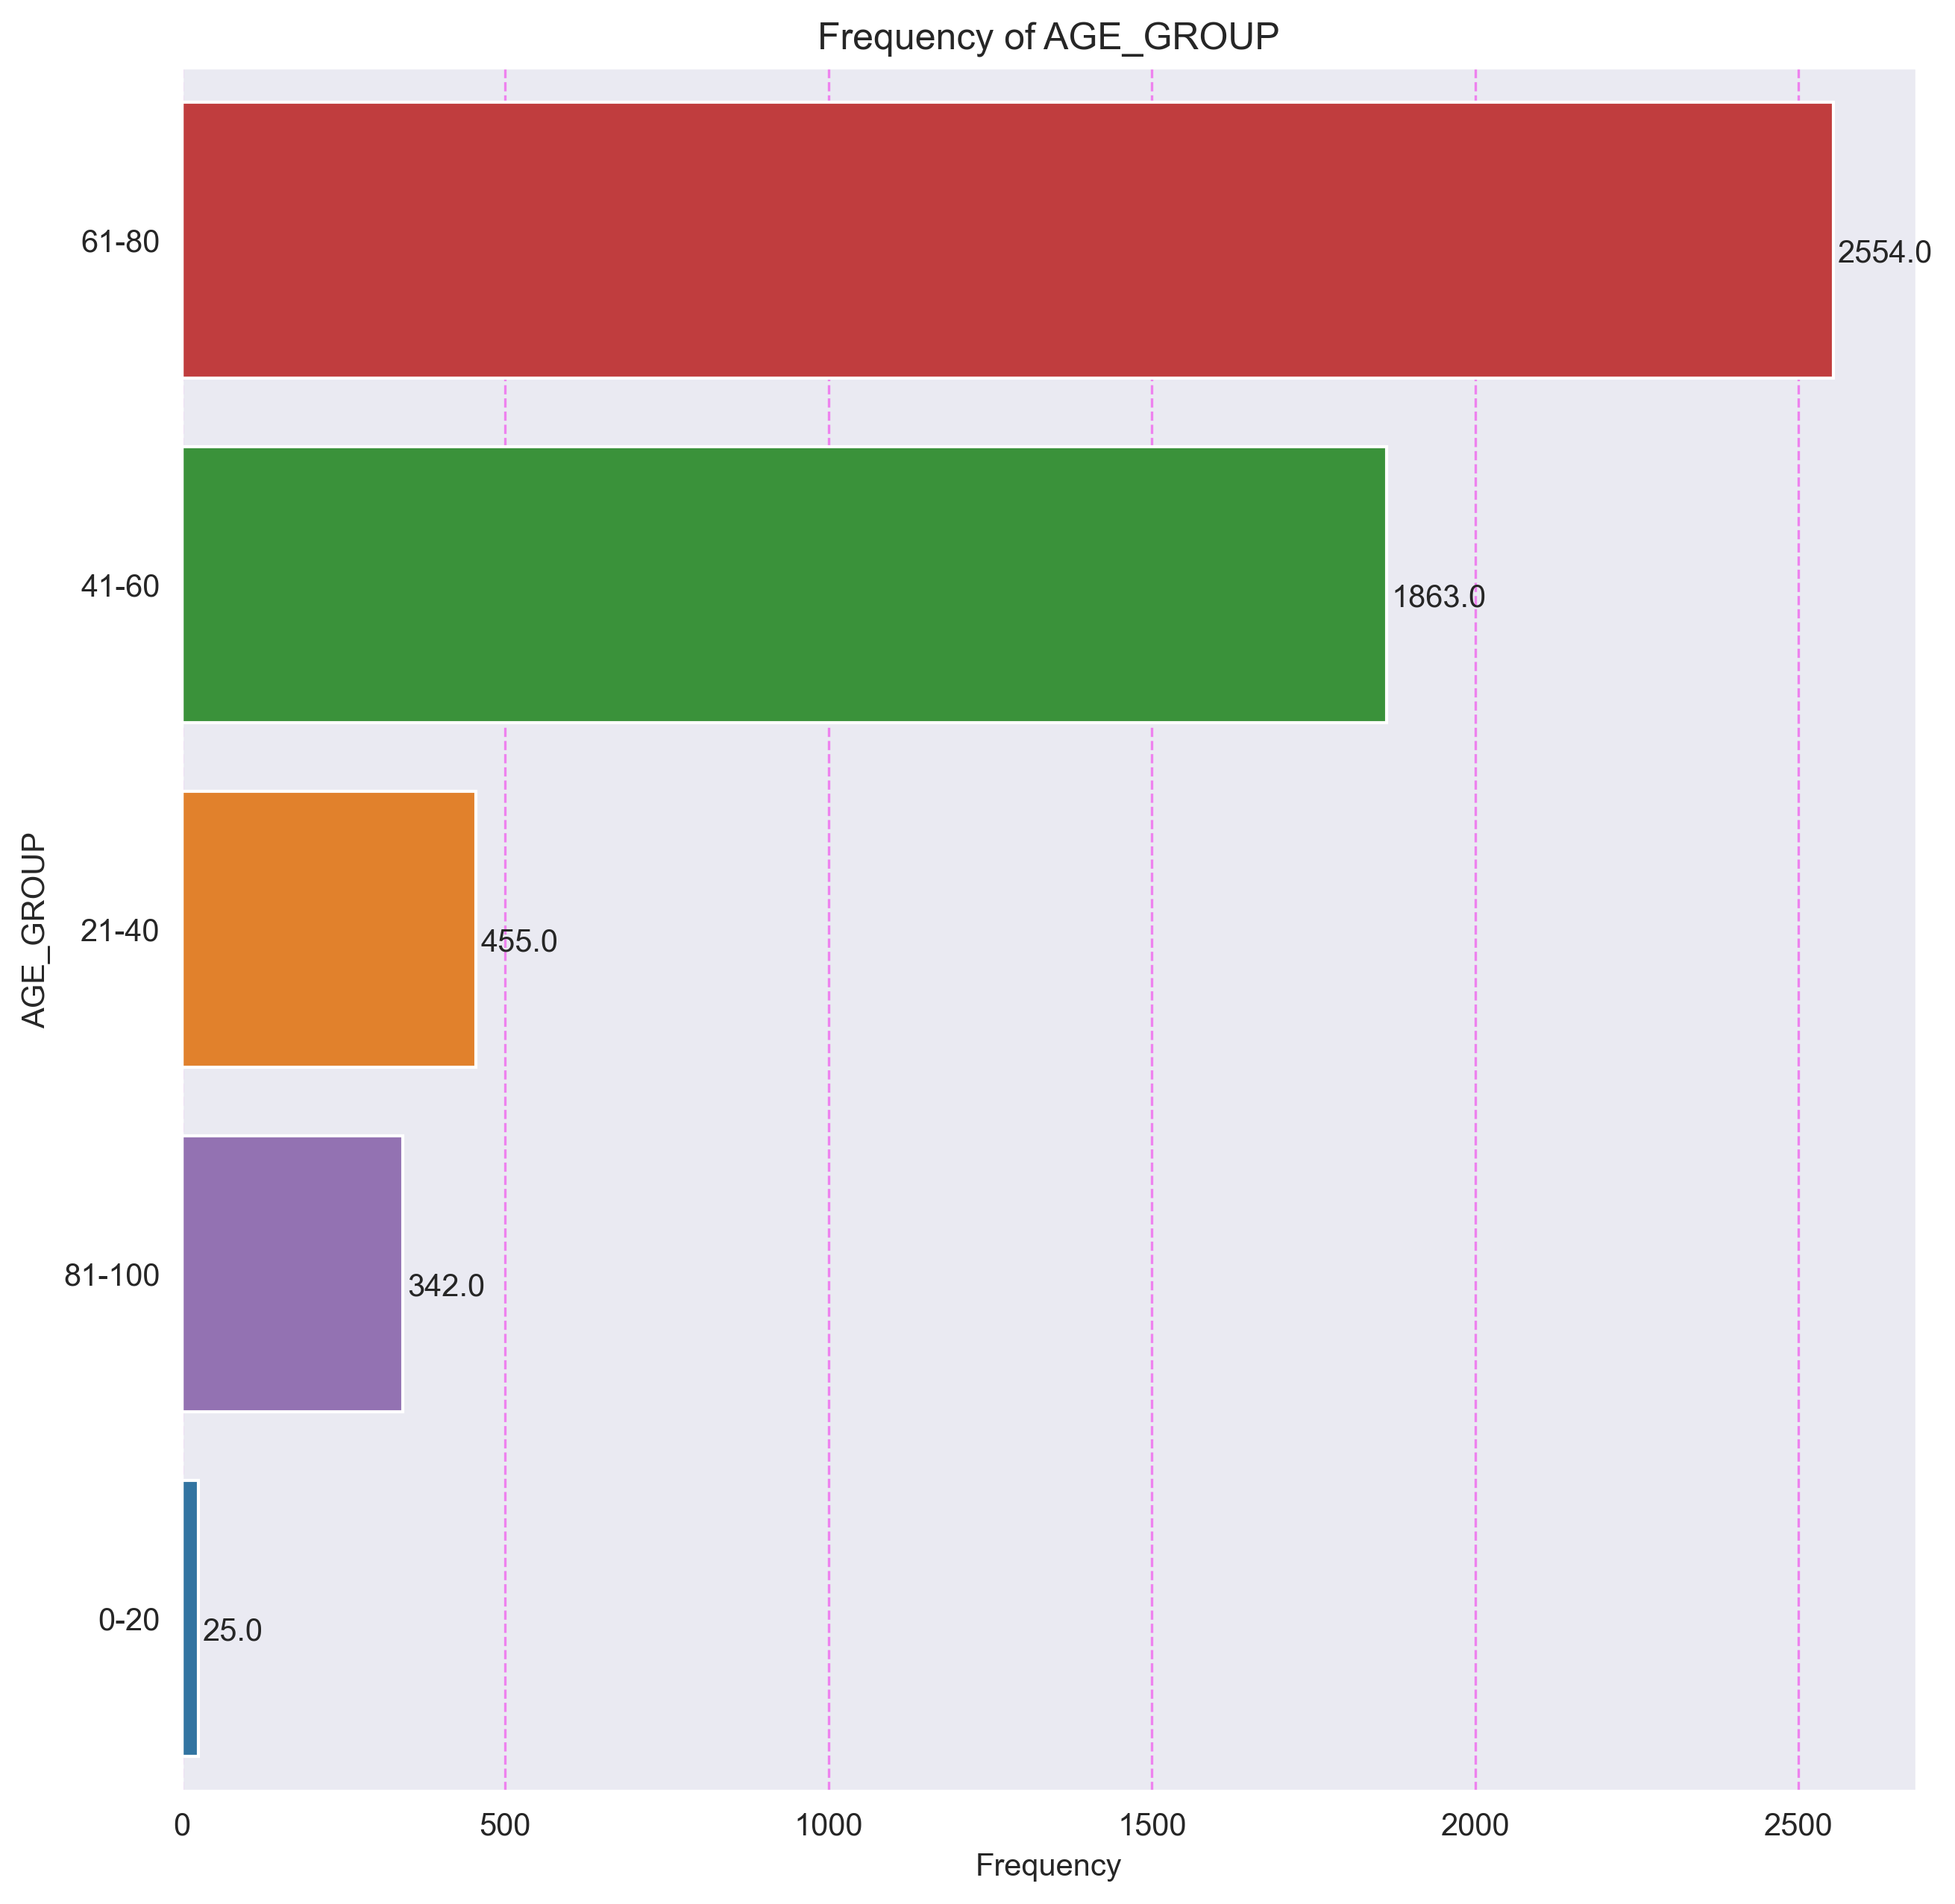

# 2. Histograma de la Edad

La variable tiene un rango de valores entre 14.0 y 90.0.

La media es 59.91 y la mediana es 61.0.

La desviación estándar es 14.21. El intervalo de dispersión a una desviación estándar es 45.7 - 74.12 y contiene el 69.35% de los datos.

El rango intercuartílico es 51.0 - 70.0.

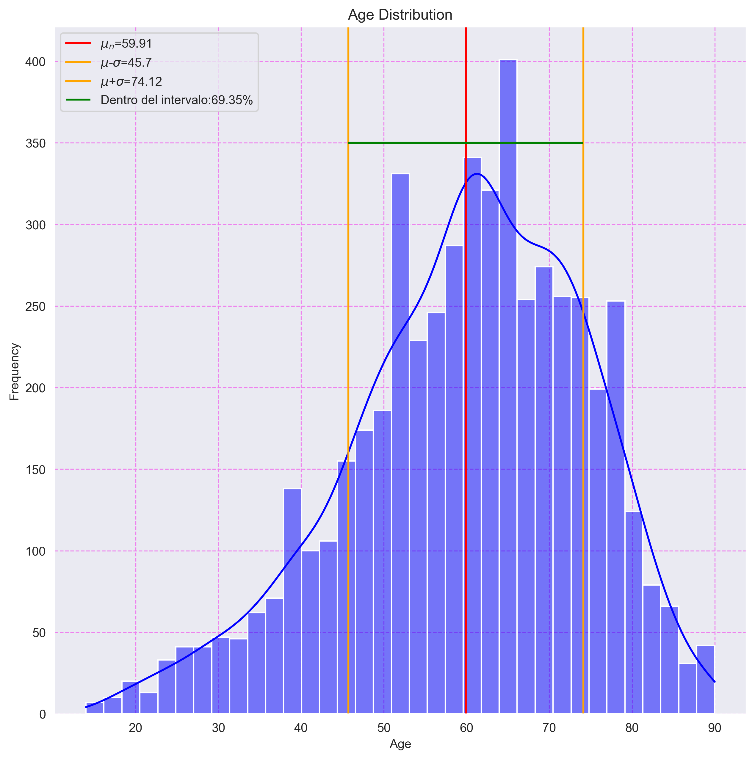

# 3. Tabla de Frecuencias por Sexo y Tipo de Cáncer

|  |  |  |
| --- | --- | --- |
| CANCER_TYPE | Female | Male |
| Breast Cancer | 897 | 9 |
| Non-Small Cell Lung Cancer | 305 | 391 |
| Head and Neck Cancer | 117 | 296 |
| Melanoma | 143 | 244 |
| Thyroid Cancer | 279 | 102 |
| Esophagogastric Cancer | 127 | 252 |
| Bladder Cancer | 100 | 272 |
| Renal Clear Cell Carcinoma | 141 | 225 |
| Colorectal Cancer | 163 | 180 |
| Hepatobiliary Cancer | 105 | 225 |
| Renal Non-Clear Cell Carcinoma | 67 | 188 |
| Pancreatic Cancer | 68 | 71 |
| Pleural Mesothelioma | 15 | 58 |
| Non-Seminomatous Germ Cell Tumor | 0 | 61 |
| Seminoma | 0 | 55 |
| Adrenocortical Carcinoma | 36 | 12 |
| Cholangiocarcinoma | 20 | 15 |

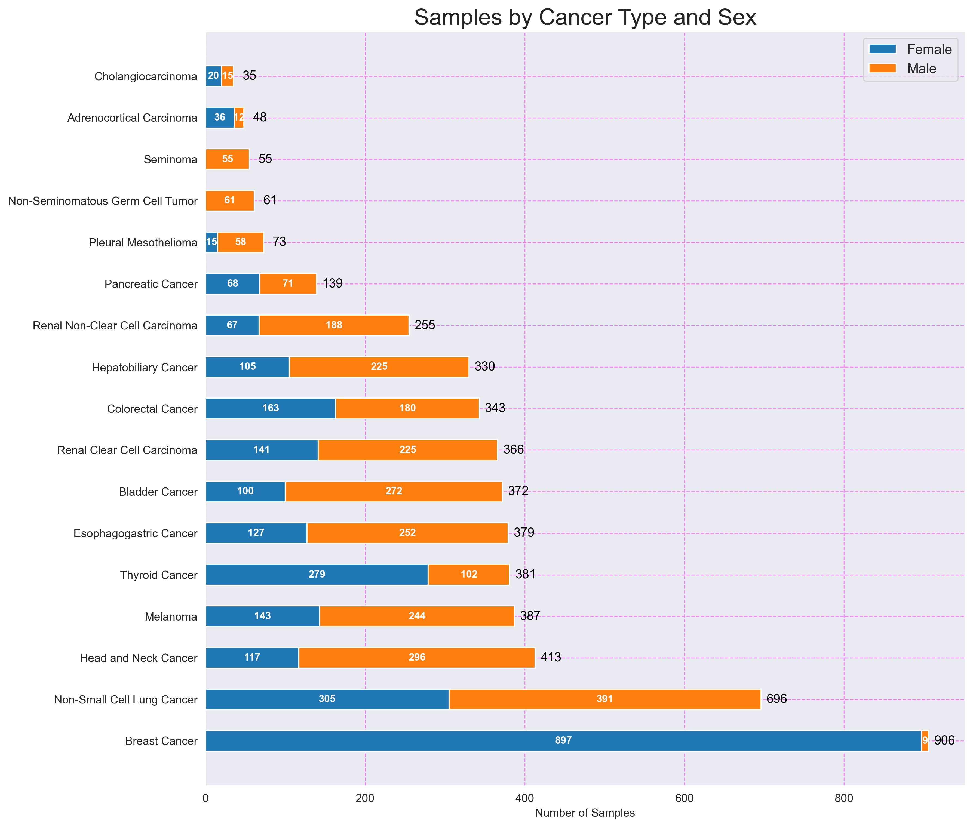

# 4. Distribución de Sexos

|  |  |
| --- | --- |
| SEX | count |
| Male | 2656 |
| Female | 2583 |

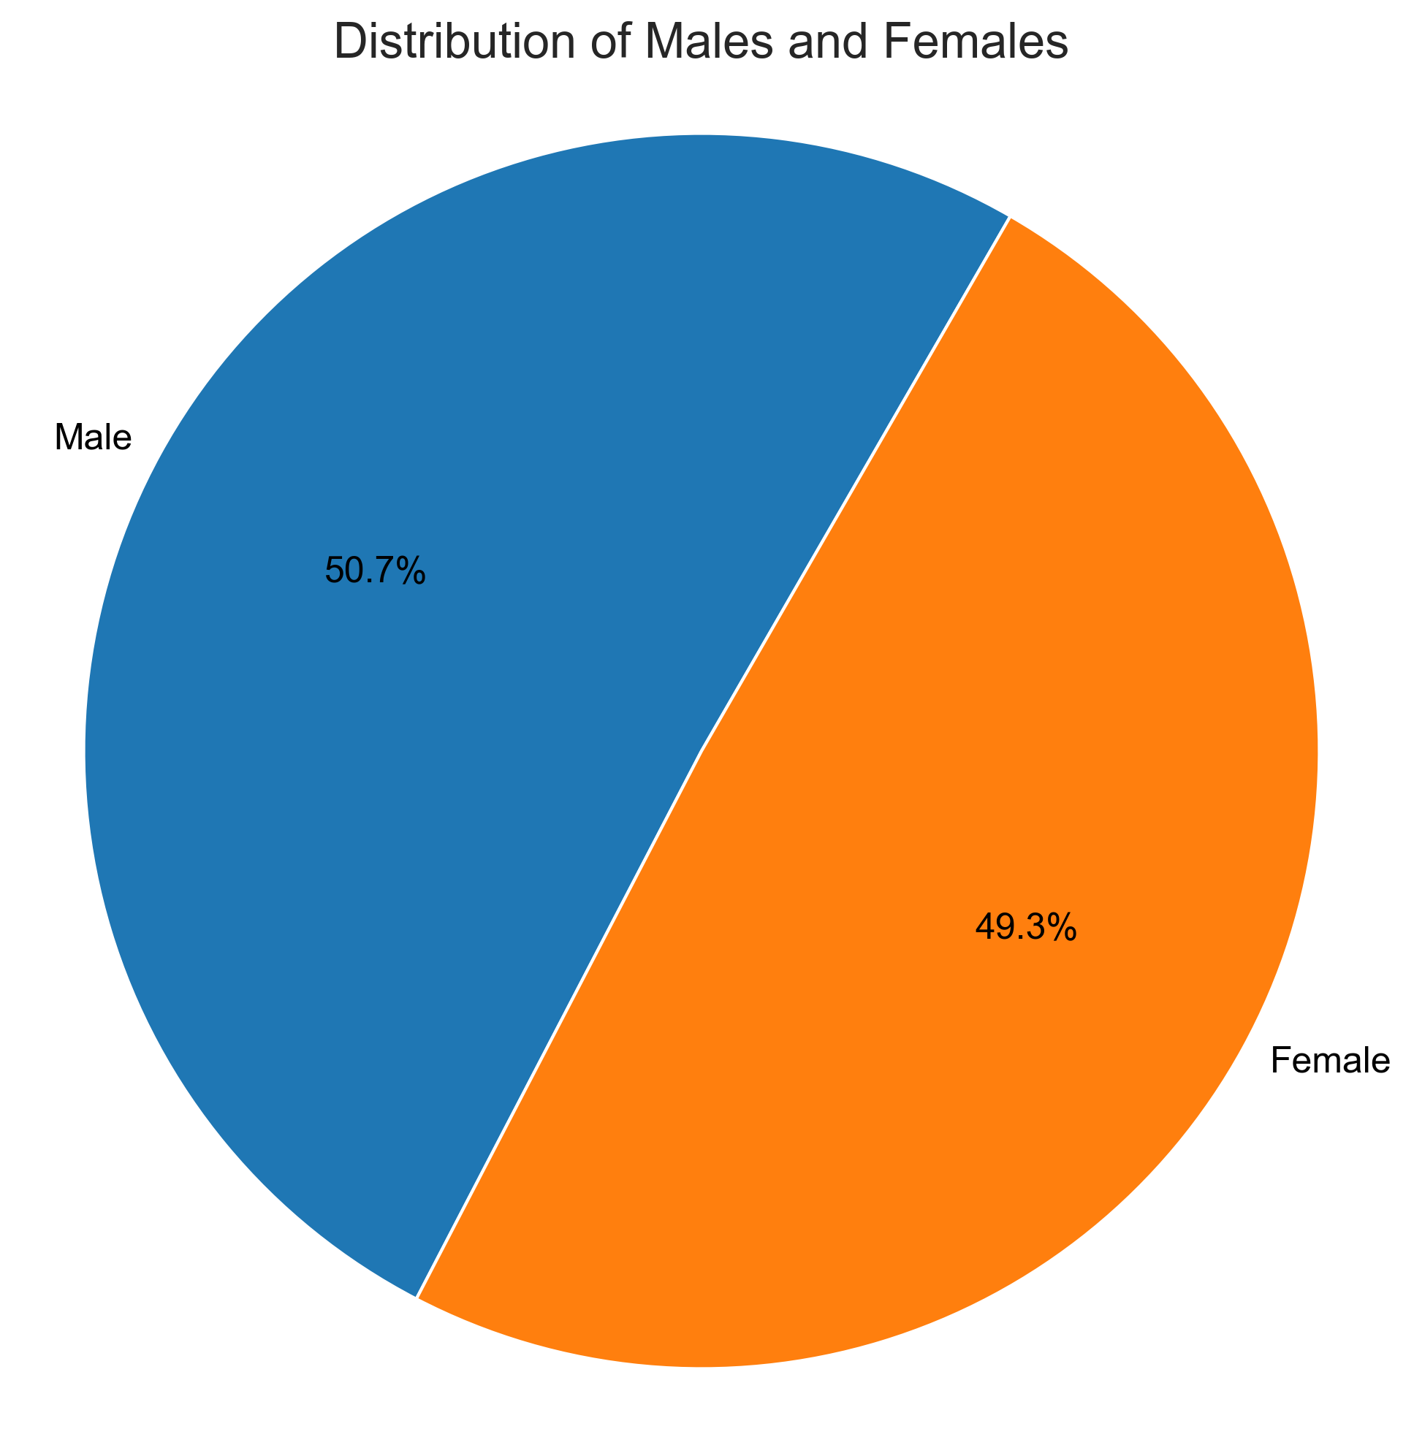

# 5. Distribución de Razas

|  |  |
| --- | --- |
| RACE | count |
| American Indian or Alaska Native | 8 |
| Asian | 499 |
| Black or African American | 527 |
| Native Hawaiian or Other Pacific Islander | 1 |
| White | 4204 |

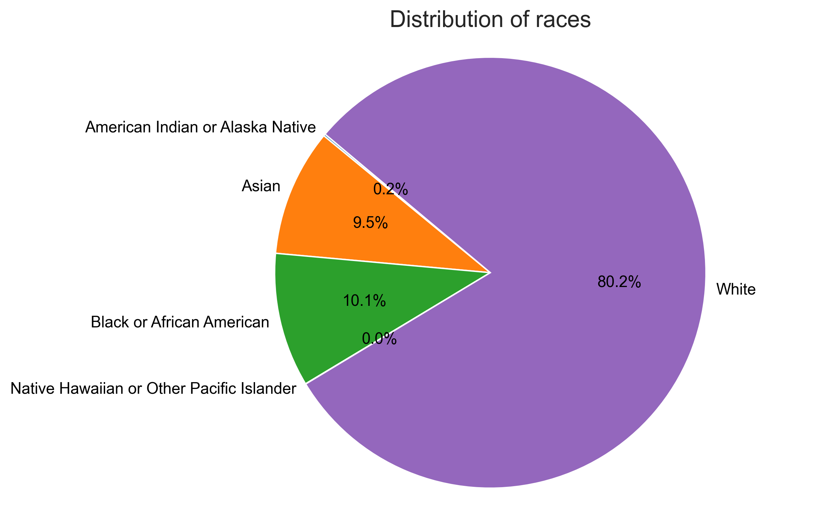

# 6. Histogramas de Edades por Tipo de Cáncer

## 1. Histograma de Edades para Adrenocortical Carcinoma

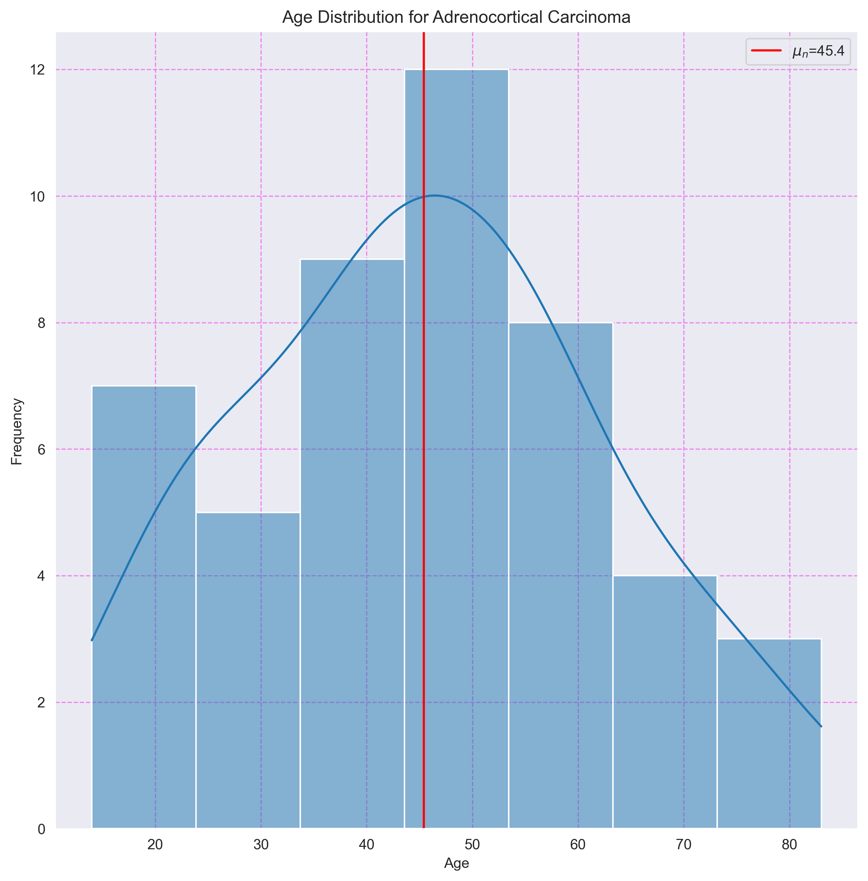

## 2. Histograma de Edades para Bladder Cancer

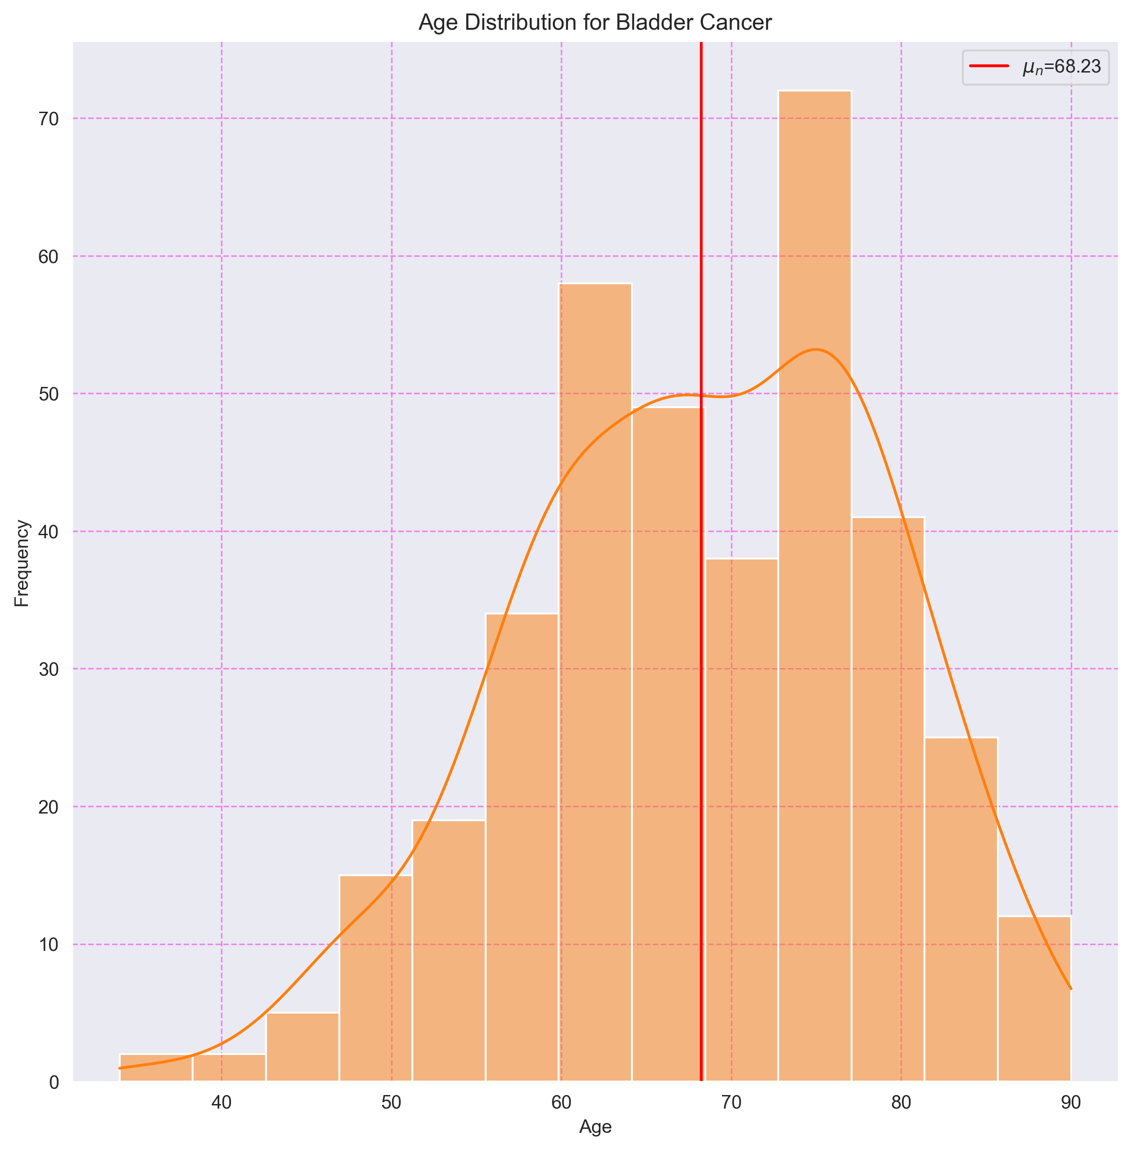

## 3. Histograma de Edades para Breast Cancer

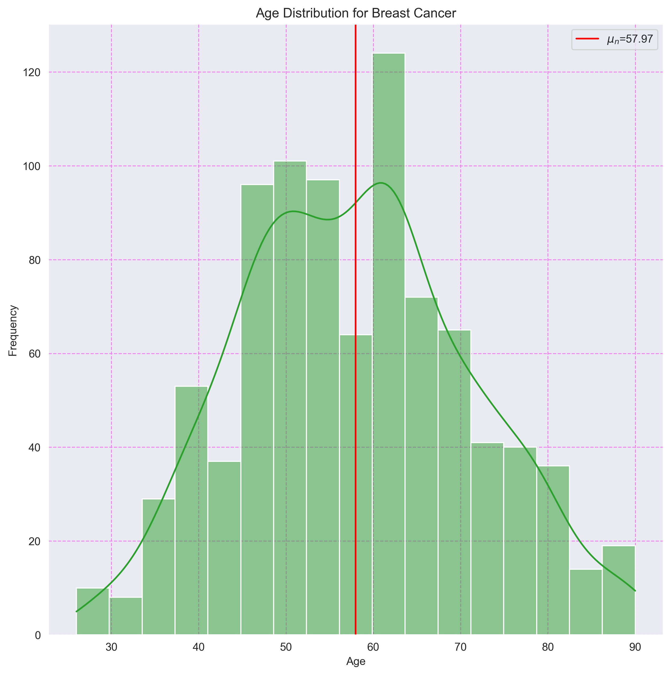

## 4. Histograma de Edades para Cholangiocarcinoma

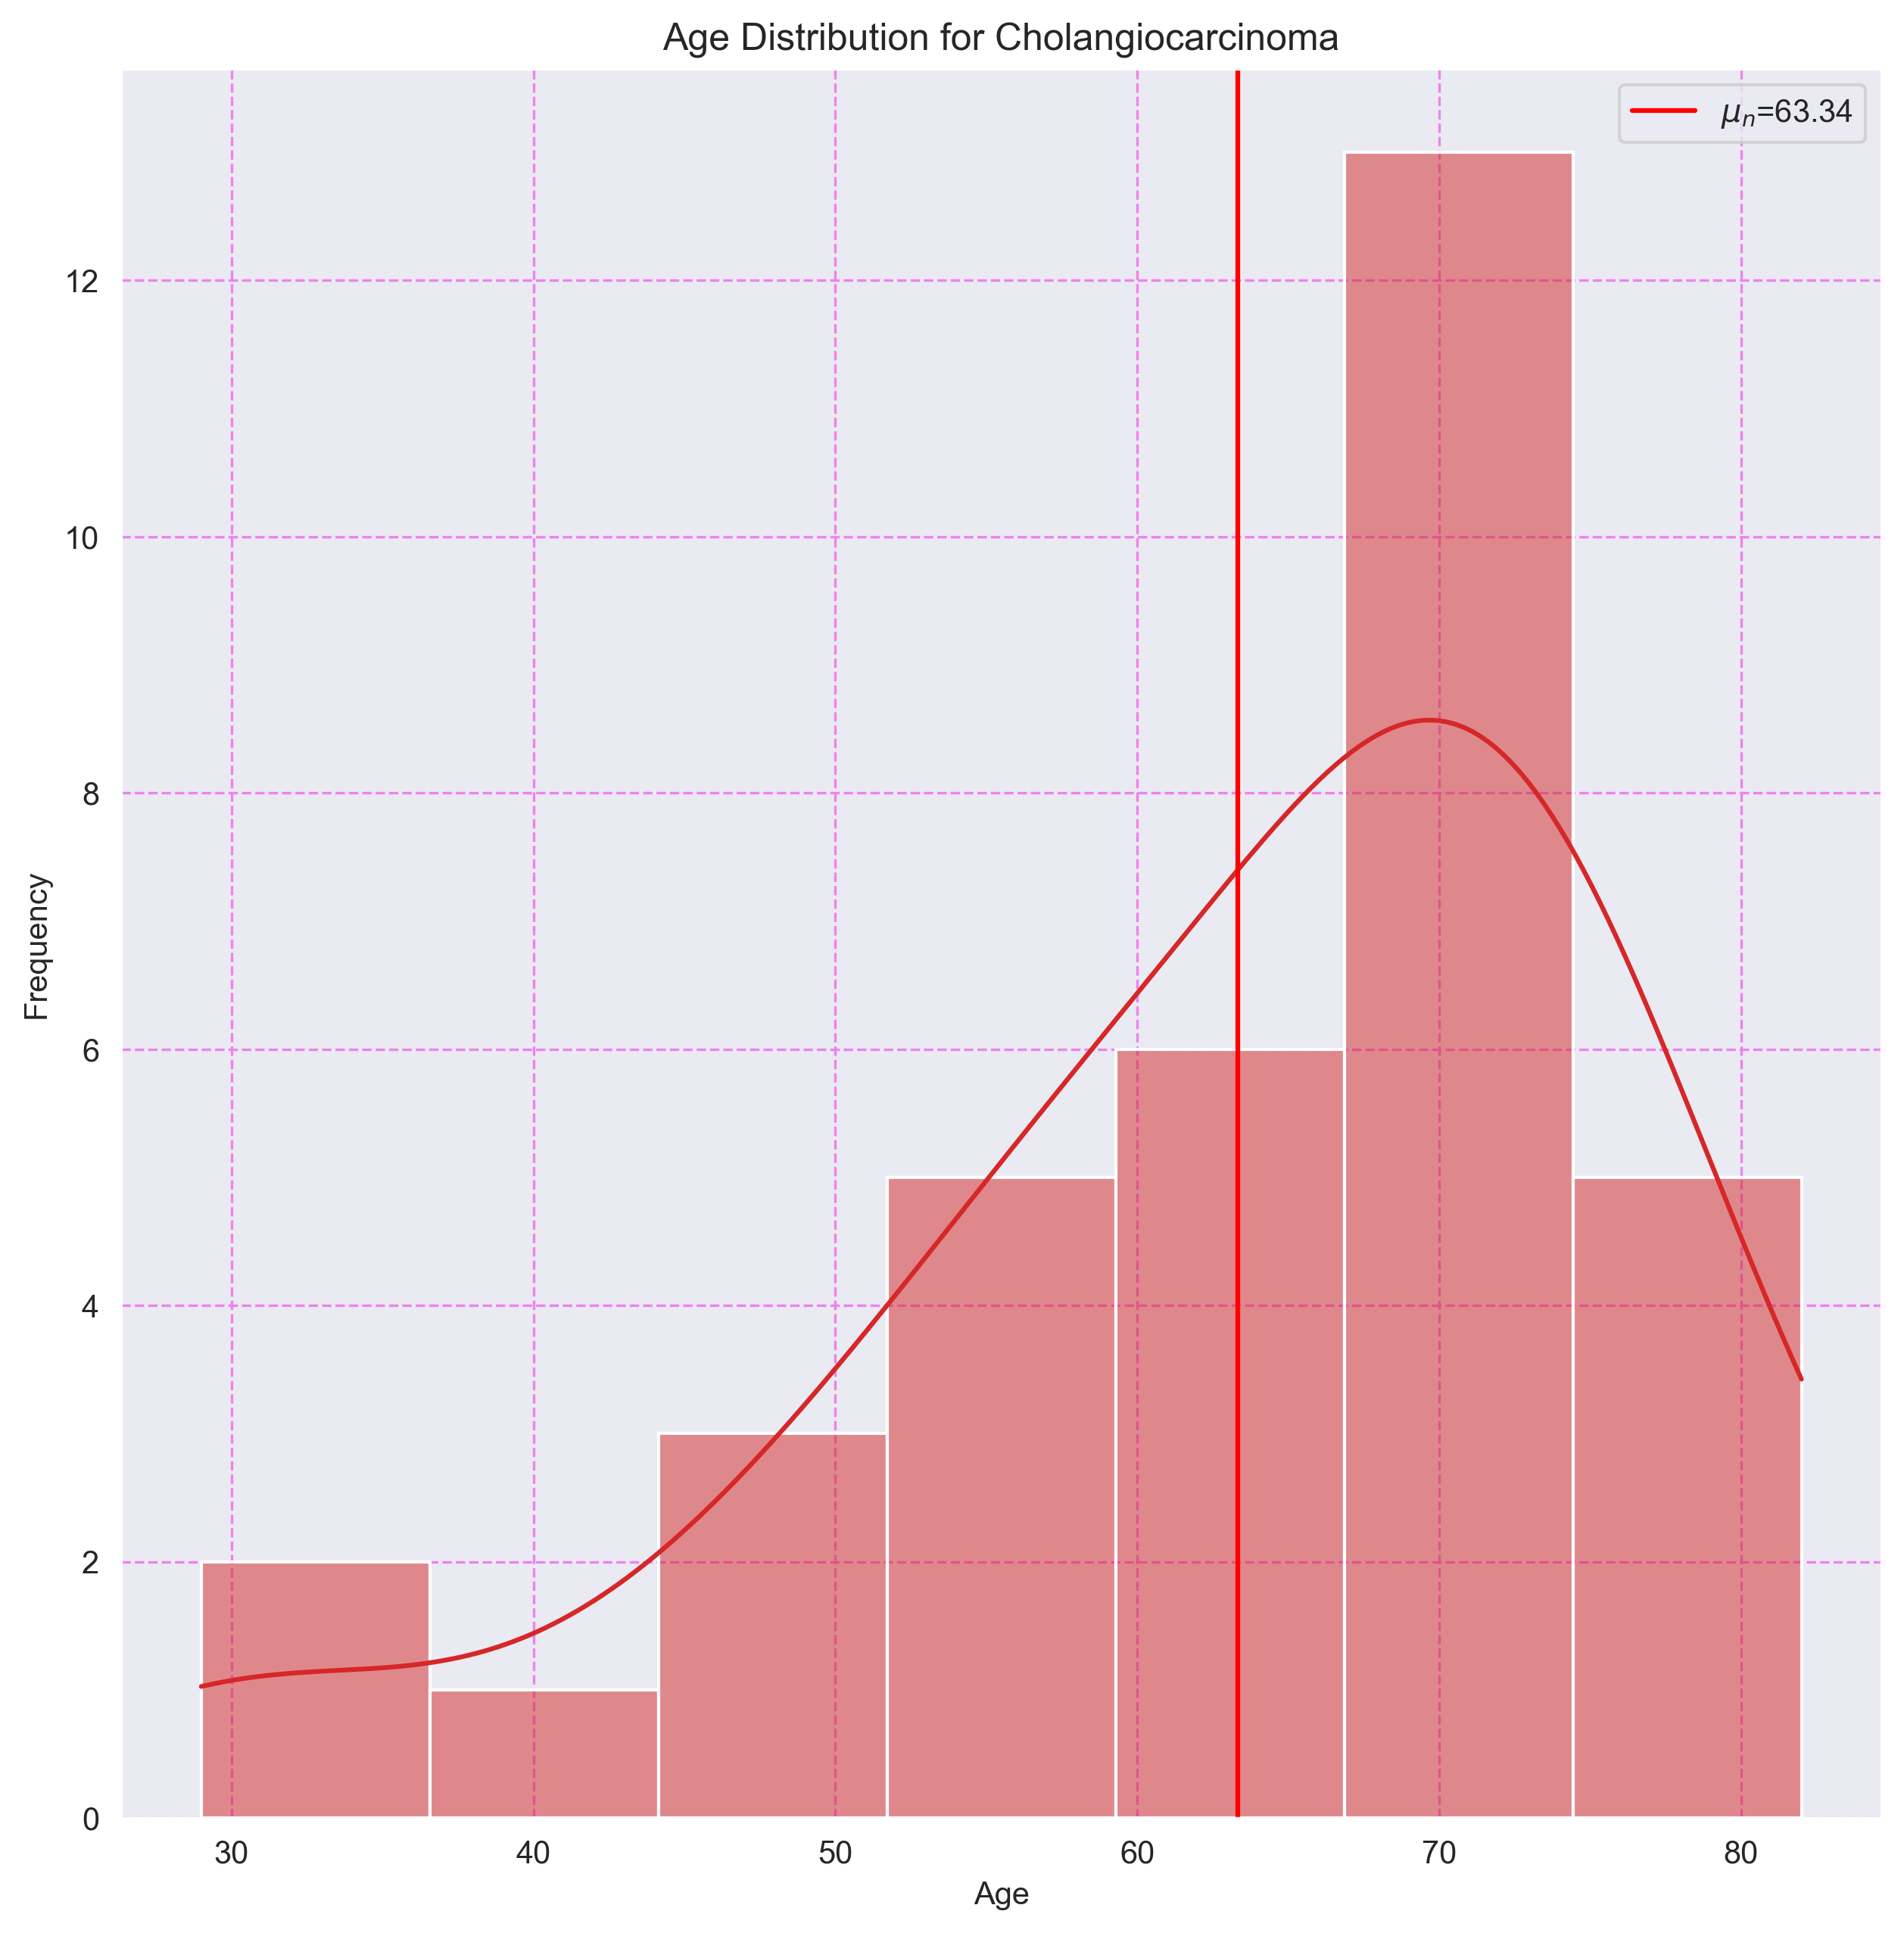

## 5. Histograma de Edades para Colorectal Cancer

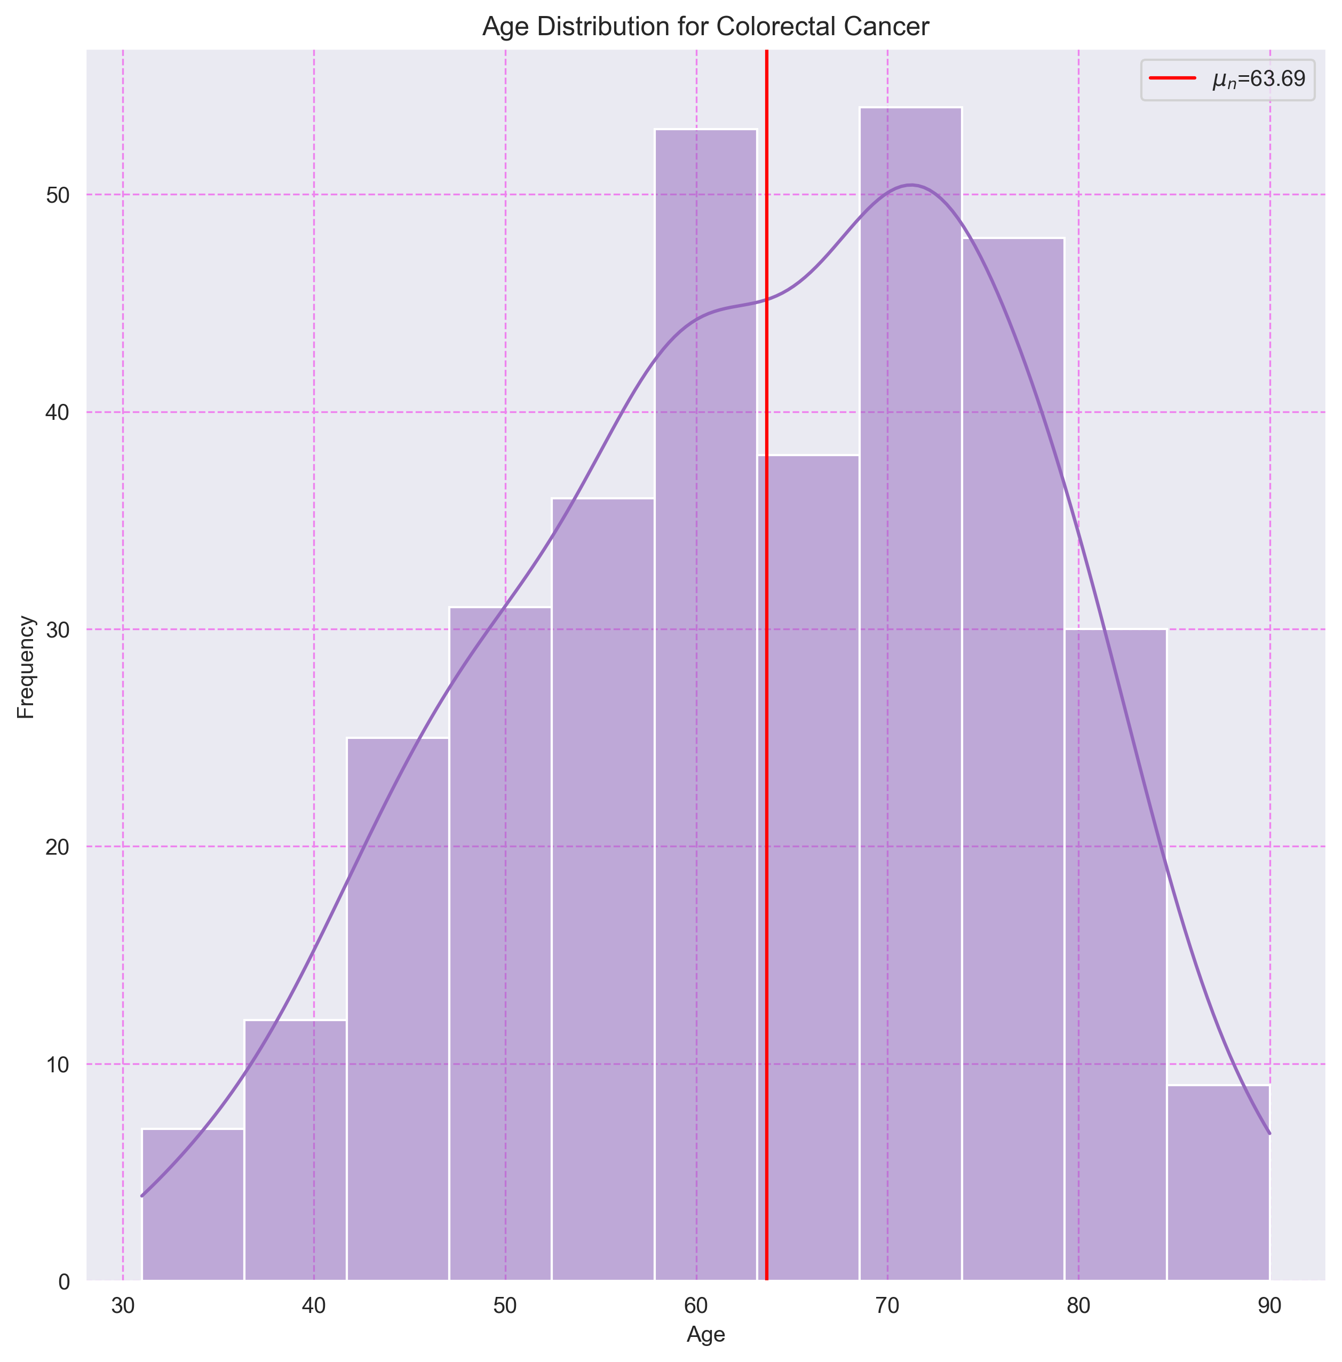

## 6. Histograma de Edades para Esophagogastric Cancer

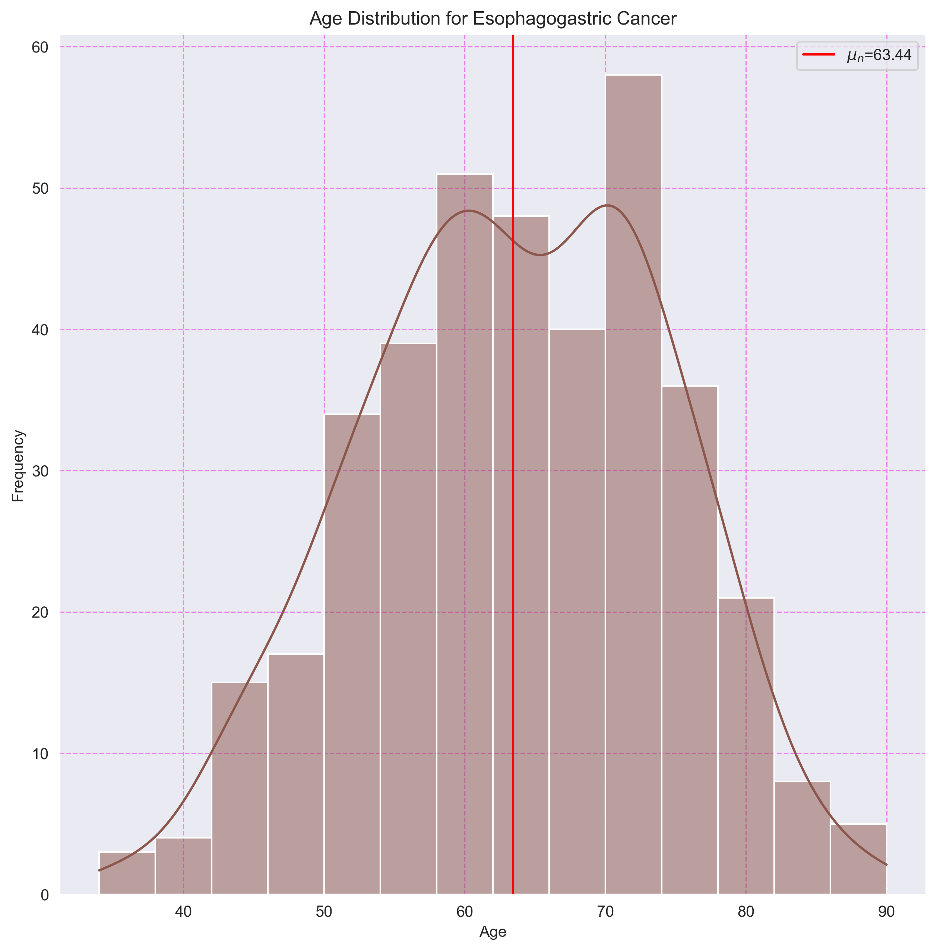

## 7. Histograma de Edades para Head and Neck Cancer

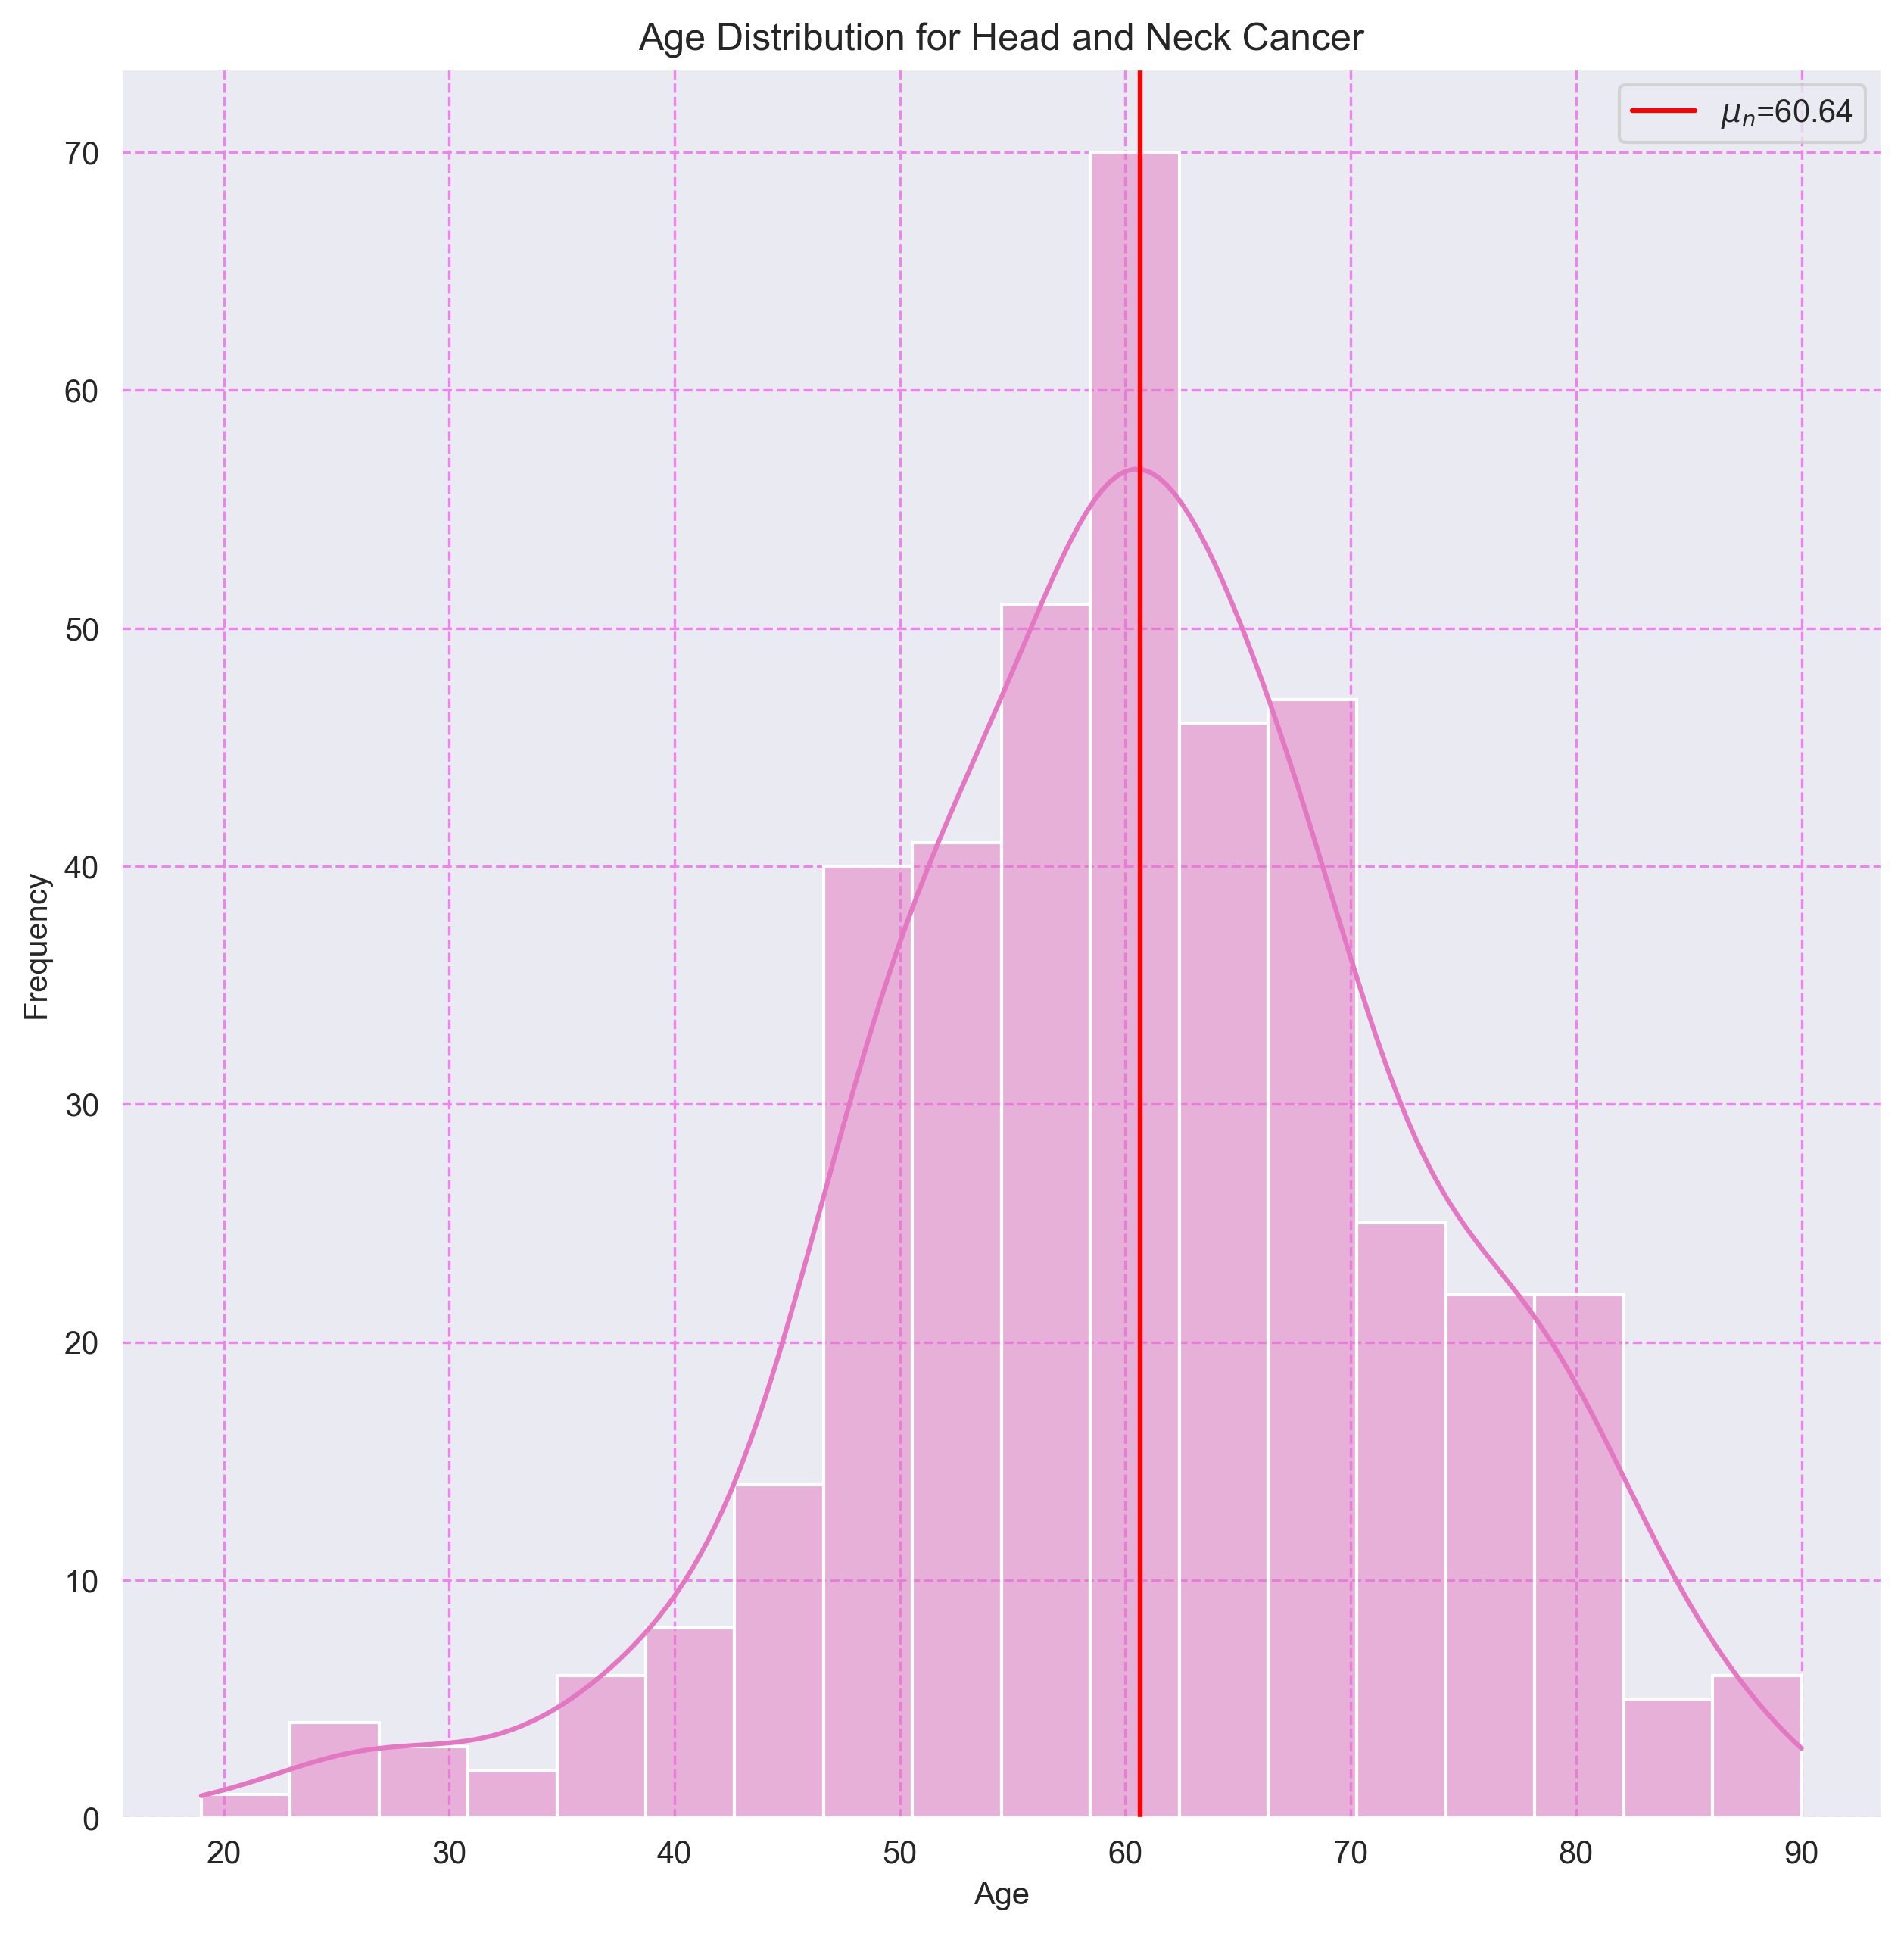

## 8. Histograma de Edades para Renal Non-Clear Cell Carcinoma

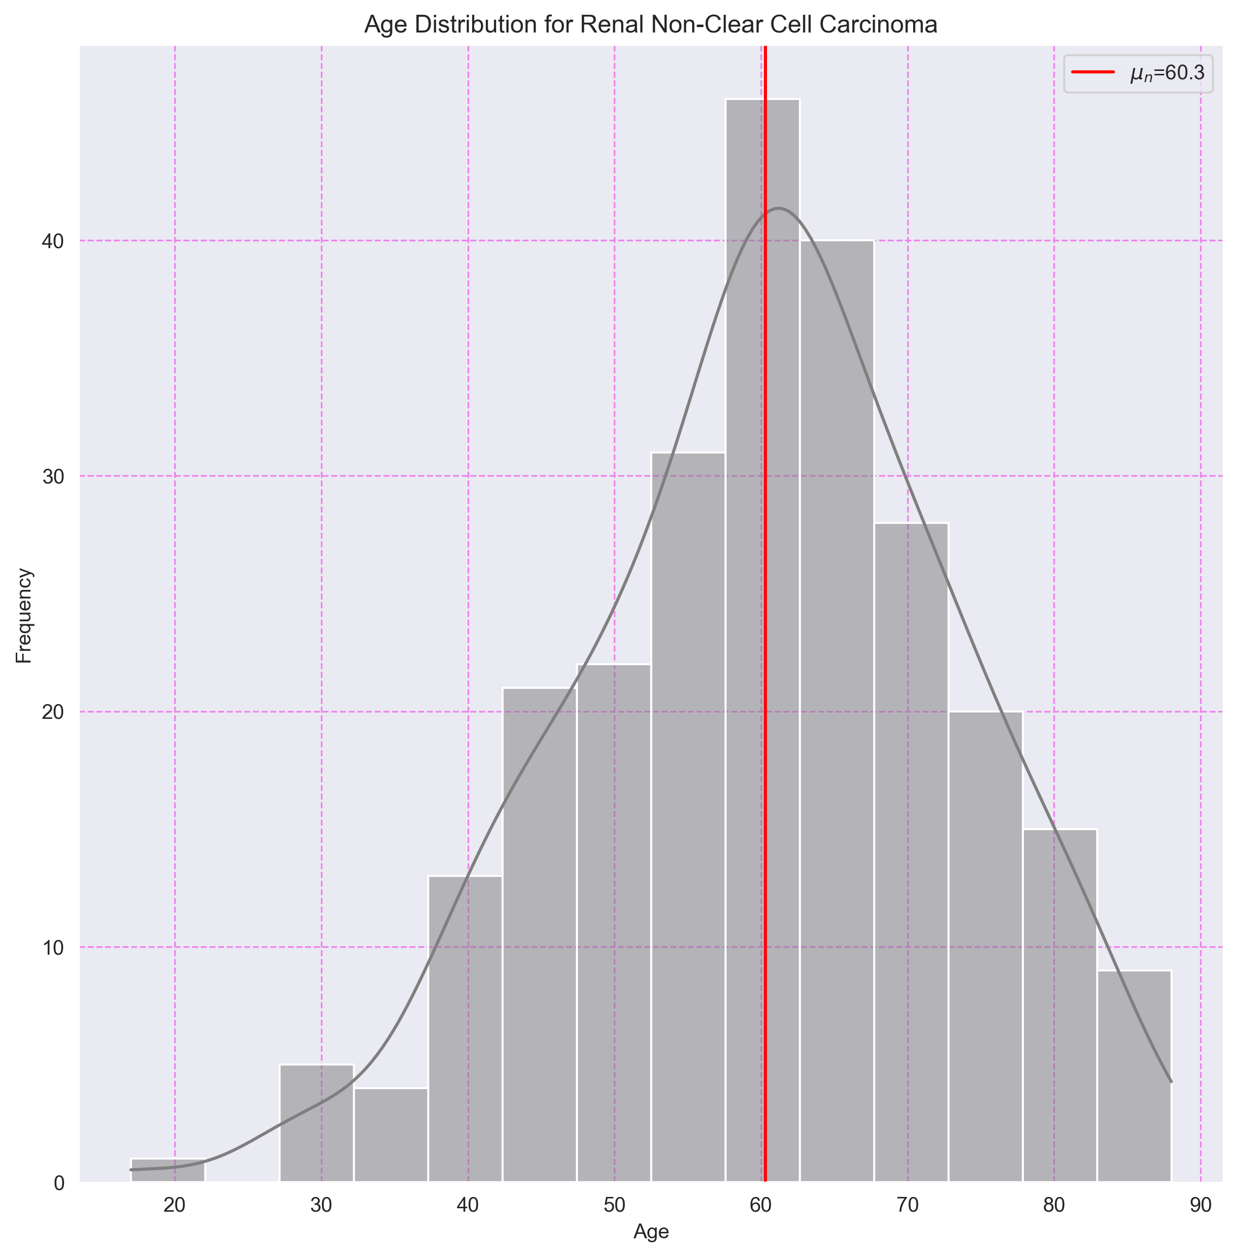

## 9. Histograma de Edades para Renal Clear Cell Carcinoma

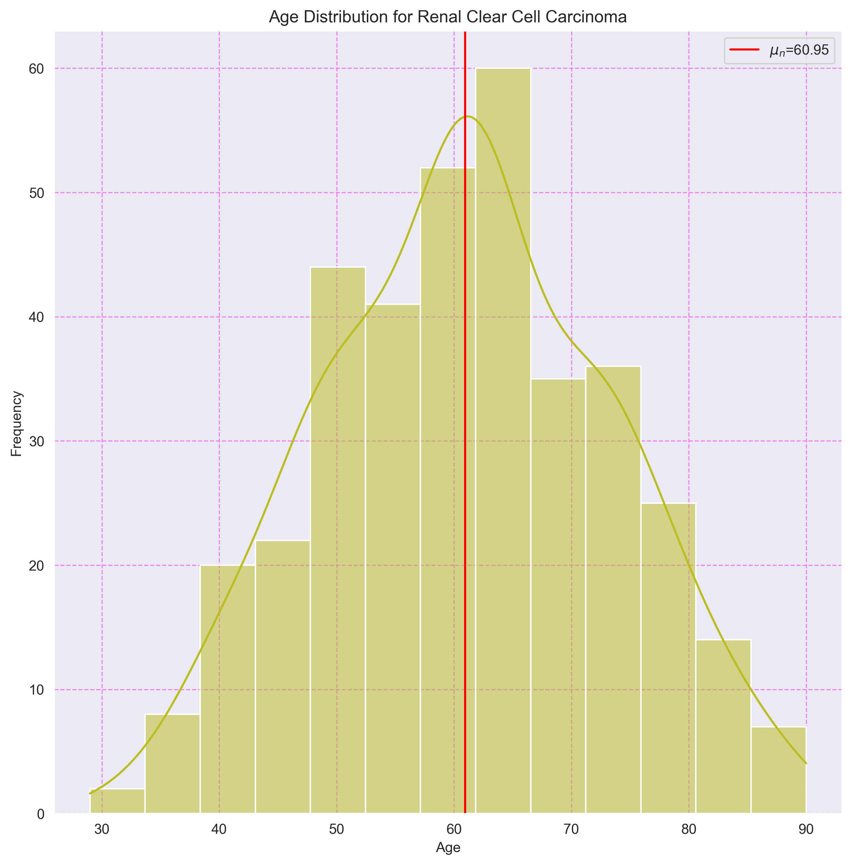

## 10. Histograma de Edades para Hepatobiliary Cancer

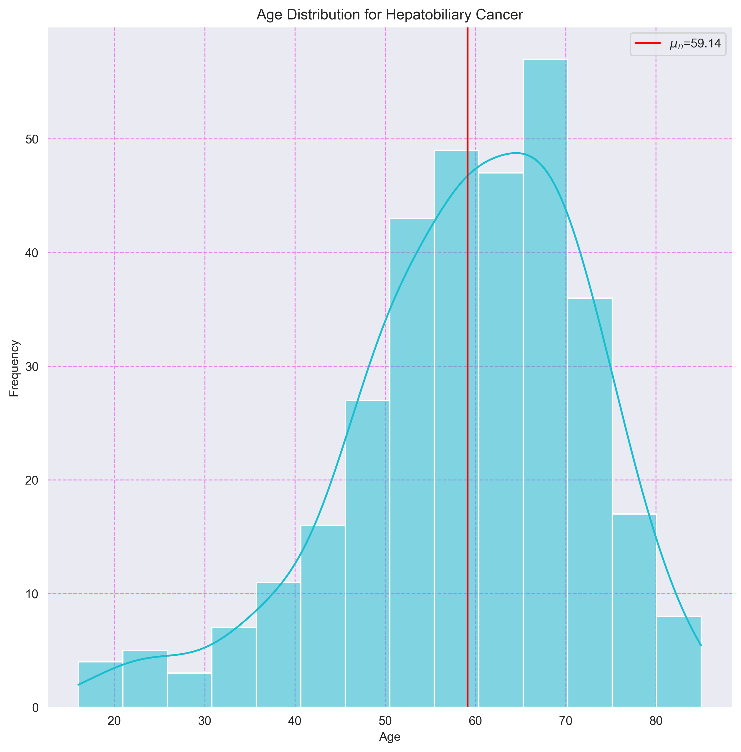

## 11. Histograma de Edades para Non-Small Cell Lung Cancer

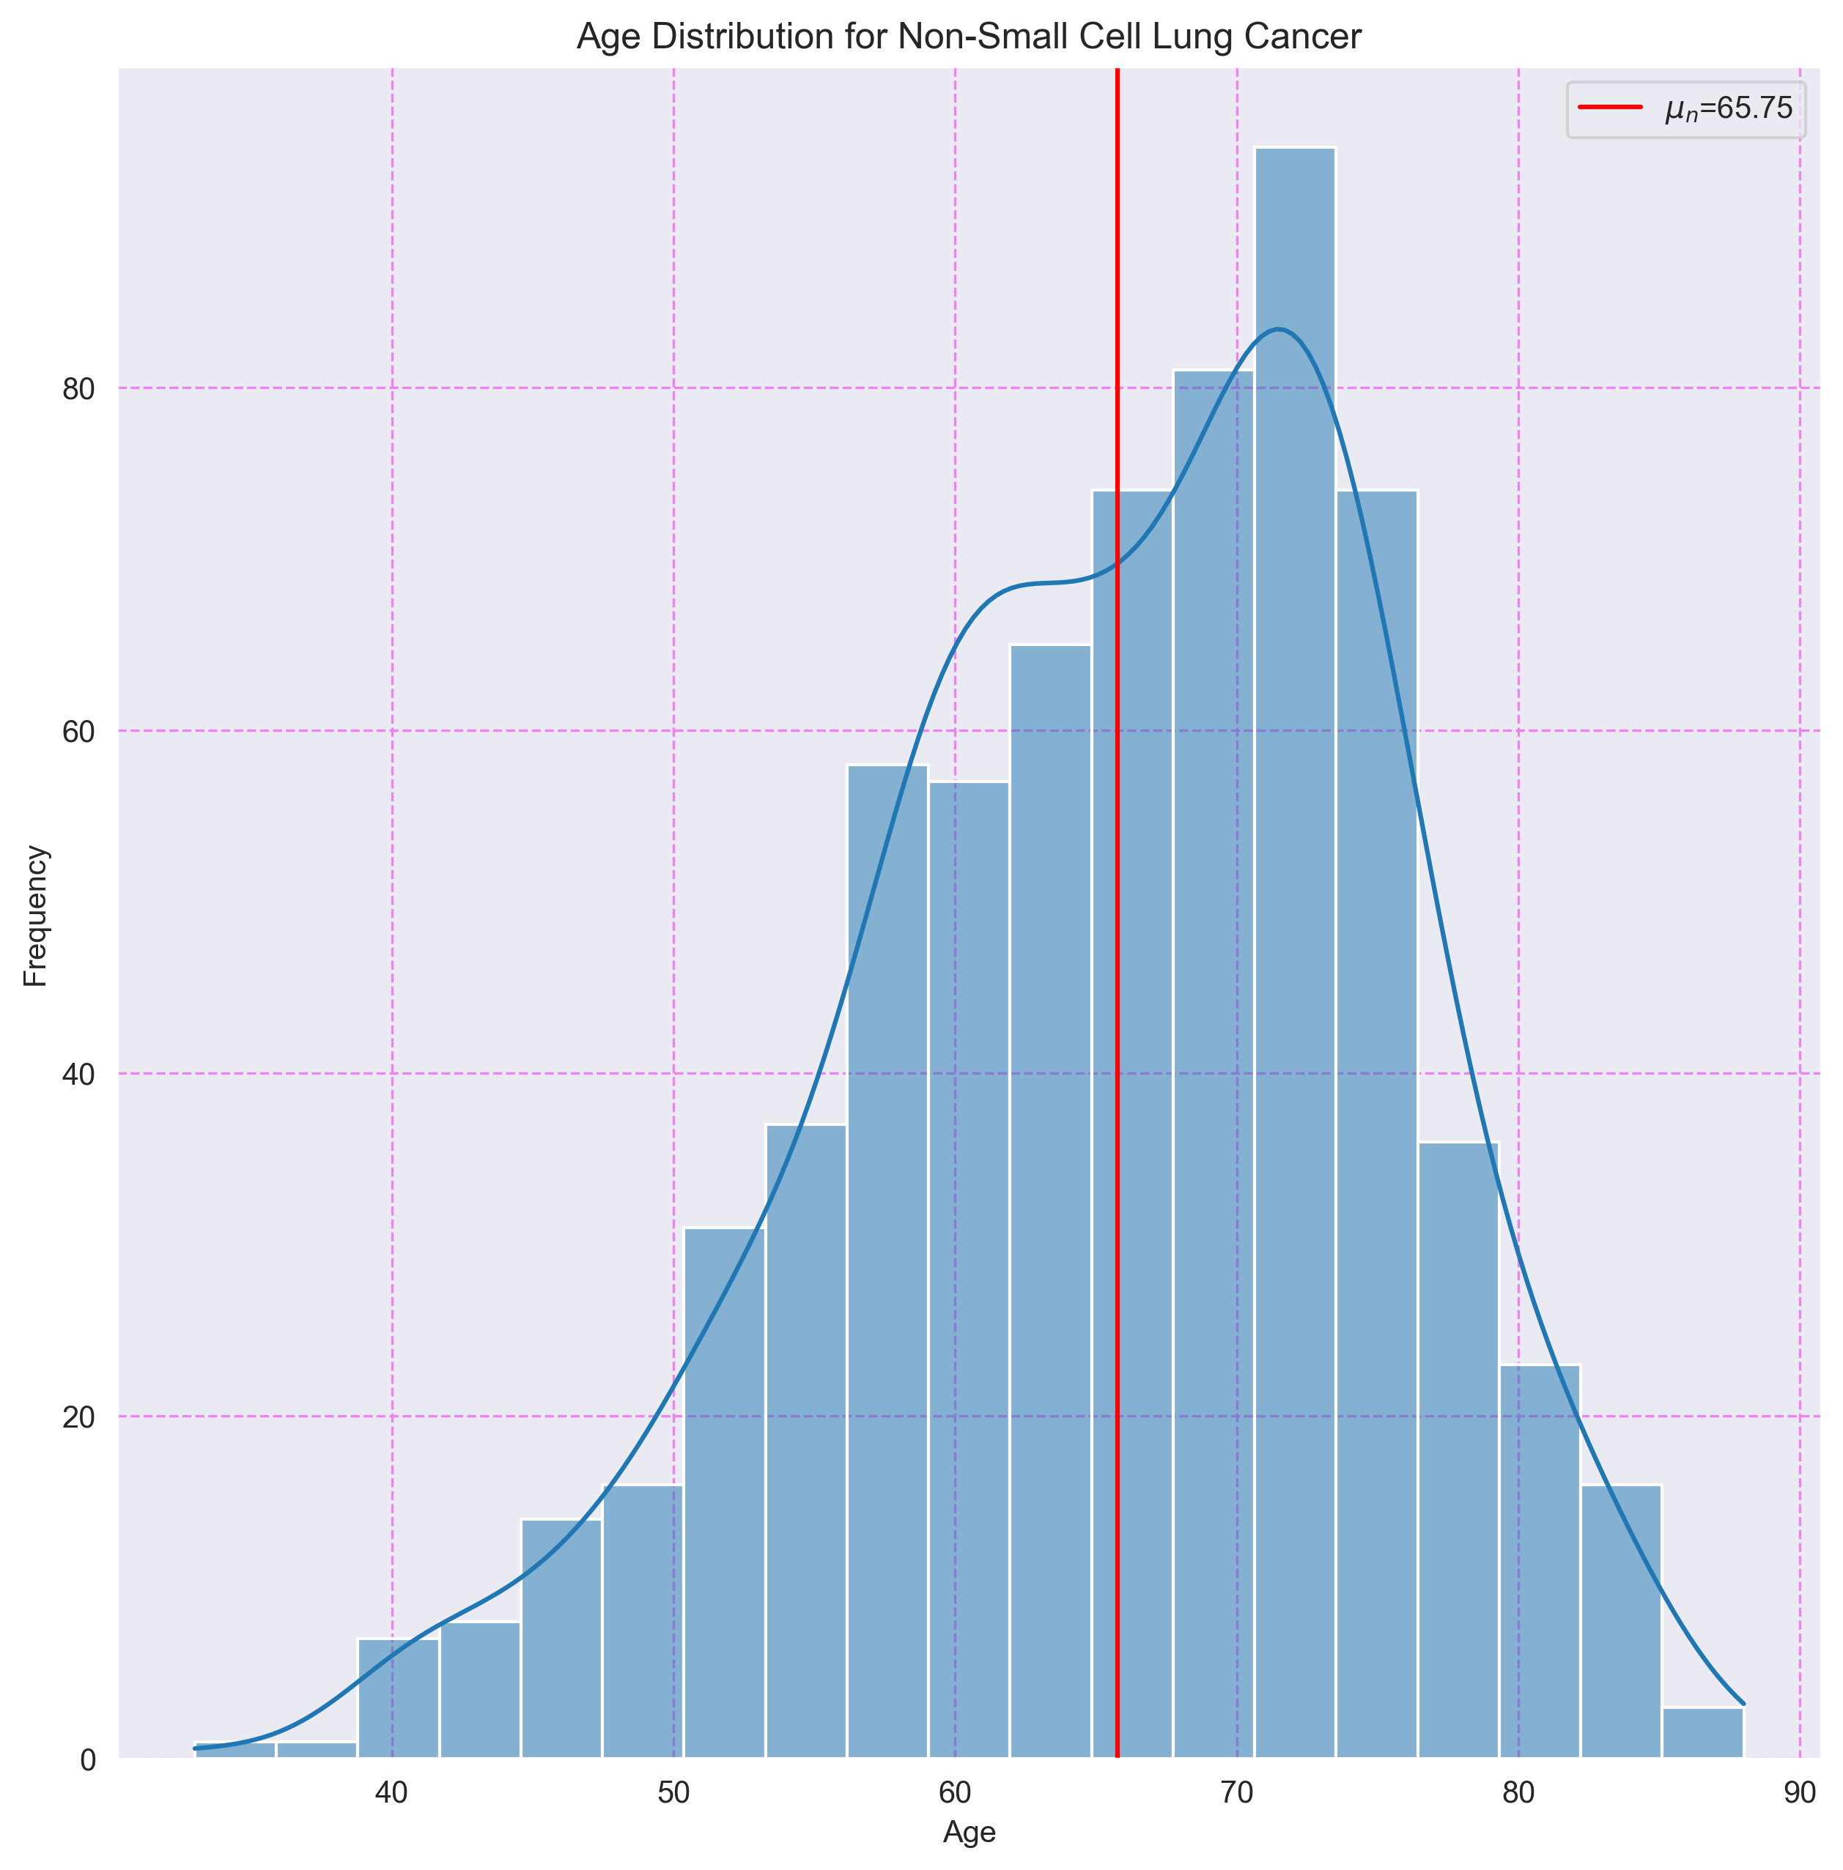

## 12. Histograma de Edades para Pleural Mesothelioma

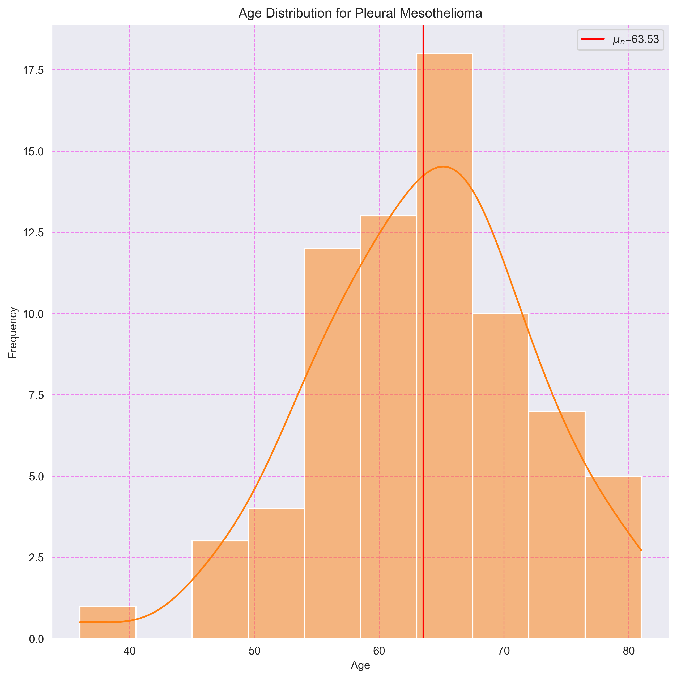

## 13. Histograma de Edades para Pancreatic Cancer

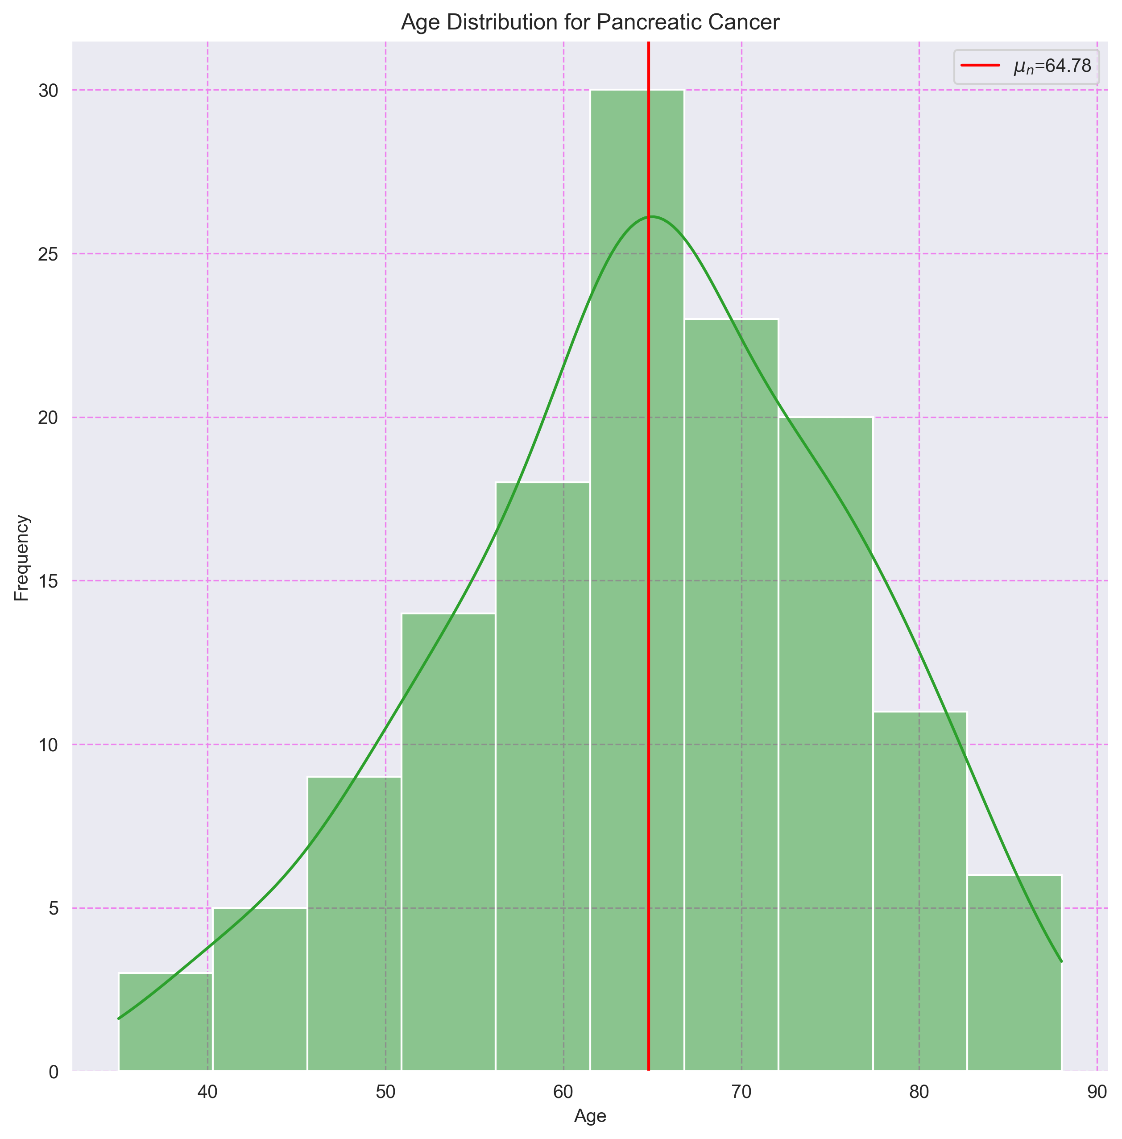

## 14. Histograma de Edades para Melanoma

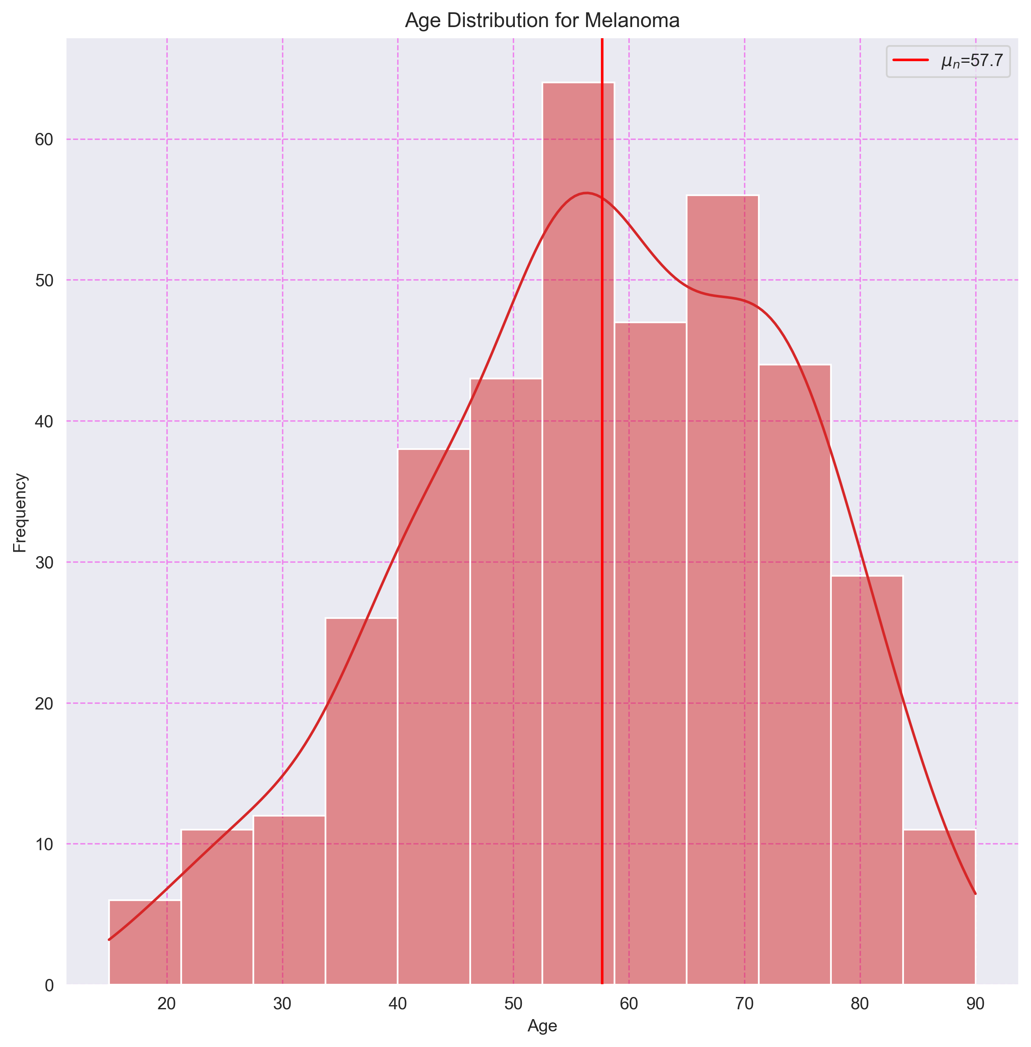

## 15. Histograma de Edades para Seminoma

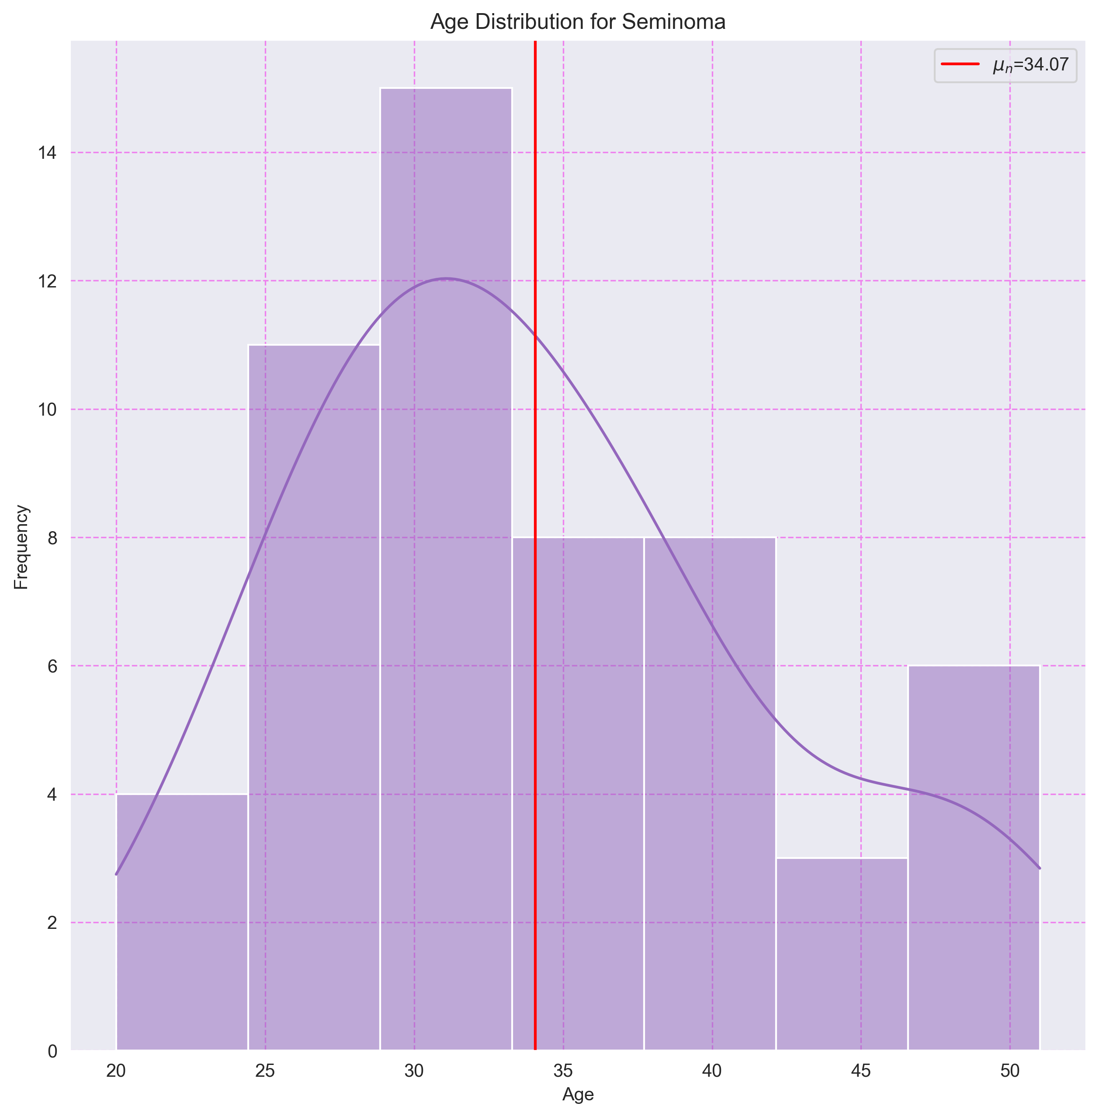

## 16. Histograma de Edades para Non-Seminomatous Germ Cell Tumor

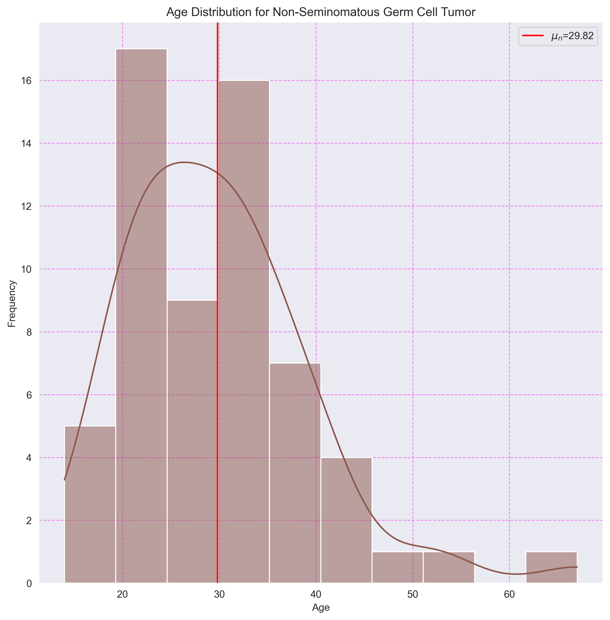

## 17. Histograma de Edades para Thyroid Cancer

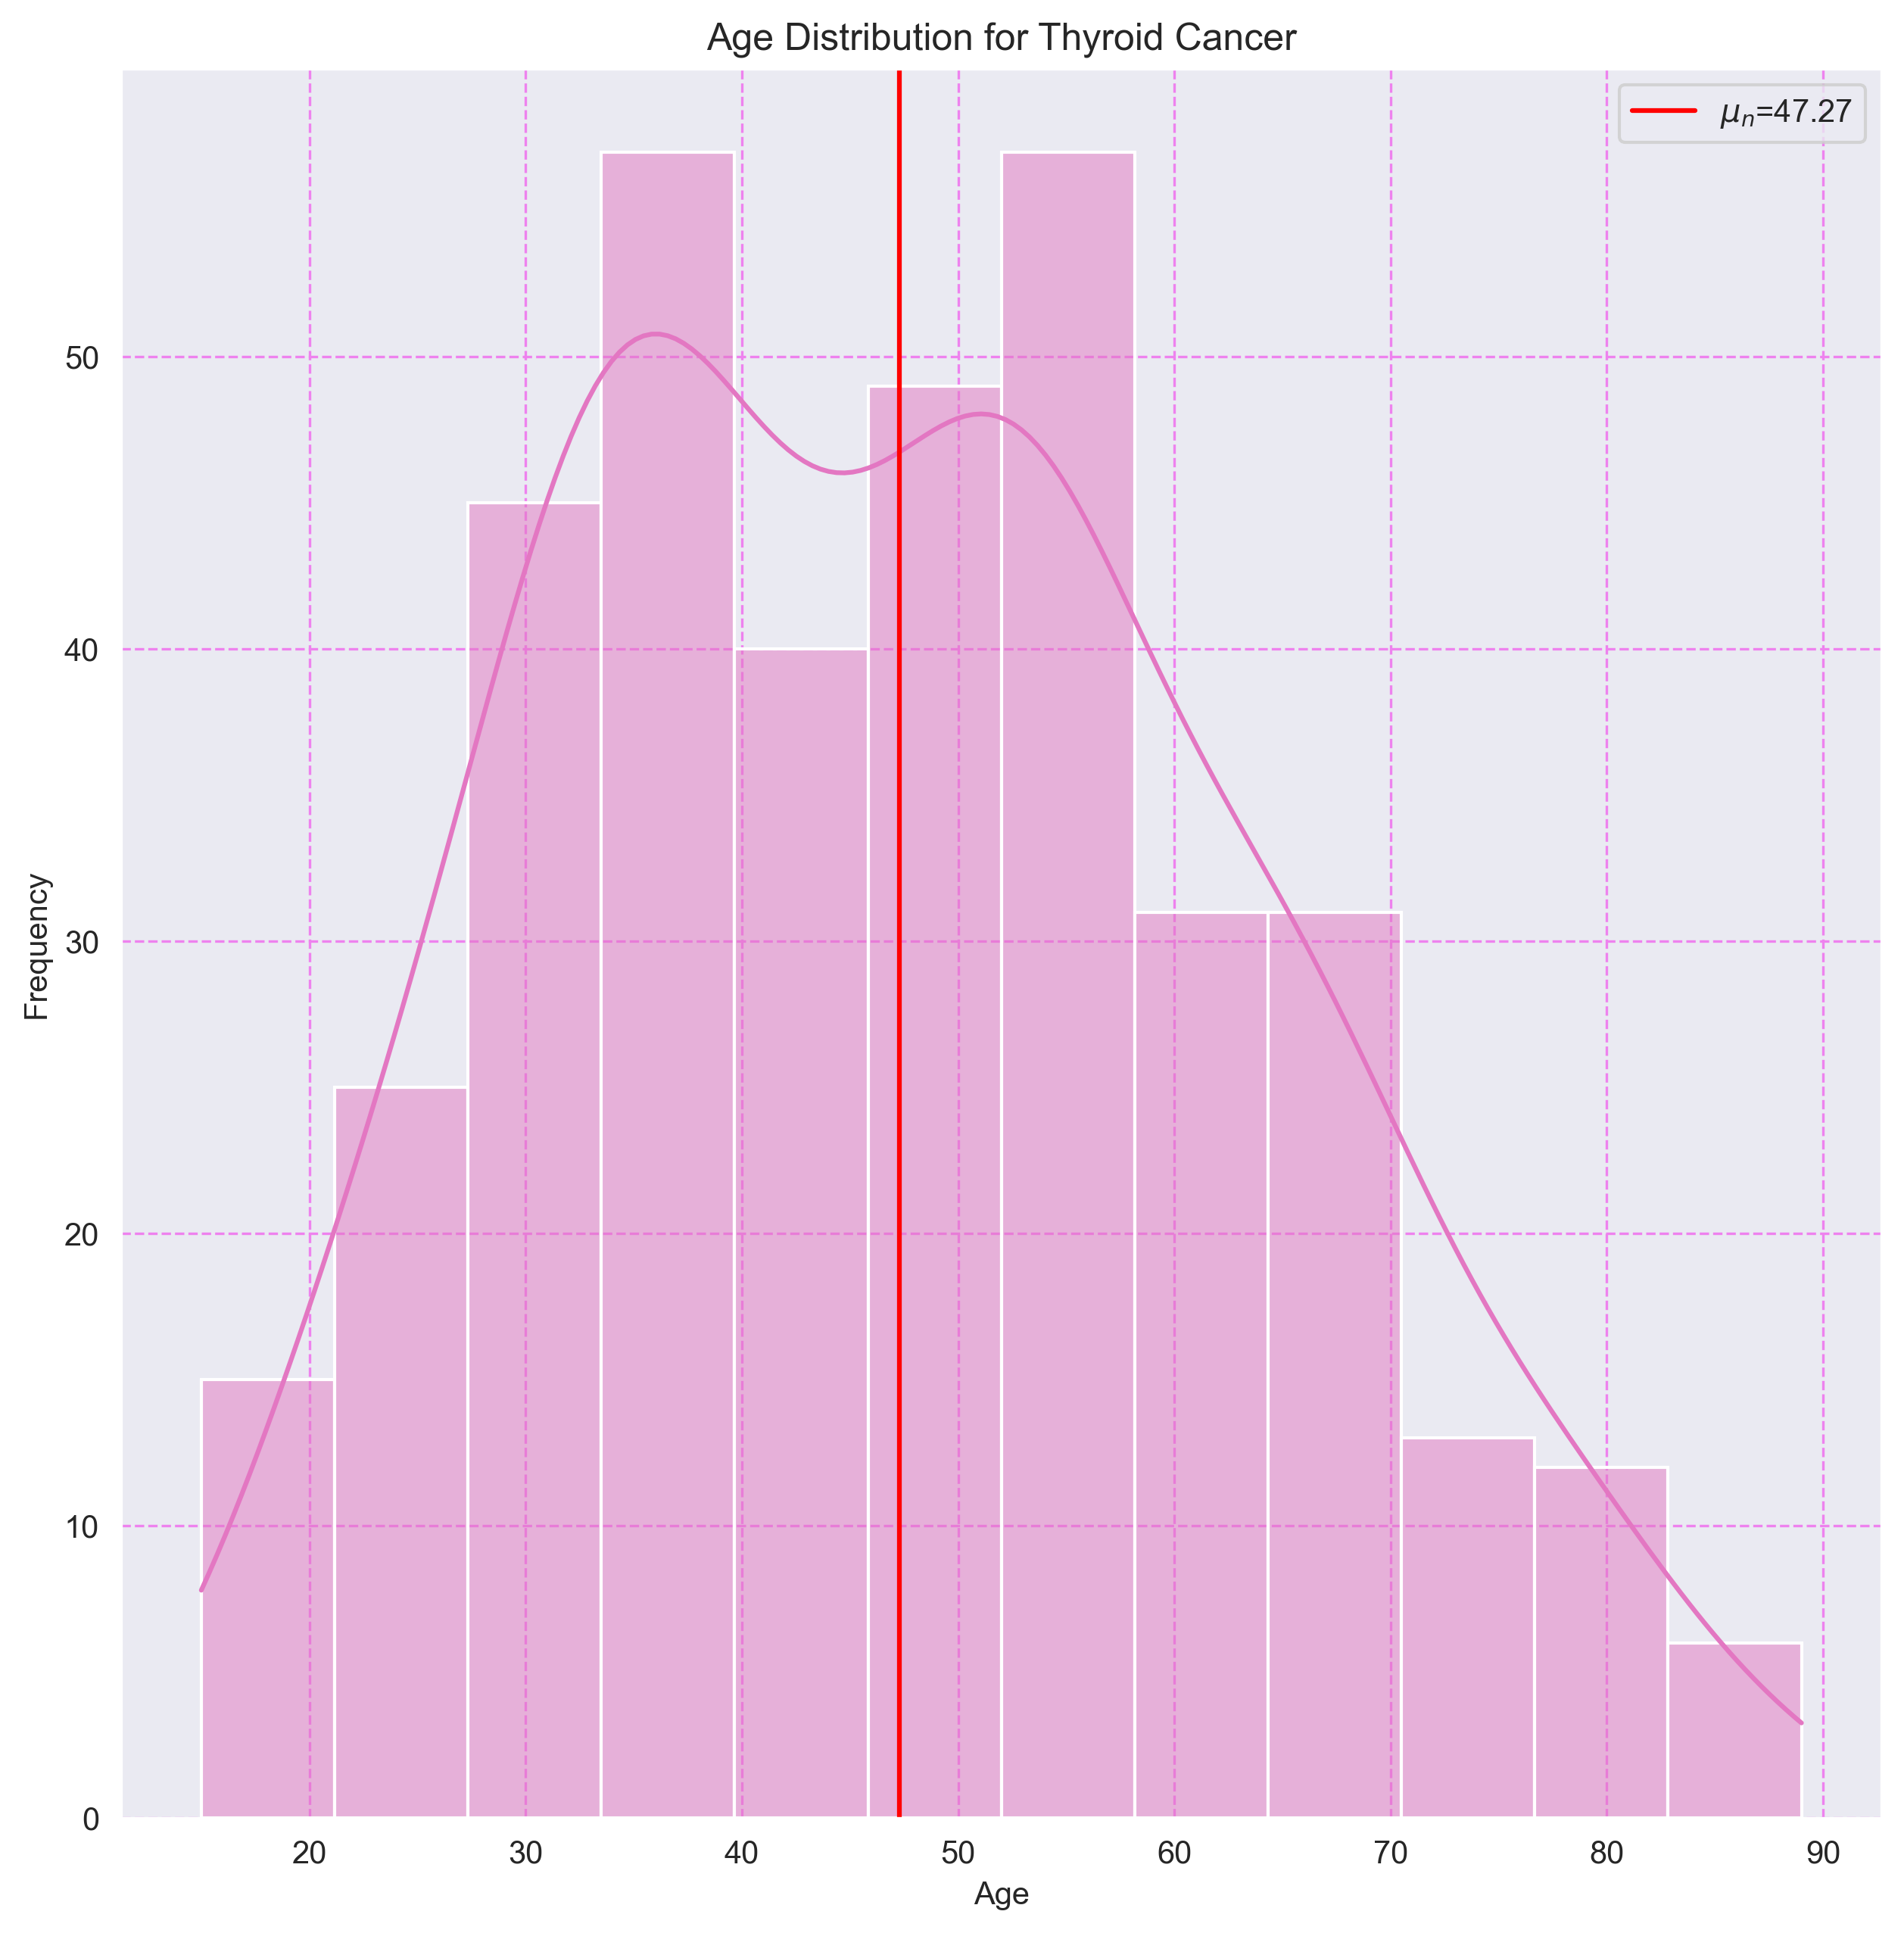

## 18. Histograma de Edades por Tipo de Cáncer

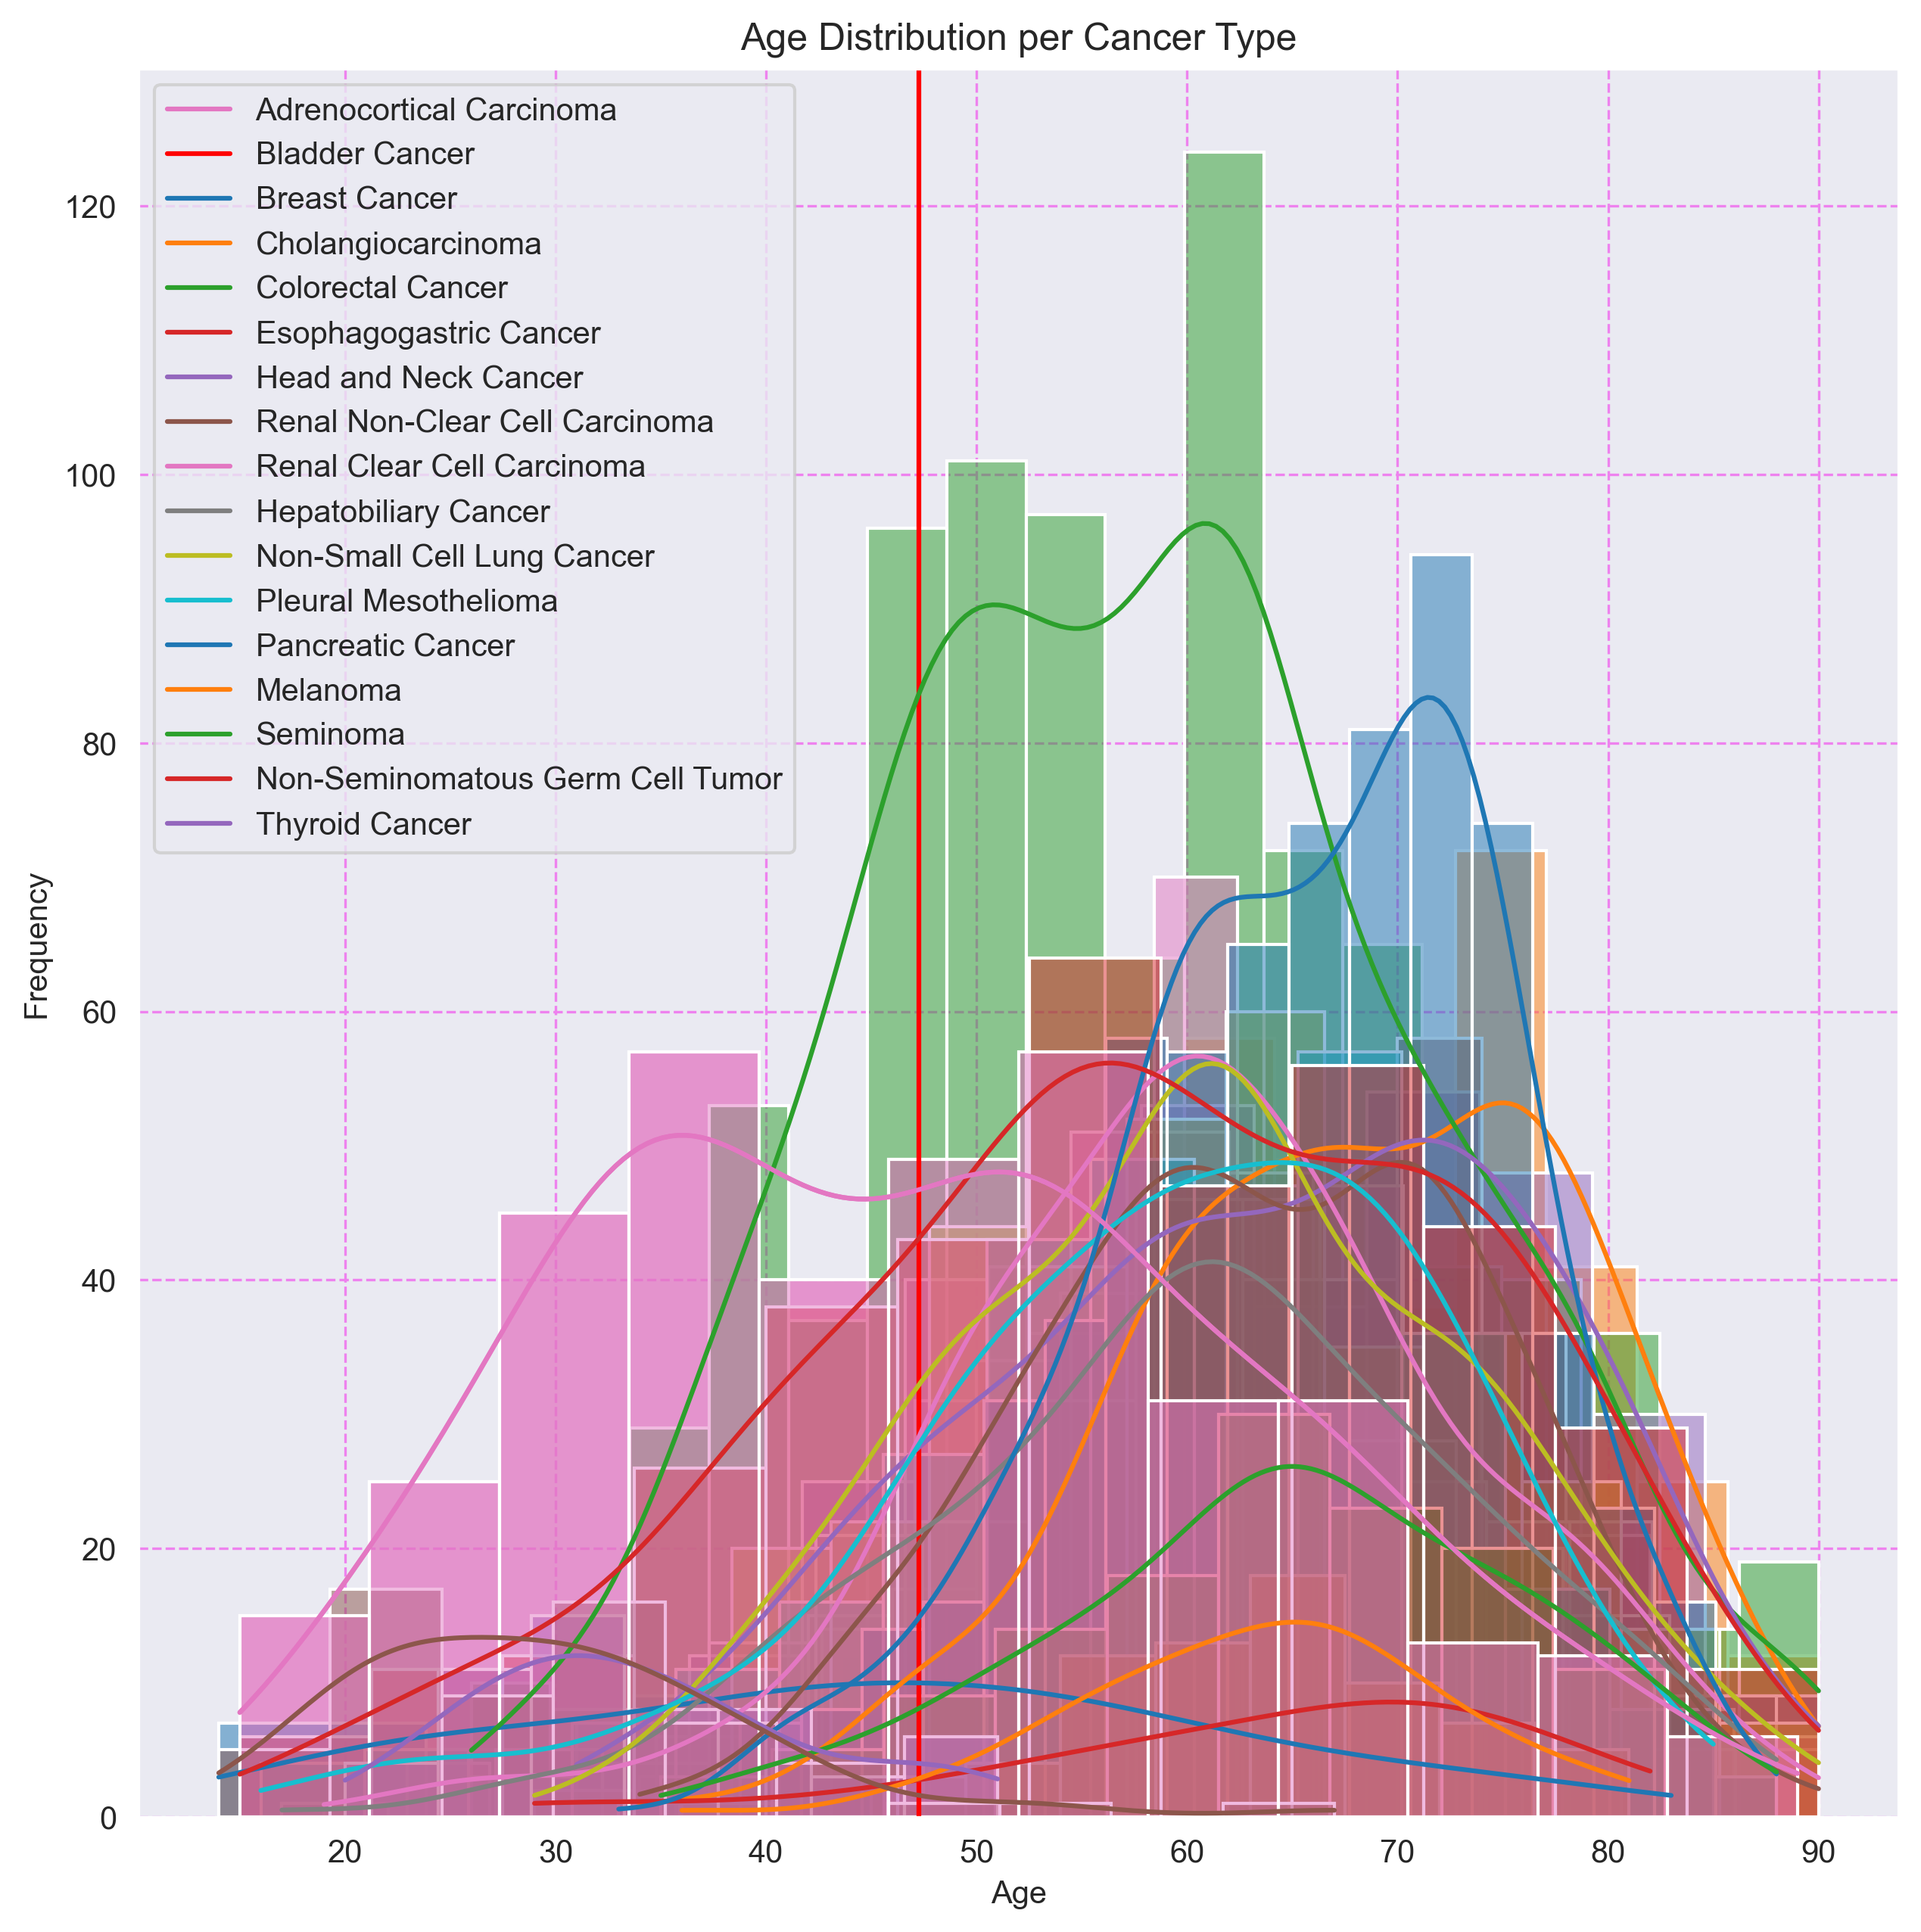

# 7. Tabla de Frecuencias por Estadio Tumoral y Tipo de Cáncer

|  |  |  |  |  |  |  |  |  |  |  |  |  |  |  |  |  |  |  |  |
| --- | --- | --- | --- | --- | --- | --- | --- | --- | --- | --- | --- | --- | --- | --- | --- | --- | --- | --- | --- |
| CANCER_TYPE | 0 | I | I/II_(NOS) | IA | IB | II | IIA | IIB | IIC | III | IIIA | IIIB | IIIC | IS | IV | IVA | IVB | IVC | X |
| Breast Cancer | 0 | 79 | 0 | 71 | 6 | 5 | 299 | 208 | 0 | 2 | 138 | 22 | 52 | 0 | 15 | 0 | 0 | 0 | 9 |
| Non-Small Cell Lung Cancer | 0 | 6 | 0 | 184 | 190 | 3 | 92 | 101 | 0 | 3 | 87 | 9 | 0 | 0 | 21 | 0 | 0 | 0 | 0 |
| Head and Neck Cancer | 0 | 26 | 0 | 0 | 0 | 70 | 0 | 0 | 0 | 74 | 0 | 0 | 0 | 0 | 0 | 230 | 12 | 1 | 0 |
| Melanoma | 6 | 29 | 9 | 17 | 29 | 26 | 17 | 22 | 47 | 39 | 15 | 41 | 67 | 0 | 23 | 0 | 0 | 0 | 0 |
| Thyroid Cancer | 0 | 215 | 0 | 0 | 0 | 34 | 0 | 0 | 0 | 90 | 0 | 0 | 0 | 0 | 2 | 35 | 0 | 5 | 0 |
| Esophagogastric Cancer | 0 | 2 | 0 | 13 | 31 | 21 | 71 | 64 | 0 | 8 | 69 | 50 | 32 | 0 | 17 | 1 | 0 | 0 | 0 |
| Bladder Cancer | 0 | 2 | 0 | 0 | 0 | 118 | 0 | 0 | 0 | 127 | 0 | 0 | 0 | 0 | 125 | 0 | 0 | 0 | 0 |
| Renal Clear Cell Carcinoma | 0 | 166 | 0 | 0 | 0 | 37 | 0 | 0 | 0 | 90 | 0 | 0 | 0 | 0 | 73 | 0 | 0 | 0 | 0 |
| Colorectal Cancer | 0 | 50 | 0 | 1 | 0 | 5 | 113 | 9 | 2 | 5 | 11 | 62 | 34 | 0 | 24 | 25 | 2 | 0 | 0 |
| Hepatobiliary Cancer | 0 | 162 | 0 | 0 | 0 | 82 | 0 | 0 | 0 | 3 | 62 | 8 | 8 | 0 | 3 | 0 | 2 | 0 | 0 |
| Renal Non-Clear Cell Carcinoma | 0 | 163 | 0 | 0 | 0 | 33 | 0 | 0 | 0 | 45 | 0 | 0 | 0 | 0 | 14 | 0 | 0 | 0 | 0 |
| Pancreatic Cancer | 0 | 1 | 0 | 5 | 14 | 0 | 20 | 90 | 0 | 4 | 0 | 0 | 0 | 0 | 5 | 0 | 0 | 0 | 0 |
| Pleural Mesothelioma | 0 | 5 | 0 | 2 | 1 | 15 | 0 | 0 | 0 | 37 | 0 | 0 | 0 | 0 | 13 | 0 | 0 | 0 | 0 |
| Non-Seminomatous Germ Cell Tumor | 0 | 5 | 0 | 4 | 5 | 5 | 5 | 0 | 0 | 2 | 1 | 4 | 1 | 29 | 0 | 0 | 0 | 0 | 0 |
| Seminoma | 0 | 14 | 0 | 18 | 4 | 0 | 0 | 1 | 1 | 0 | 0 | 1 | 1 | 15 | 0 | 0 | 0 | 0 | 0 |
| Adrenocortical Carcinoma | 0 | 3 | 0 | 0 | 0 | 21 | 0 | 0 | 0 | 13 | 0 | 0 | 0 | 0 | 11 | 0 | 0 | 0 | 0 |
| Cholangiocarcinoma | 0 | 19 | 0 | 0 | 0 | 9 | 0 | 0 | 0 | 1 | 0 | 0 | 0 | 0 | 1 | 2 | 3 | 0 | 0 |

# 8. Distribuciones de Estadios Tumorales y Tipo de Cáncer

## 1. Distribución de Estadios Tumorales para Adrenocortical Carcinoma

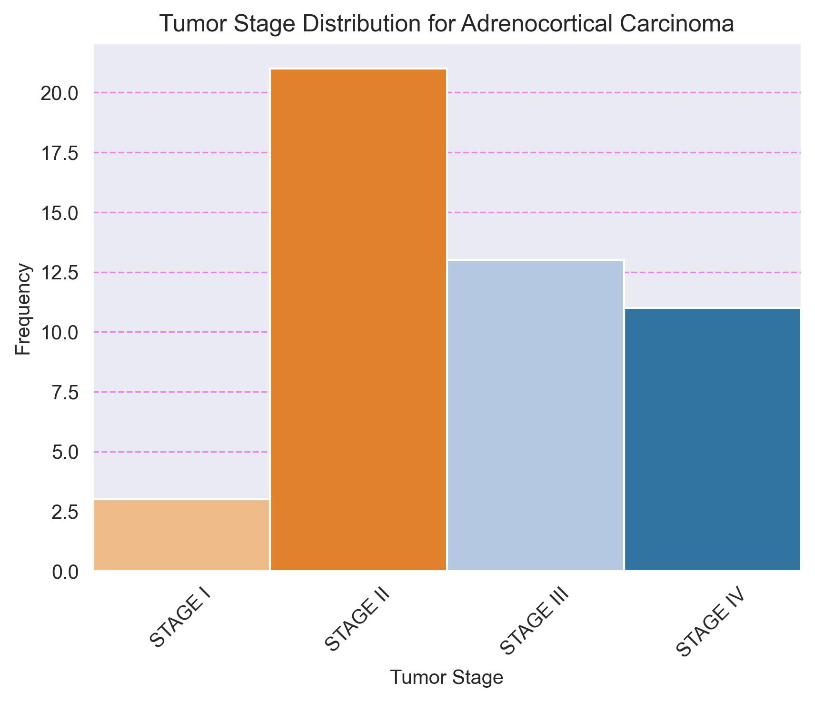

## 2. Distribución de Estadios Tumorales para Bladder Cancer

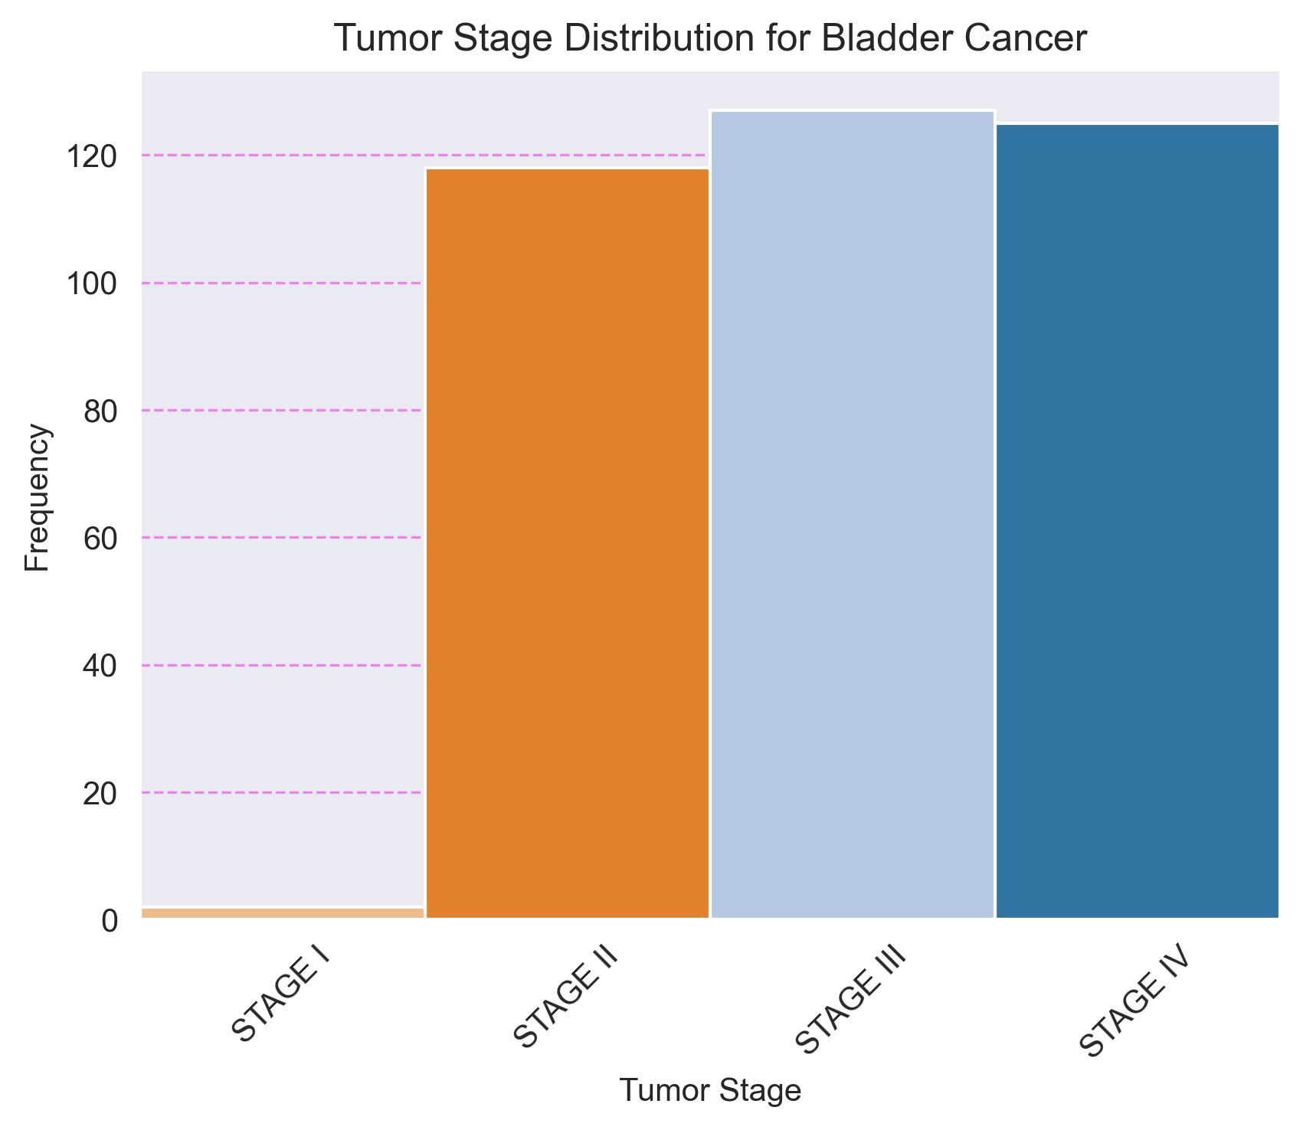

## 3. Distribución de Estadios Tumorales para Breast Cancer

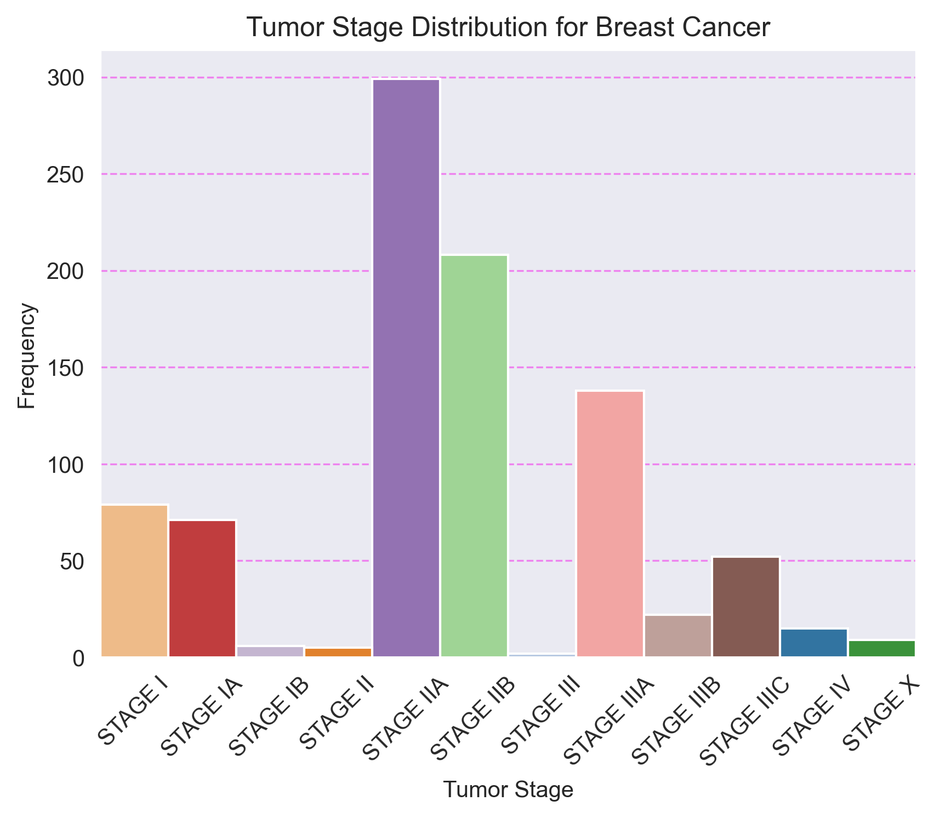

## 4. Distribución de Estadios Tumorales para Cholangiocarcinoma

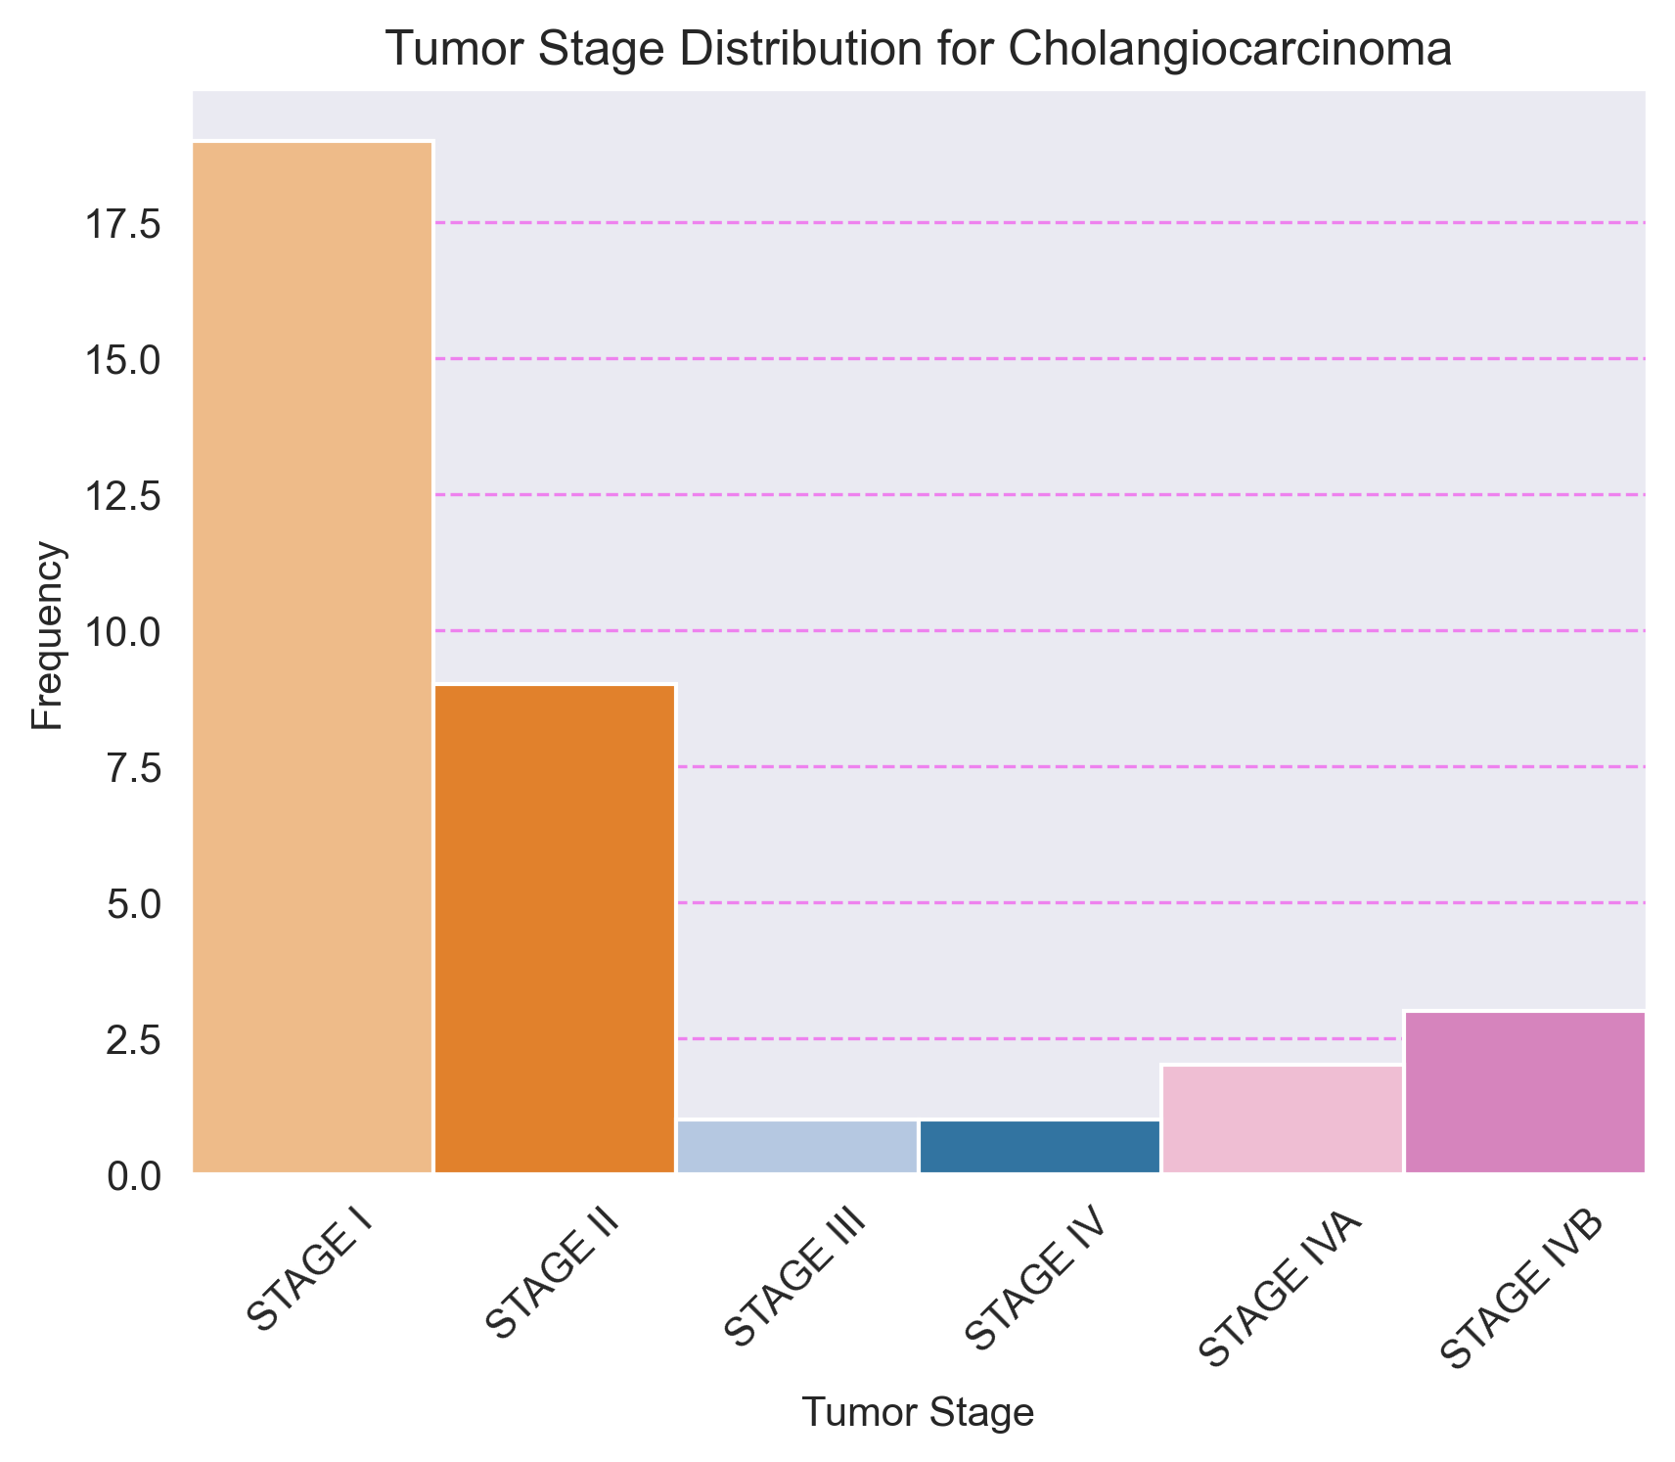

## 5. Distribución de Estadios Tumorales para Colorectal Cancer

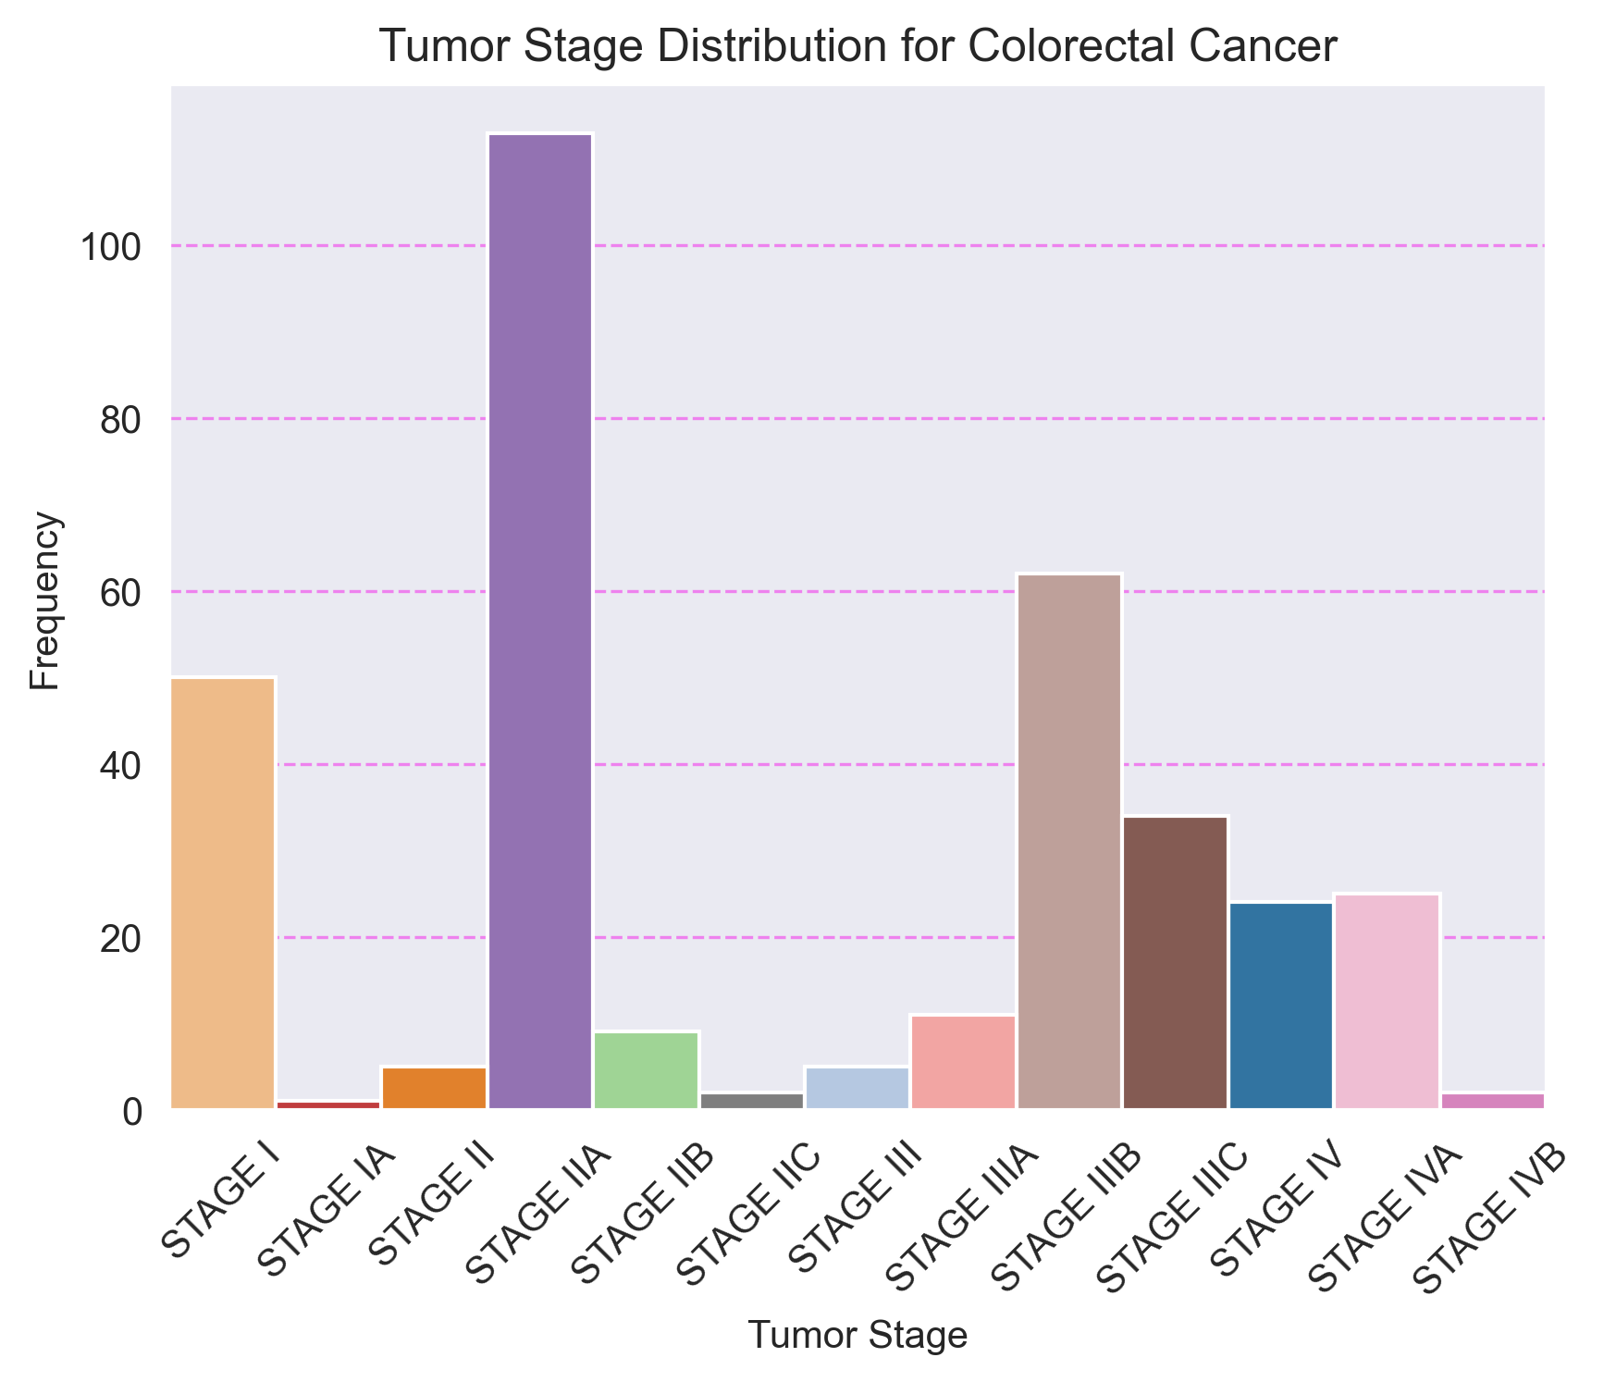

## 6. Distribución de Estadios Tumorales para Esophagogastric Cancer

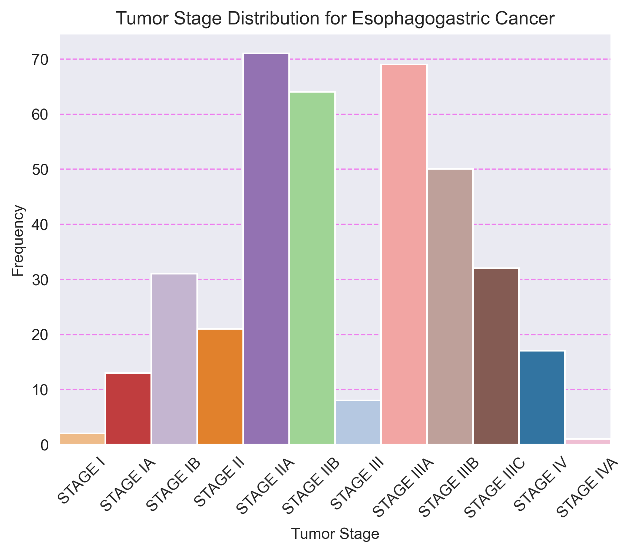

## 7. Distribución de Estadios Tumorales para Head and Neck Cancer

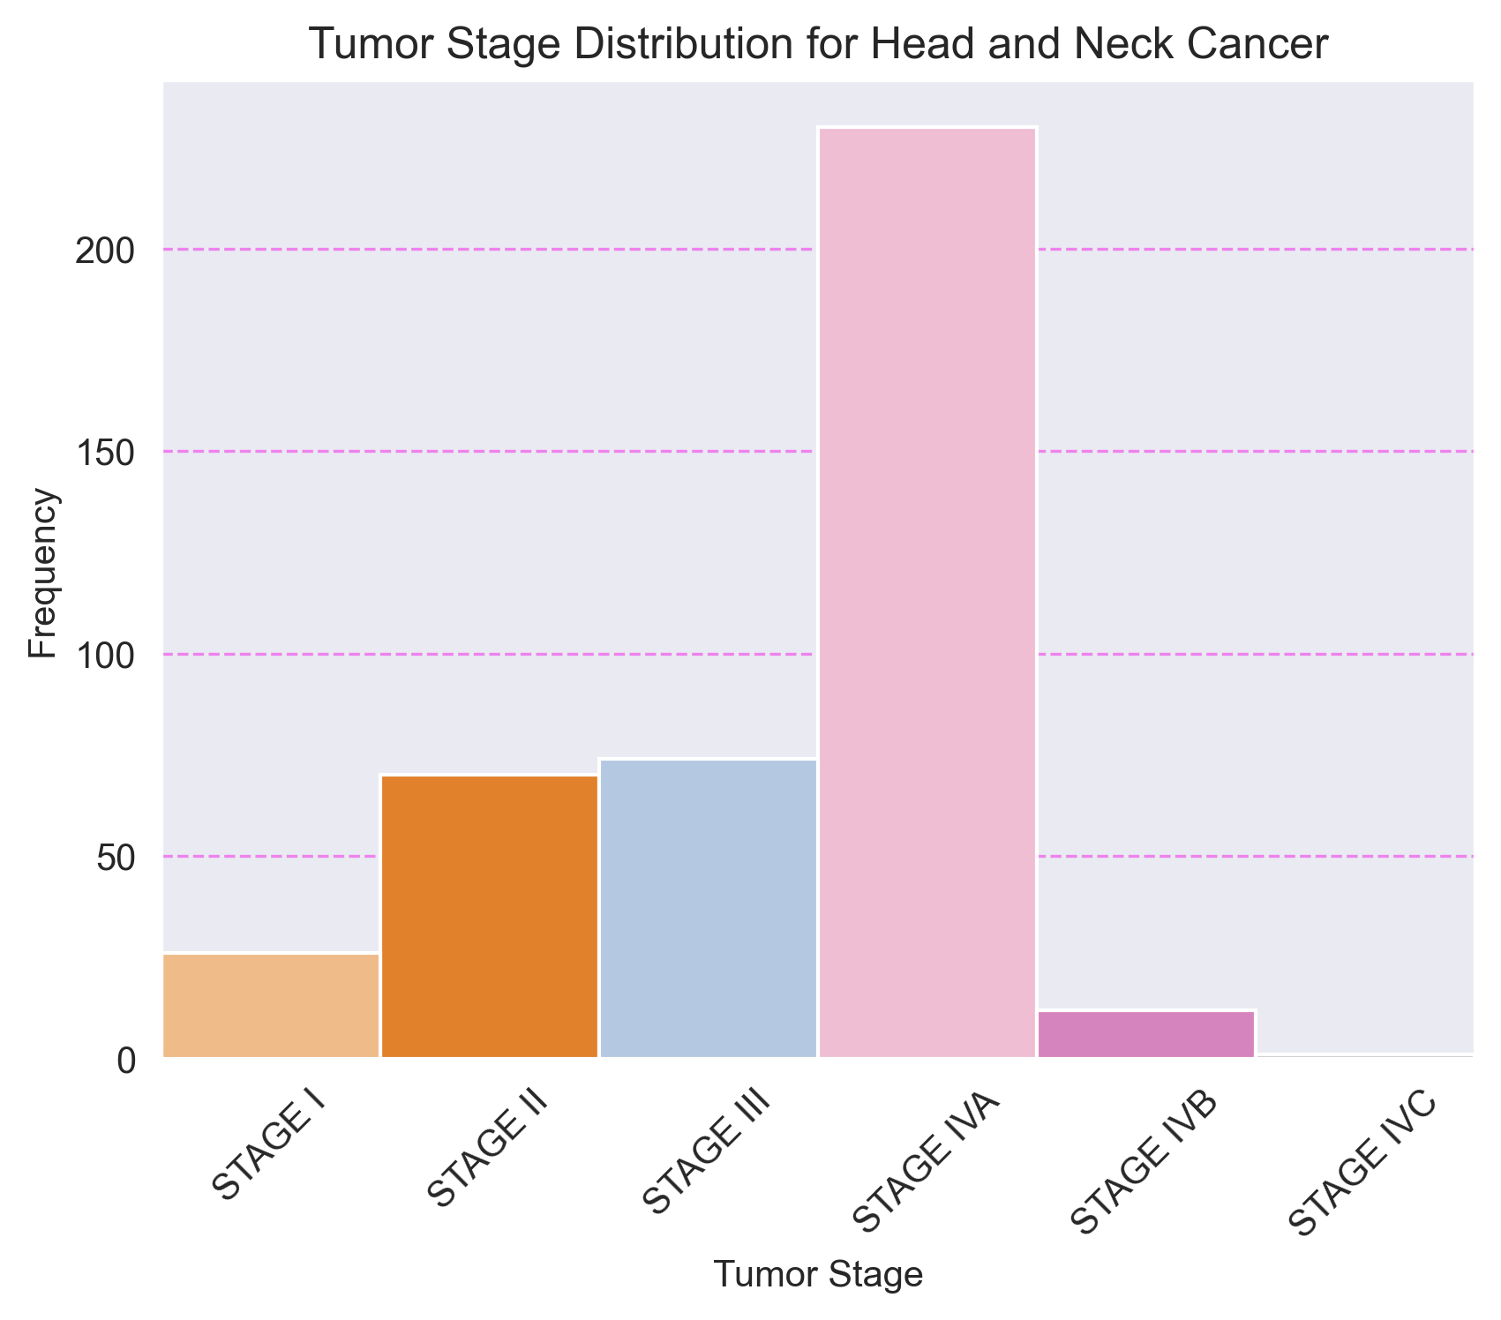

## 8. Distribución de Estadios Tumorales para Renal Non-Clear Cell Carcinoma

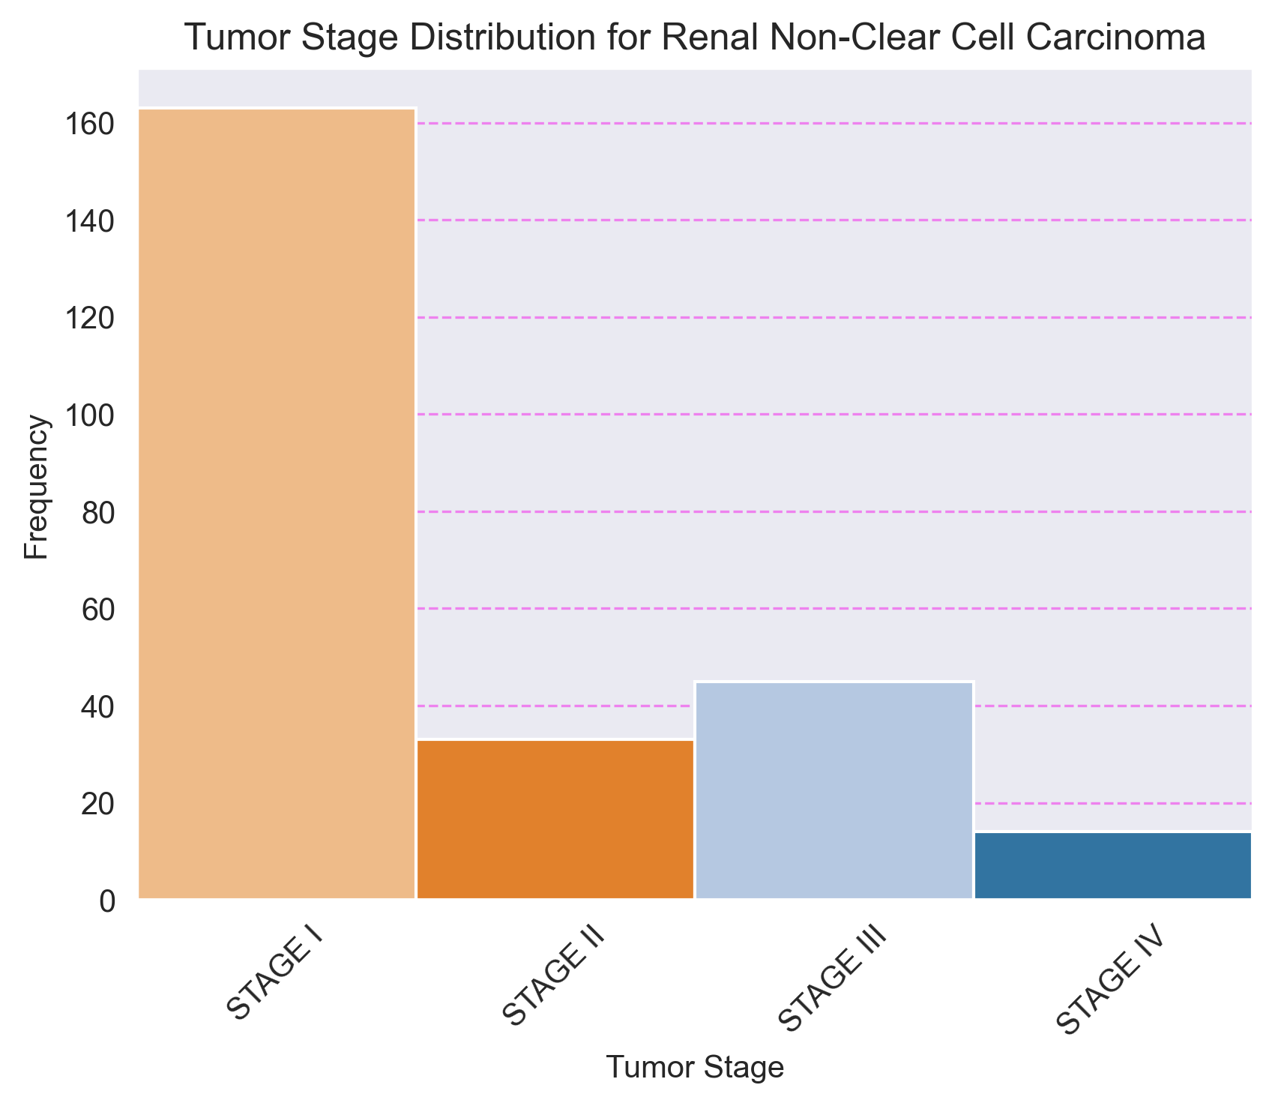

## 9. Distribución de Estadios Tumorales para Renal Clear Cell Carcinoma

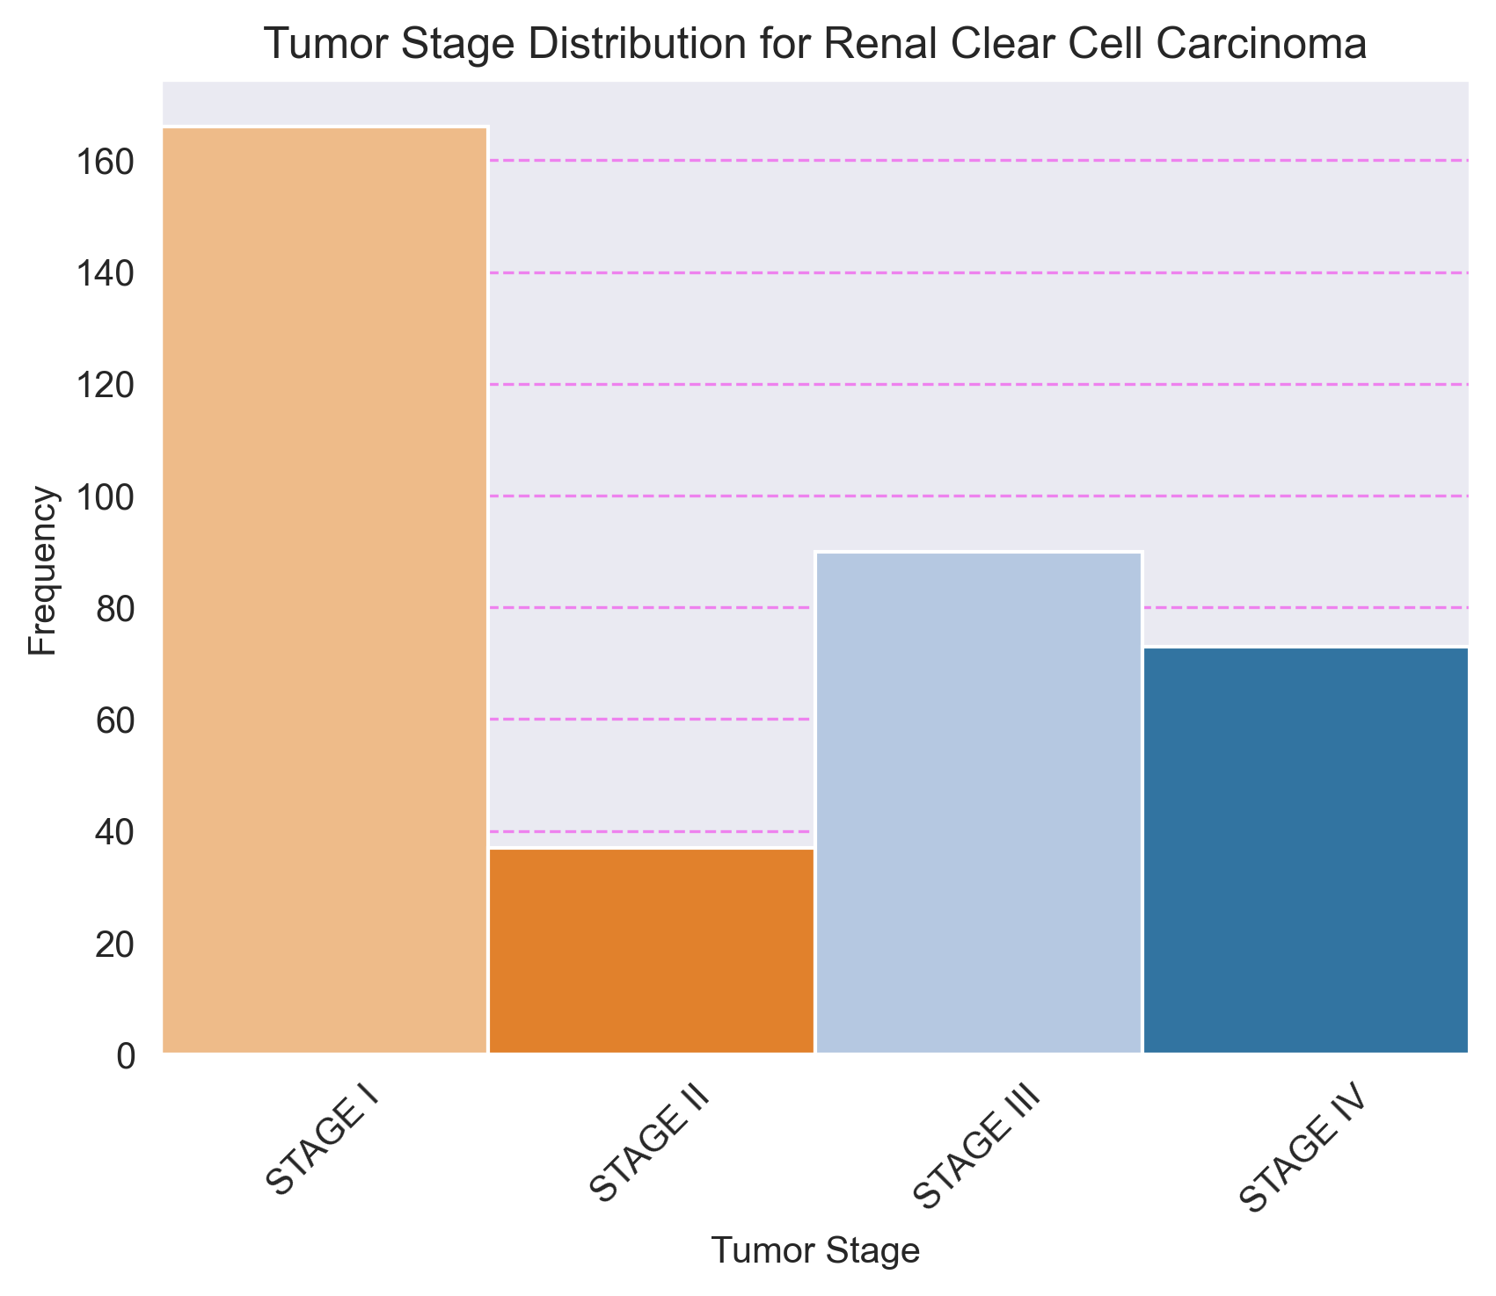

## 10. Distribución de Estadios Tumorales para Hepatobiliary Cancer

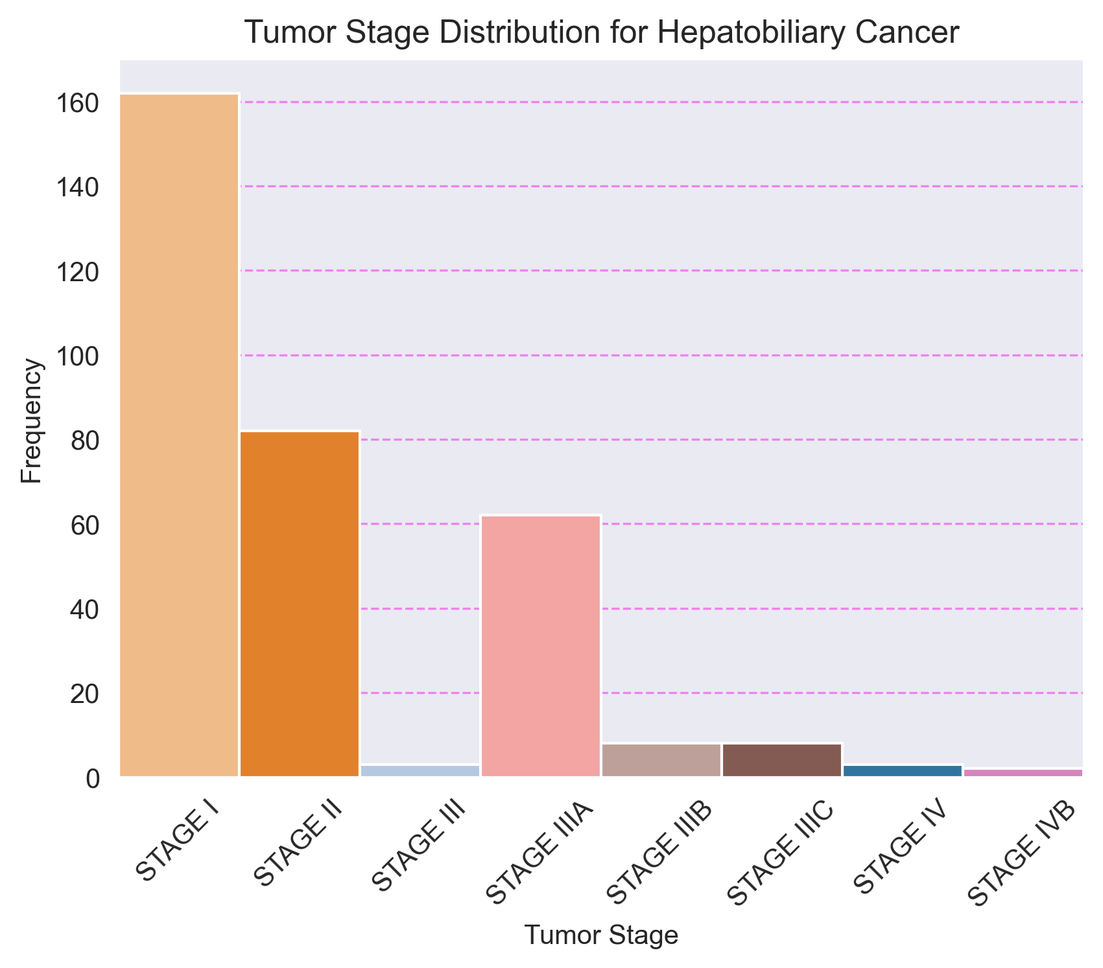

## 11. Distribución de Estadios Tumorales para Non-Small Cell Lung Cancer

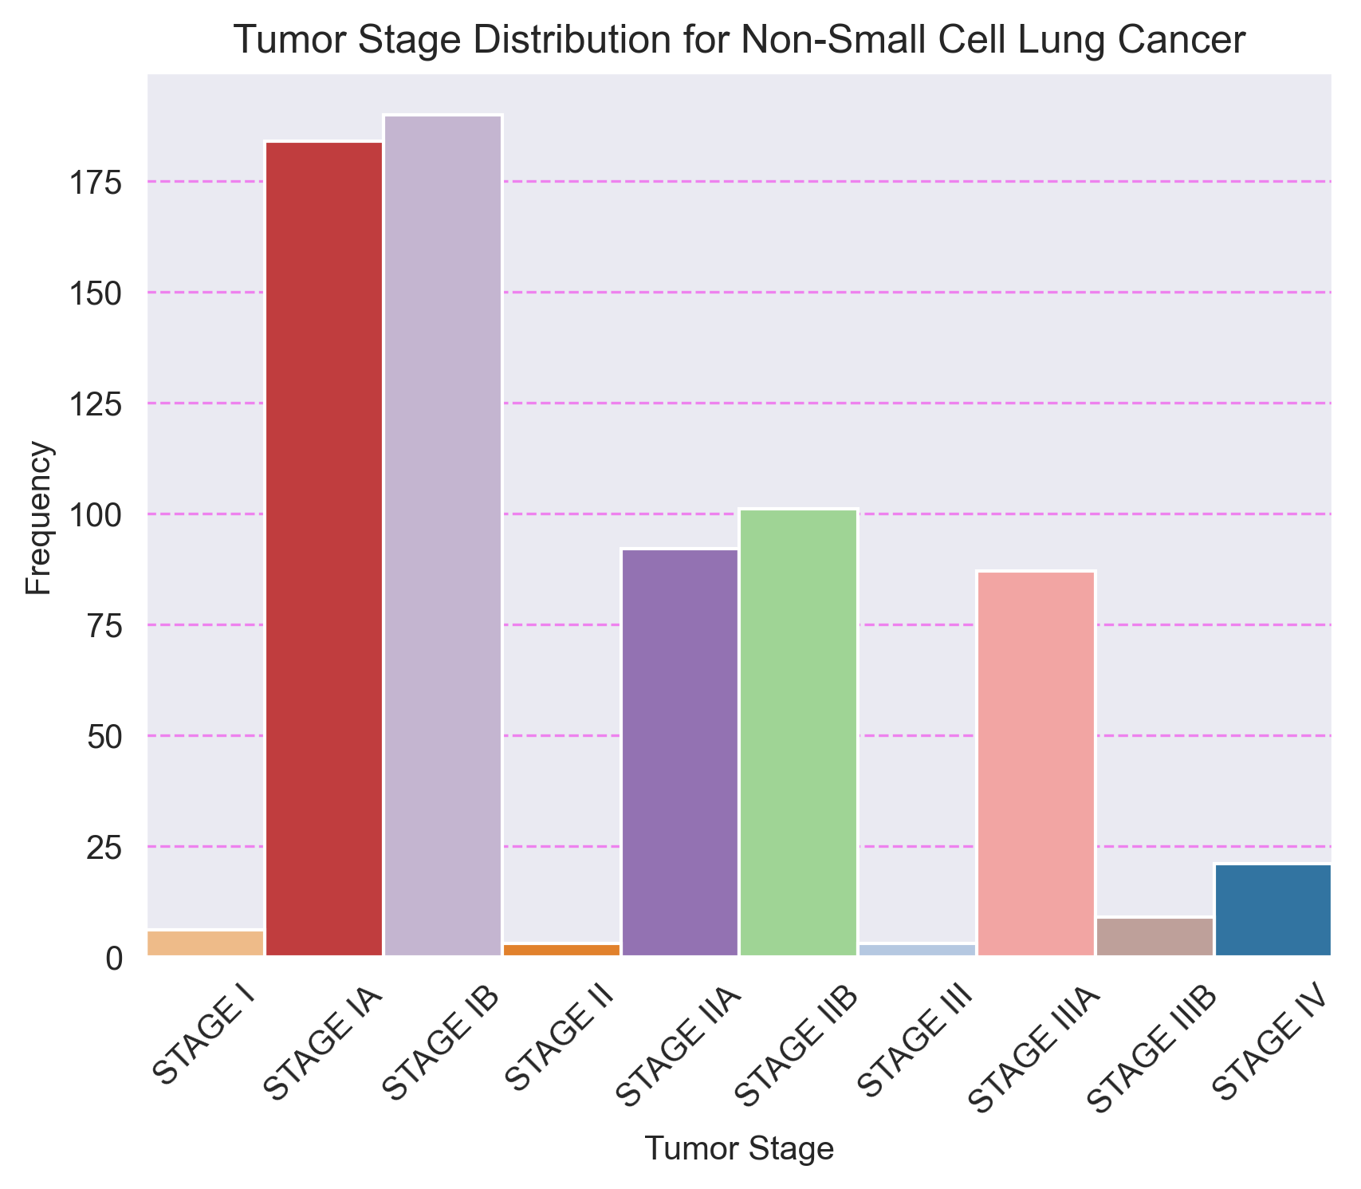

## 12. Distribución de Estadios Tumorales para Pleural Mesothelioma

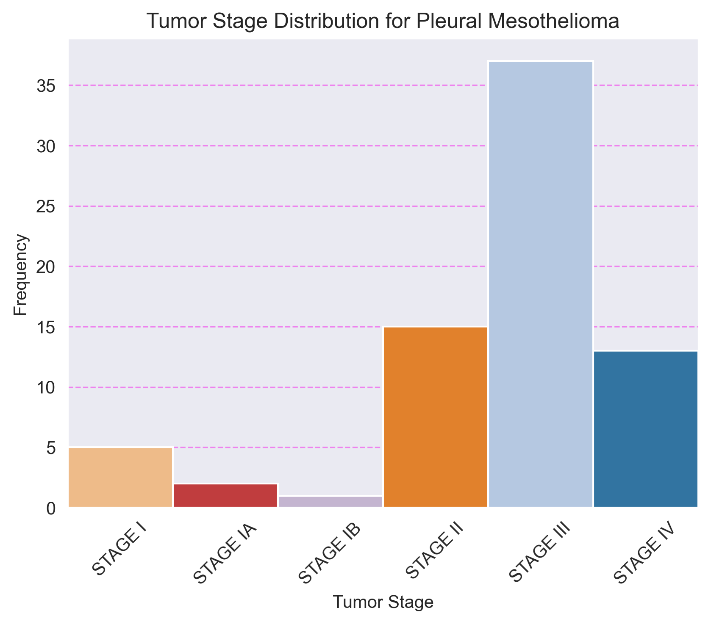

## 13. Distribución de Estadios Tumorales para Pancreatic Cancer

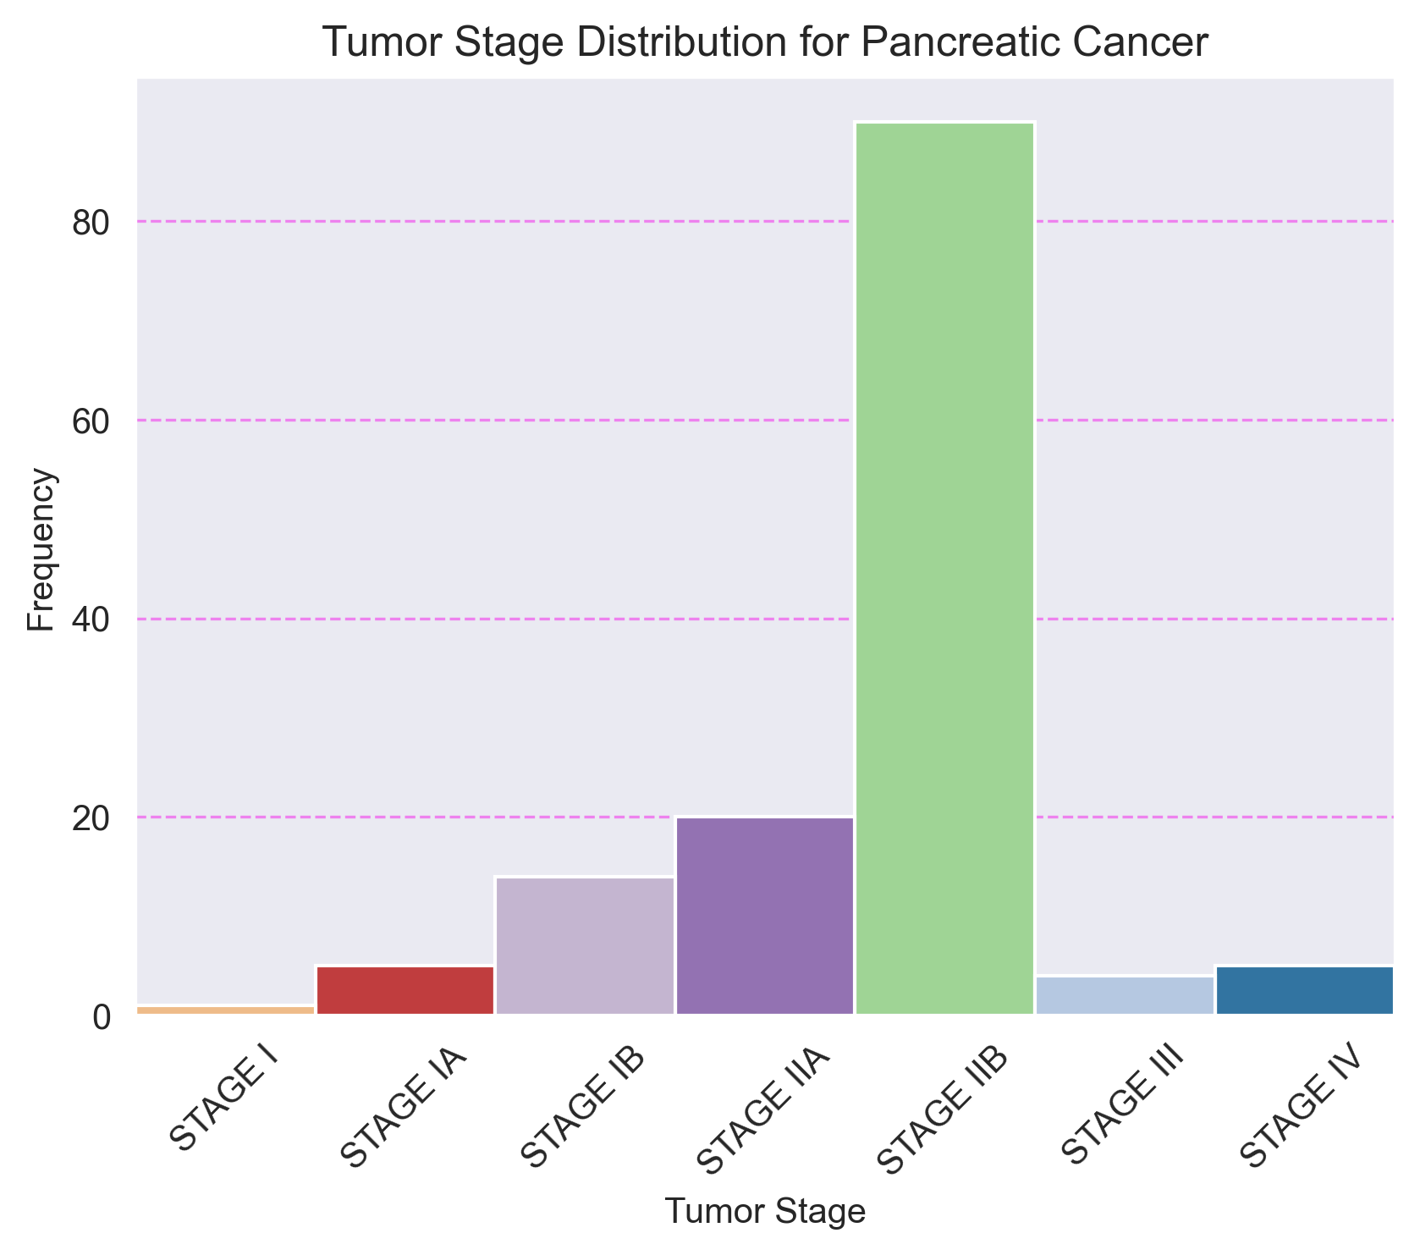

## 14. Distribución de Estadios Tumorales para Melanoma

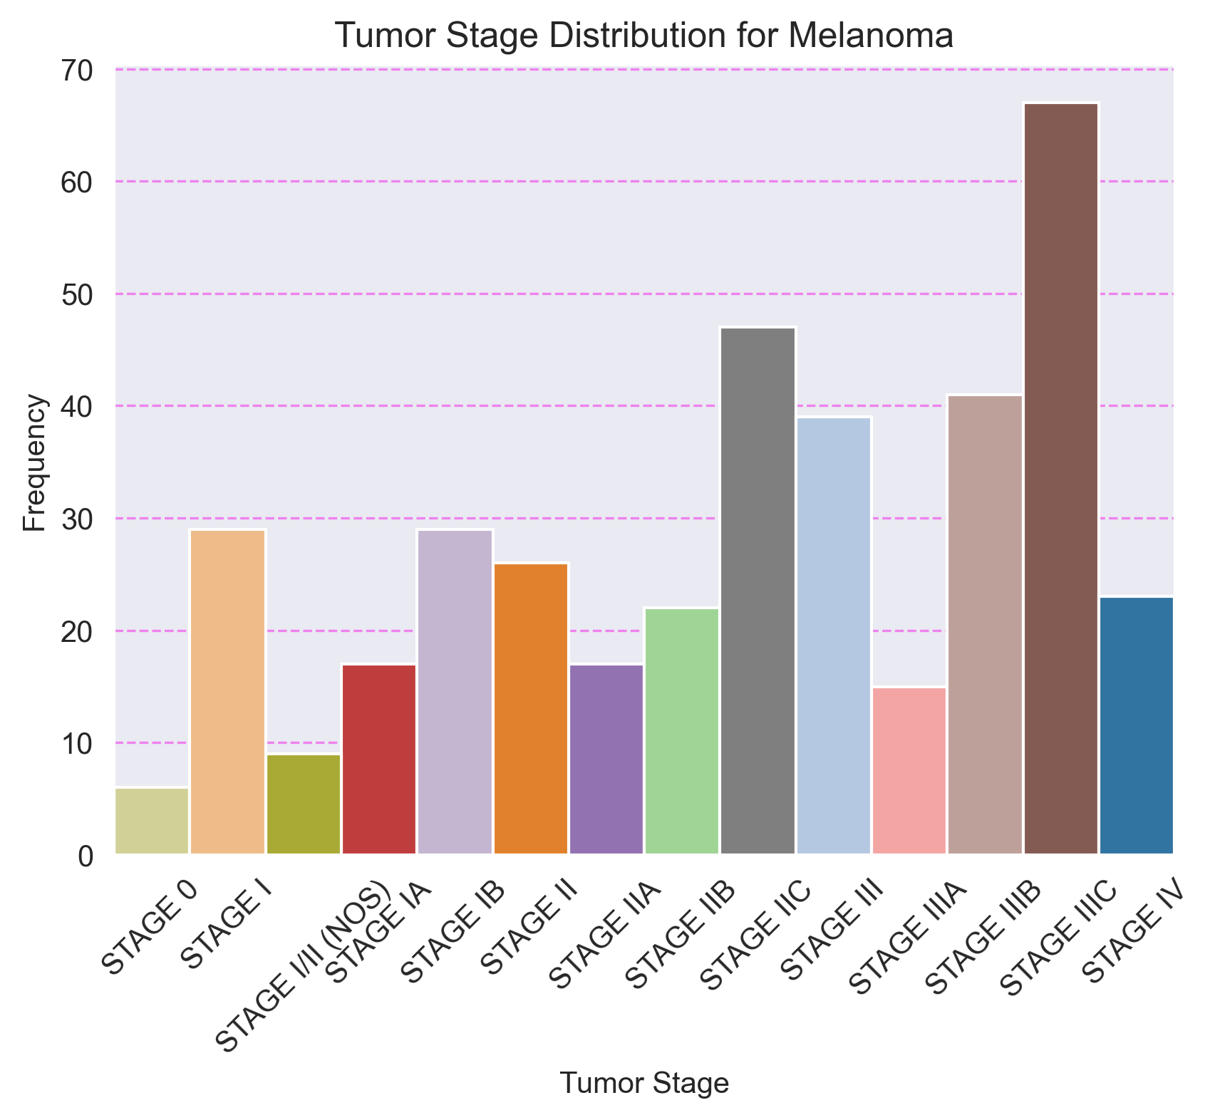

## 15. Distribución de Estadios Tumorales para Seminoma

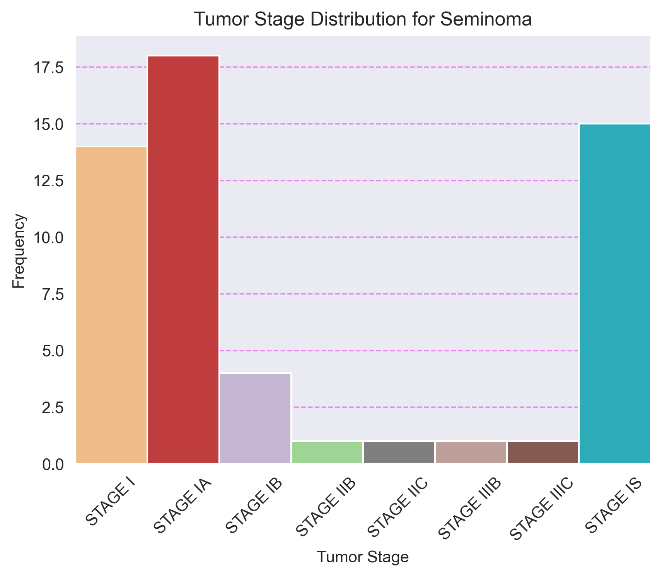

## 16. Distribución de Estadios Tumorales para Non-Seminomatous Germ Cell Tumor

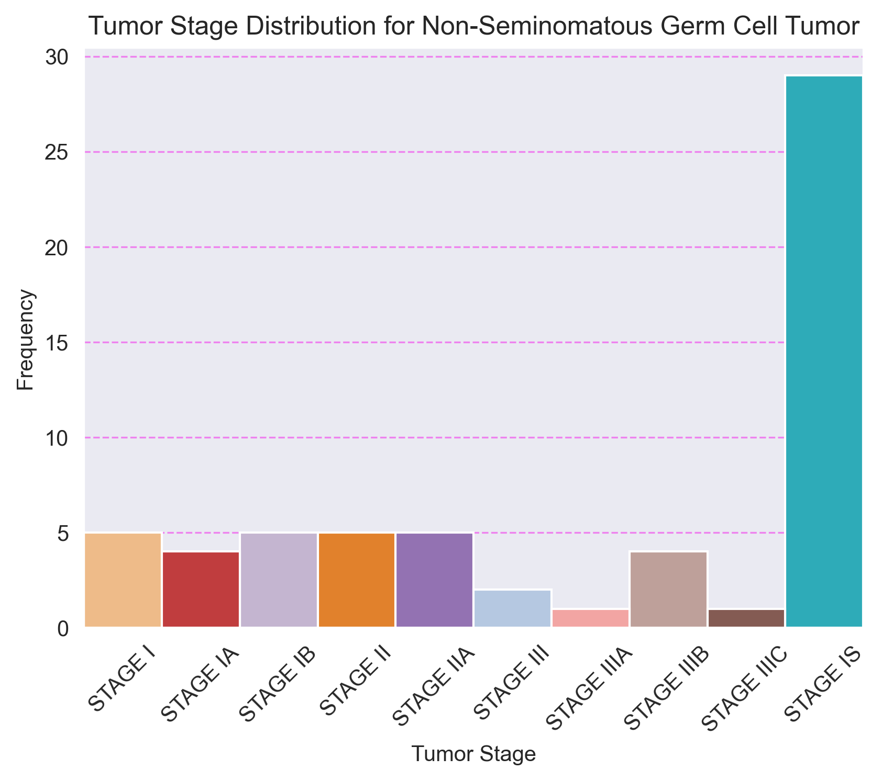

## 17. Distribución de Estadios Tumorales para Thyroid Cancer

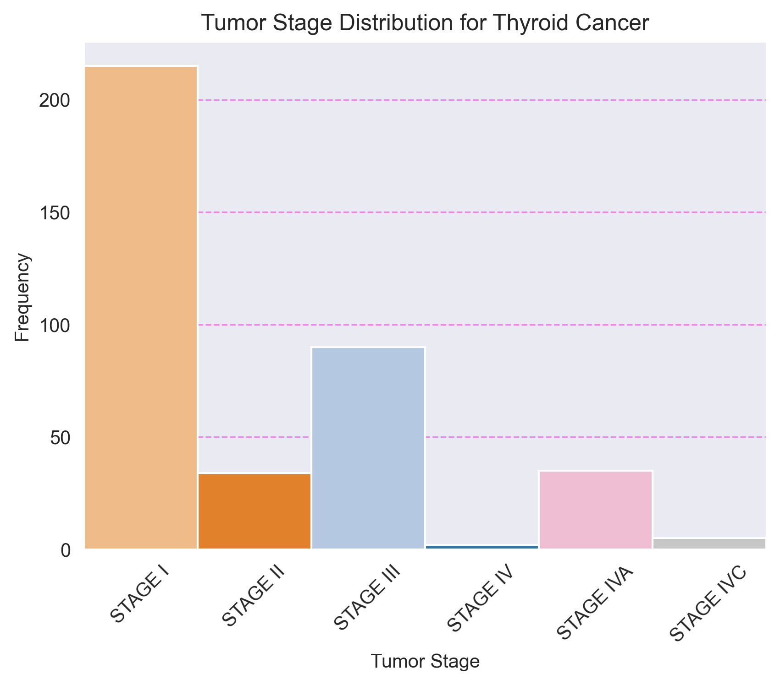

# 9. Distribución de Sexos por Tipo de Cáncer y Estadio Tumoral

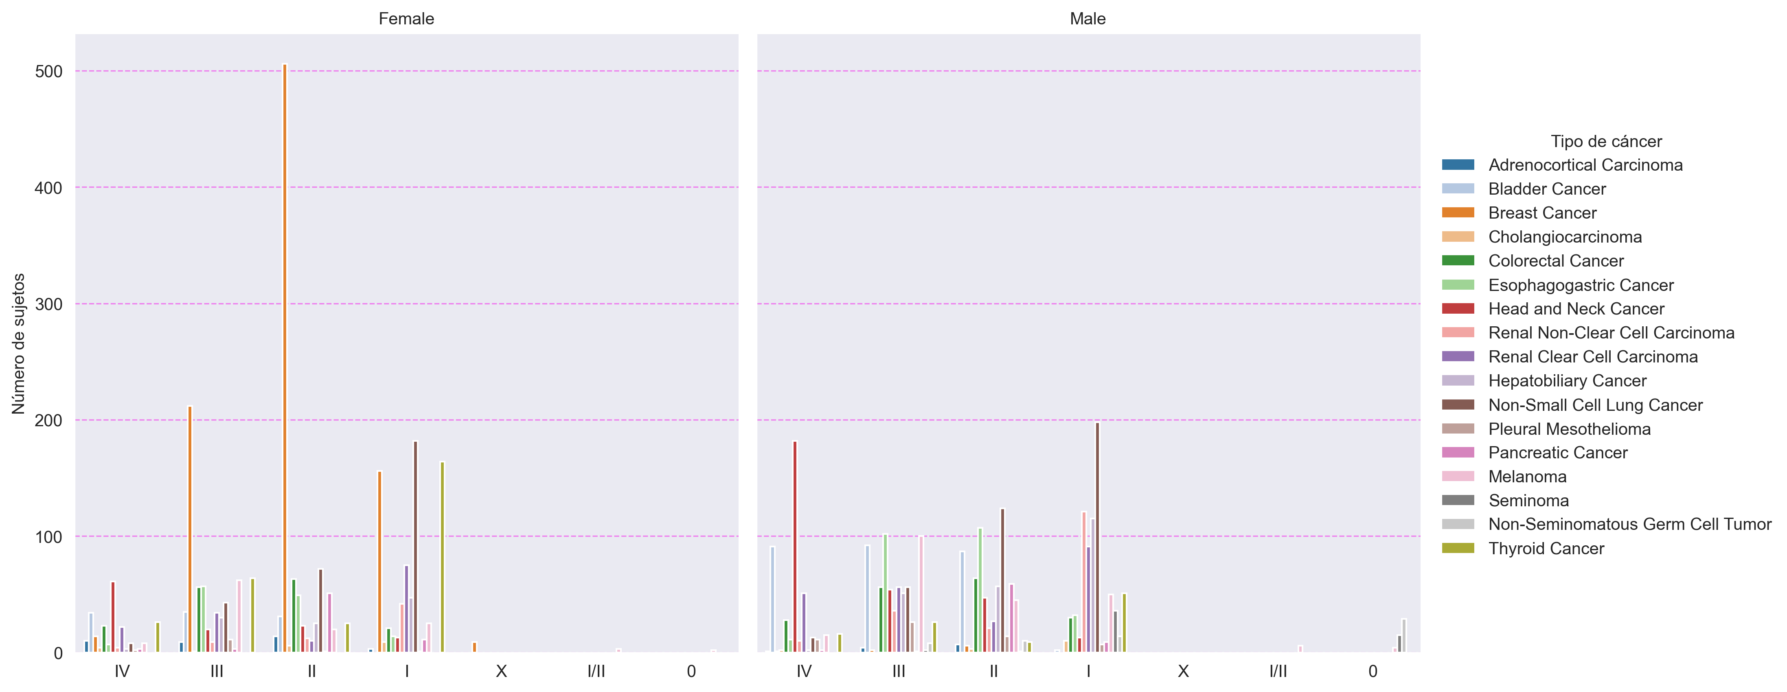

# 10. Distribución de Sexos por Tipo de Cáncer y Grupos de Edad

